Chapter 02
Basic Financial Statements

True / False Questions
1. | The sale of additional shares of capital stock will cause treasury stock to increase.  True False

2. | A business entity is regarded as separate from the personal activities of its owners whether it is a sole proprietorship, a partnership, or a corporation.  True False

3. | Assets need not always have physical characteristics as do buildings, machinery, or inventory.  True False

4. | The going concern principle assumes that the business will continue indefinitely.  True False

5. | Notes payable and accounts payable both require a company to pay an amount owed by a certain date. Notes payable generally have interest, while accounts payable generally do not.  True False

6. | Any business event that might affect the future profitability of a business should be reported in its balance sheet.  True False

7. | The practice of showing assets on the balance sheet at their cost, rather than at their current market value is explained, in part, by the fact that cost is supported by objective evidence that can be verified by independent experts.  True False

8. | Liabilities are usually listed in order of magnitude, from smallest dollar amount to largest dollar amount.  True False

9. | The entity principle states that the affairs of the owners are not part of the financial operations of a business entity and should be separated.  True False

10. | The accounting equation may be stated as "assets minus liabilities equals owners' equity."  True False

11. | Total assets plus total liabilities must equal total owners' equity.  True False

12. | A transaction that causes an increase in an asset may also cause a decrease in another asset, an increase in a liability, or an increase in owners' equity.  True False

13. | The collection of an account receivable will cause total assets to decrease.  True False

14. | The payment of a liability causes an increase in owners' equity.  True False

15. | When a business borrows money from a bank, the immediate effect is an increase in total assets and a decrease in liabilities or owners' equity.  True False

16. | The purchase of an asset, such as office equipment, for cash will cause owners' equity to decrease.  True False

17. | Total assets must always equal total liabilities plus total owners' equity.  True False

18. | If a company purchases equipment with cash, its total assets will increase.  True False

19. | If a company purchases equipment by issuing a note payable, its total assets will not change.  True False

20. | A net profit results from having more revenues than liabilities.  True False

21. | A statement of cash flows reports revenue and expense activities for a specific time period such as one month or one year.  True False

22. | It is not unusual for an entity to report a significant increase in cash from operating activities, but a decrease in the total amount of cash.  True False

23. | The statement of cash flows provides a link between two balance sheets by showing how net income (or loss) has changed owners' equity from one balance sheet date to the next.  True False

24. | Articulation between the financial statements means that they relate closely to each other on the basis of the same underlying transaction information.  True False

25. | Limited liability means that owners of a business are only liable for the debts of the business up to the amounts they can afford.  True False

26. | In a business organized as a corporation, it is not necessary to list the equity of each stockholder on the balance sheet.  True False

27. | The owner of a sole proprietorship is personally liable for the debts of the business, whereas the stockholders of a corporation are not personally liable for the debts of the business.  True False

28. | Window dressing occurs when management attempts to make a company look financially stronger than it actually is.  True False

29. | Decision makers outside the organization base their credit decisions on weekly, or even daily, financial statements.  True False

30. | The major outgrowth from business failures and allegations of fraudulent financial reporting during the 1990's was the passage of the Securities and Exchange Act.  True False

Multiple Choice Questions
31. | Which of the following is the primary objective of an income statement?  A. Providing managers with detailed information about where the enterprise stands at a specific date.  B. Providing users outside the business organization with information about the company's financial position and operating results.  C. Reporting to the Internal Revenue Service the company's taxable income.  D. Indicating to investors in a particular company the current market values of their investments.

32. | Which of the following describes the proper form of a balance sheet?  A. The heading sets forth the period of time covered.  B. Cash is always the first asset listed, followed by permanent assets (such as land and buildings), and finally by assets such as receivables and supplies.  C. Liabilities are listed before owners' equity.  D. A subtotal for total assets plus total liabilities is shown.

33. | A balance sheet is designed to show:  A. How much a business is worth.  B. The profitability of the business during the current year.  C. The assets, liabilities, and owners' equity of a business as of a particular date.  D. The cost of replacing the assets and of paying off the liabilities at December 31.

34. | Blue Wholesale Shirt Co. sold shirts to Pink Retail Shoppe. The owner of Pink Retail said she would pay Blue at a later date, which Blue Wholesale agreed to. Blue Wholesale Shirt Co. is considered to be a:  A. borrower.  B. liability.  C. creditor.  D. debtor.

35. | Which of the following best defines an asset?  A. Something with physical form that is valued at cost in the accounting records.  B. An economic resource owned by a business and expected to benefit future operations.  C. An economic resource representing cash or the right to receive cash in the near future.  D. Something owned by a business that has a ready market value.

36. | From an accounting viewpoint, when is a business considered as an entity separate from its owner(s)?  A. Only when organized as a sole proprietorship.  B. Only when organized as a partnership.  C. Only when organized as a corporation.  D. A business is always considered as an accounting entity separate from the activities of the owner(s).

37. | The accounting principle that assumes that a company will operate in the foreseeable future is:  A. Going concern.  B. Objectivity.  C. Liquidity.  D. Disclosure.

38. | The valuation of assets in the balance sheet is based primarily upon:  A. What it would cost to replace the assets.  B. Cost, because cost is usually factual and verifiable.  C. Current fair market value as established by independent appraisers.  D. Cost, because in the event of liquidation, the assets would be sold at an amount equal to their original cost.

39. | Which of the following is not a generally accepted accounting principle relating to the valuation of assets?  A. The cost principle - in general, assets are valued at cost, rather than at estimated market values.  B. The objectivity principle - accountants prefer to use objective, rather than subjective, information as the basis for accounting information.  C. The safety principle - assets are valued at no more than the value for which they are insured.  D. The going-concern assumption - one reason for valuing assets such as buildings and equipment at cost rather than at their current market values is the assumption that the business will use these assets rather than sell them.

40. | Each year, the accountant for Southern Real Estate Company adjusts the recorded value of each asset to its market value. Using these market value figures on the balance sheet violates:  A. The accounting equation.  B. The stable-dollar assumption.  C. The business entity concept.  D. The cost principle.

41. | The owner of Westhampton Fish Eatery purchased a new car for his daughter who is away at college at a cost of $43,000 and reported this amount as Delivery Vehicle in the restaurant's balance sheet. The reporting of this item in this manner violated the:  A. Cost principle.  B. Business entity concept.  C. Objectivity principle.  D. Going-concern assumption.

42. | Eton Corporation purchased land in 1998 for $190,000. In 2014, it purchased a nearly identical parcel of land for $430,000. In its 2014 balance sheet, Eton valued these two parcels of land at a combined value of $860,000. Reporting the land in this manner violated the:  A. Cost principle.  B. Principle of the business entity.  C. Objectivity principle.  D. Going-concern assumption.

43. | Bob Bertolucci, owner of Bob's Bazaar, also owns a personal residence that costs $575,000. The market value of his residence is $725,000. During preparation of the financial statements for Bob's Bazaar, the accounting principle most relevant to the presentation of Bob's home is:  A. The concept of the business entity.  B. The cost principle.  C. The going-concern assumption.  D. The objectivity principle.

44. | Which of the following will not cause a change in the owners' equity of a business?  A. Purchase of land with cash.  B. Withdrawal of cash by the owner.  C. Sale of land at a profit.  D. Losses from unprofitable operations.

45. | Which of the following is correct when a corporation uses cash to pay for an expense?  A. Total assets will decrease.  B. Retained earnings will increase.  C. Owners' equity will increase.  D. Liabilities will increase.

46. | Deerpark Corporation recently borrowed $70,000 cash from its bank. Which of the following was unaffected by this transaction?  A. Assets.  B. Liabilities.  C. Owners' equity.  D. Cash.

47. | Which of the following transactions would cause an increase in both assets and owners' equity?  A. Investment of cash in the business by the owner.  B. Sale of land for a price less than its cost.  C. Borrowing money from a bank.  D. Sale of land for cash at a price equal to its cost.

48. | A transaction caused an increase in both assets and owners' equity. This transaction could have been resulted from the:  A. Sale of services to a customer.  B. Sale of land for a price less than its cost.  C. Borrowing money from a bank.  D. Sale of land for cash at a price equal to its cost.

49. | The amount of owners' equity in a business is not affected by:  A. The percentage of total assets held in cash.  B. The investments made in the business by the owner.  C. The profitability of the business.  D. The amount of dividends paid to stockholders.

50. | Decreases in owners' equity are caused by:  A. Purchases of assets and payment of liabilities.  B. Purchases of assets and incurrence of liabilities.  C. Payment of liabilities and unprofitable operations.  D. Distributions of assets to the owners and unprofitable operations.

51. | Which of the following transactions would cause a change in owners' equity?  A. Repayment of the principal on a bank loan.  B. Purchase of a delivery truck on credit.  C. Sale of land on credit for a price above cost.  D. Borrowing money from a bank.

52. | On the statement of financial position, assets are normally presented in and liabilities are usually presented in:  A. Their order of permanence; the order in which they become due.  B. The order in which they become due; their order of permanence.  C. Order of profitability; order of liquidity.  D. Order of liquidity; order of profitability.

53. | Which of the following assets would most likely be listed last on a statement of financial position?  A. Land.  B. Cash.  C. Accounts receivable.  D. Equipment.

54. | Which of the following liabilities would most likely be listed last on a statement of financial position?  A. Bonds payable, due in 20 years.  B. Accounts payable.  C. Note payable, due in 3 years.  D. Income taxes payable.

55. | If a transaction causes an asset account to decrease, which of the following related effects may occur?  A. An increase of equal amount in an owners' equity account.  B. An increase in a liability account.  C. An increase of equal amount in another asset account.  D. An increase in the combined total of liabilities and owners' equity.

56. | A payment of a business debt not including interest:  A. Decreases total assets.  B. Increases total liabilities.  C. Increases the owners' equity in the business.  D. Decreases the owners' equity in the business.

57. | If total assets equal $270,000 and total liabilities equal $202,500, the total owners' equity must equal:  A. $472,500.  B. $67,500.  C. $270,000.  D. Cannot be determined from the information given.

58. | If total assets equal $345,000 and total owners' equity equal $120,000, then total liabilities must equal:  A. $465,000.  B. $225,000.  C. $120,000.  D. Cannot be determined from the information given.

59. | Owners' equity in a business increases as a result of which of the following?  A. Payments of cash to the owners.  B. Losses from unprofitable operation of the business.  C. Earnings from profitable operation of the business.  D. Borrowing from a commercial bank.

60. | Owners' equity in a business decreases as a result of which of the following?  A. Investments of cash by the owners.  B. Profits from operating the business.  C. Losses from unprofitable operation of the business.  D. Repaying a loan to a commercial bank.

61. | To appear in a balance sheet of a business entity, an asset need not:  A. Be an economic resource.  B. Have a ready market value.  C. Be expected to benefit future operations.  D. Be owned by the business.

62. | A balance sheet:  A. Provides owners, investors, and other interested parties with all the financial information they need to evaluate the financial strength, profitability, and future prospects of a given business entity.  B. Shows the current market value of the owners' equity in the business at the balance sheet date.  C. Assists creditors in evaluating the debt-paying ability of a business by showing the assets and liabilities of the business combined with those of its owner (or owners).  D. Shows the assets, liabilities, and owners' equity of a business entity, valued in conformity with generally accepted accounting principles.

63. | Which of the following is correct if a company purchases equipment for $70,000 cash?  A. Total assets will increase by $70,000.  B. Total assets will decrease by $70,000.  C. Total assets will remain the same.  D. The company's total owners' equity will decrease.

64. | If a company purchases equipment for $65,000 by issuing a note payable:  A. Total assets will increase by $65,000.  B. Total assets will decrease by $65,000.  C. Total assets will remain the same.  D. The company's total owners' equity will decrease.

65. | If a company has a profit:  A. Assets will be equal to liabilities plus owners' equity.  B. Assets will be less than liabilities plus owners' equity.  C. Assets will be greater than liabilities plus owners' equity.  D. Owners' equity will be greater than its assets.

66. | Capital stock represents:  A. The amount invested in the business by stockholders when shares of stock were initially issued by a corporation.  B. The owners' equity for a business organized as a corporation.  C. The owners' equity accumulated through profitable operations that have not been paid out as dividends.  D. The price paid by the current owners to acquire shares of stock in the corporation, regardless of whether they bought the shares directly from the corporation or from another stockholder.

67. | The balance sheet item that represents the portion of owners' equity resulting from profitable operations of the business is:  A. Accounts receivable.  B. Cash.  C. Capital stock.  D. Retained earnings.

68. | Retained earnings appears on:  A. The income statement.  B. The balance sheet.  C. The statement of cash flows.  D. All three of the financial statements.

At December 31, 2014, the accounting records of Braun Corporation contain the following items:
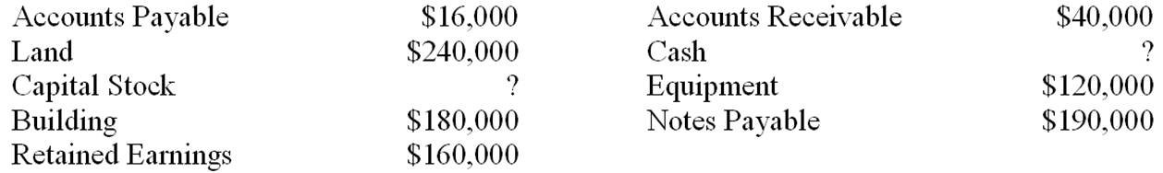

69. | Refer to the information above. If Capital Stock is $260,000, what is the December 31, 2014 cash balance?  A. $86,000.  B. $94,000.  C. $46,000.  D. $686,000.

70. | Refer to the information above. If Capital Stock is $320,000, total assets of Braun Corporation at December 31, 2014, amounts to:  A. $686,000.  B. $926,000.  C. $726,000.  D. $106,000.

71. | Refer to the information above. If Cash at December 31, 2014, is $86,000, Capital Stock is:  A. $260,000.  B. $300,000.  C. $620,000.  D. $168,000.

72. | Refer to the information above. If Cash at December 31, 2014, is $26,000, total owners' equity is:  A. $160,000.  B. $366,000.  C. $606,000.  D. $400,000.

73. | Refer to the information above. If Cash at December 31, 2014, is $66,000, total assets amounts to:  A. $606,000.  B. $806,000.  C. $662,000.  D. $646,000.

At December 31, 2014, the accounting records of Hercules Manufacturing, Inc. contain the following items:
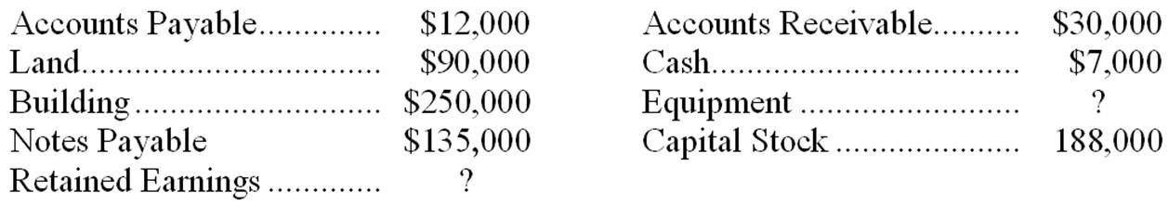

74. | Refer to the information above. If total assets of Hercules Manufacturing, Inc. are $556,000, Equipment is carried in Hercules Manufacturing accounting records at:  A. $377,000.  B. $179,000.  C. $150,000.  D. $90,000.

75. | Refer to the information above. If total assets of Hercules Manufacturing, Inc. are $556,000, Retained Earnings at December 31, 2014, must be:  A. $811,000.  B. $180,000.  C. $221,000.  D. $335,000.

76. | Refer to the information above. If Retained Earnings at December 31, 2014, is $140,000, total assets amounts to:  A. $98,000.  B. $377,000.  C. $475,000.  D. $188,000.

77. | Refer to the information above. If Retained Earnings at December 31, 2014, is $100,000, Equipment is carried in Hercules Manufacturing, Inc. accounting records at:  A. $42,000.  B. $58,000.  C. $43,500.  D. $345,000.

78. | Refer to the information above. Assume that the Equipment shown above was acquired by the business five years ago and has a book value of $156,000, but has a current appraised value of $200,000. Hercules Manufacturing's Retained Earnings at December 31, 2014, amounts to:  A. $533,000.  B. $345,000.  C. $198,000.  D. $356,000.

At December 31, 2014 the accounting records of Gordon, Inc. contain the following items:
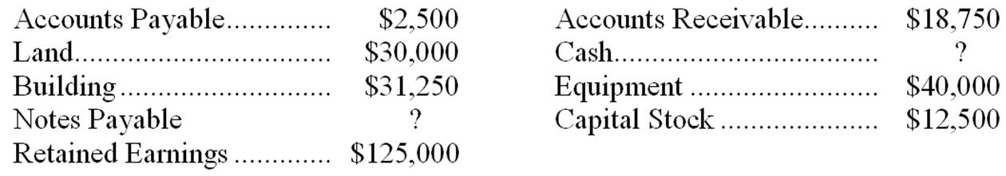

79. | Refer to the information above. If the Notes Payable is $10,000, the December 31, 2014 cash balance is:  A. $60,000.  B. $160,000.  C. $30,000.  D. $20,000.

80. | Refer to the information above. If the Notes Payable balance is $25,000, then the total assets of Gordon, Inc. at December 31, 2014 amount to:  A. $27,500.  B. $152,500.  C. $120,000.  D. $165,000.

81. | Refer to the information above. If the Cash balance at December 31, 2014 is $67,500, the Notes Payable balance is:  A. $118,750.  B. $47,500.  C. $137,500.  D. $140,000.

82. | Refer to the information above. If the Cash balance at December 31, 2014 is $62,500 then Total Liabilities amounts to:  A. $42,500.  B. $140,000.  C. $45,000.  D. $182,500.

83. | Which of the following is correct if at the end of Crystal Imports' first year of operations, Assets are $800,000 and Owners' Equity is $720,000?  A. The owner(s) must have invested $800,000 to start the business.  B. The business must be operating profitably.  C. Liabilities are $80,000.  D. Liabilities are $1,520,000.

84. | During the current year, the assets of Wheatley's increased by $362,000, and the liabilities increased by $260,000. The owners' equity in the business must have:  A. Decreased by $102,000.  B. Decreased by $622,000.  C. Increased by $102,000.  D. Increased by $622,000.

85. | The total liabilities of Hogan's Company on the balance sheet are $270,000; this amount is equal to three-fourths of the total assets. What is the amount of owners' equity?  A. $202,500.  B. $90,000.  C. $360,000.  D. $630,000.

86. | Thirty percent of the total assets of Shanahan Corporation have been financed through borrowing. The total liabilities of the company are $600,000. What is the amount of owners' equity?  A. $180,000.  B. $2,000,000.  C. $1,400,000.  D. $2,600,000.

87. | A transaction caused a $60,000 increase in both assets and total liabilities. This transaction could have been which of the following?  A. Purchase for office equipment for $60,000 cash.  B. Purchase of office equipment for $120,000, paying $60,000 cash and issuing a note payable for the balance.  C. Repayment of a $60,000 bank loan.  D. Investment of $60,000 cash in the business by the owner.

88. | If $9,600 cash and a $31,000 note payable are given in exchange for some office machines to be used in a business:  A. Total assets are increased.  B. Total liabilities are decreased.  C. Total assets are decreased.  D. The owners' equity is increased.

89. | If during the current year, liabilities of Corbett's Store increased by $220,000 and owners' equity increased by $160,000, then:  A. Assets at the end of the year total $380,000.  B. Assets at the end of the year total $60,000.  C. Assets increased during the year by $380,000.  D. Assets decreased during the year by $60,000.

90. | If during the current year, liabilities of Hayden Travel decreased by $50,000 and owners' equity increased by $75,000, then:  A. Assets at the end of the year total $125,000.  B. Assets at the end of the year total $25,000.  C. Assets increased during the year by $25,000.  D. Assets decreased during the year by $125,000.

91. | At the end of the current year, the owners' equity in Barclay Bakery is $246,000. During the year, the assets of the business had increased by $120,000 and the liabilities had increased by $72,000. Owners' equity at the beginning of the year must have been:  A. $198,000.  B. $174,000.  C. $284,000.  D. $438,000.

92. | At the end of the current year, the owners' equity in Durante Co. is $360,000. During the year, the assets of the business had increased by $68,000 and the liabilities had increased by $118,000. Owners' equity at the beginning of the year must have been:  A. $410,000.  B. $310,000.  C. $546,000.  D. $174,000.

93. | During the current year, the assets of Quality Stairs increased by $175,000 and the liabilities decreased by $15,000. If the owners' equity in the business is $475,000 at the end of the year, the owners' equity at the beginning of the year must have been:  A. $335,000.  B. $285,000.  C. $665,000.  D. $615,000.

94. | An expense is best defined as:  A. Any payment of cash for the benefit of the company.  B. Past, present, or future payments of cash required to generate revenues.  C. Past payments of cash required to generate revenues.  D. Future payments of cash required to generate revenues.

95. | A revenue transaction will result in all of the following except:  A. An increase in assets.  B. An increase in owners' equity.  C. A positive cash flow in either the past, present, or future.  D. An increase in liabilities.

Astoria Co. had the following transactions during the month of August 2014:
* Cash received from bank loans was $20,000.
* Dividends of $9,500 were paid to stockholders in cash.
* Revenues earned and received in cash amounted to $33,500.
* Expenses incurred and paid were $26,000.

96. | Refer to the information above. What amount of net income will be reported on an income statement for the month of August?  A. $20,000.  B. $7,500.  C. $0.  D. $33,500.

97. | Refer to the information above. At the beginning of August, 2014, owners' equity in Astoria was $160,000. Given the transactions of August, what will be the owners' equity be at the end of the month?  A. $167,500.  B. $150,500.  C. $193,500.  D. $158,000.

98. | Refer to the information above. For the month of August, net cash flows from operating activities for Astoria were:  A. $33,500.  B. $7,500.  C. $20,000.  D. $26,000.

Waldorf Co. had the following transactions during the month of October 2014:
* Cash received from bank loans was $60,000.
* Dividends of $18,500 were paid to stockholders in cash.
* Revenues earned and received in cash amounted to $100,500.
* Expenses incurred and paid were $78,000.

99. | Refer to the information above. What amount of net income will be reported on an income statement for the month of October?  A. $18,500.  B. $22,500.  C. $78,000.  D. $100,500.

100. | Refer to the information above. At the beginning of October, owners' equity in Waldorf was $480,000. Given the transactions of October, 2014, what will be the owners' equity at the end of the month?  A. $480,000.  B. $484,000.  C. $502,500.  D. $580,500.

101. | Refer to the information above. For the month of October, net cash flows from operating activities for Waldorf were:  A. $18,500.  B. $22,500.  C. $78,000.  D. $100,500.

102. | Which of the following activities is not a category into which cash flows are classified?  A. Marketing activities.  B. Operating activities.  C. Financing activities.  D. Investing activities.

103. | A strong statement of cash flows indicates that significant cash is being generated by:  A. Operating activities.  B. Financing activities.  C. Investing activities.  D. Effective tax planning.

104. | During the month of May, Henderson Company had the following transactions:  * Revenues of $60,000 were earned and received in cash.  * Bank loans of $9,000 were paid off.  * Equipment of $20,000 was purchased.  * Expenses of $36,800 were paid.  * Stockholders purchased additional shares for $22,000 cash.  A statement of cash flows for May would report net cash flows from operating activities of:  A. $60,000.  B. $16,200.  C. $23,200.  D. $20,000.

During the month of August, Boyce Company had the following transactions:
* Revenues of $120,000 were earned and received in cash.
* Bank loans of $18,000 were paid off.
* Equipment of $40,000 was purchased with cash.
* Expenses of $73,600 were paid.
* Stockholders purchased additional shares for $44,000 cash.

105. | Refer to the information above. A statement of cash flows for August, would report net cash flows from operating activities of:  A. $26,000.  B. $32,400.  C. $40,000.  D. $46,400.

106. | Refer to the information above. A statement of cash flows for August, would report net cash flows from financing activities of:  A. $26,000.  B. $32,400.  C. $40,000.  D. $46,400.

107. | Refer to the information above. A statement of cash flows for August, would report net cash flows from investing activities of:  A. ($26,000).  B. $32,400.  C. ($40,000).  D. $46,400.

108. | Refer to the information above. A statement of cash flows for August, would report an increase in cash of:  A. $26,000.  B. $32,400.  C. $40,000.  D. $46,400.

During the month of February, Fadness Company had the following transactions:
* Revenues of $225,000 were earned and received in cash.
* Bank loans of $18,000 were paid off.
* New bank loans of $15,000 were incurred.
* Equipment of $40,000 was purchased with cash.
* Equipment was sold for its book value of $36,000. Cash was received.
* Expenses of $171,400 were paid.
* Stockholders purchased additional shares for $50,000 cash.

109. | Refer to the information above. A statement of cash flows for February, would report net cash flows from operating activities of:  A. $4,000.  B. $35,600.  C. $53,600.  D. $96,600.

110. | Refer to the information above. A statement of cash flows for February, would report net cash flows from financing activities of:  A. $4,000.  B. $47,000.  C. $83,000.  D. $96,600.

111. | Refer to the information above. A statement of cash flows for February, would report net cash flows from investing activities of:  A. ($4,000).  B. $47,000.  C. $53,600.  D. $76,000.

112. | Refer to the information above. A statement of cash flows for February, would report an increase in cash of:  A. $4,000.  B. $47,000.  C. $53,600.  D. $96,600.

113. | If cash flows from operating activities is a positive amount, then:  A. The amount will be shown on the statement of cash flows in parentheses.  B. The company must have had a net profit for the year.  C. The company must have paid off more debts than it earned during the year.  D. The company may still have a decrease in the total amount of cash for the period.

114. | The change in owners' equity due to only revenue and expense transactions is explained by the:  A. Statement of cash flows.  B. Statement of financial position.  C. Income statement.  D. Tax return.

115. | Which one of the following is not considered as one of the three primary financial statements?  A. Balance sheet.  B. Income statement.  C. Statement of cash flows.  D. Statement of budgeting activities.

116. | The way in which financial statements relate is known as:  A. Solvency.  B. Objectivity.  C. Articulation.  D. Entity.

117. | Which business organization is recognized as a separate legal entity under the law?  A. Corporation.  B. Sole proprietorship.  C. Partnership.  D. All business organizations are separate legal entities.

118. | Retained earnings is:  A. The positive cash flows of a company.  B. The net worth of a company.  C. The owners' equity that has accumulated as a result of profitable operations.  D. Equal to the total assets of a company.

119. | Which of the following best describes liquidity?  A. The ability to increase the value of retained earnings.  B. The ability to pay the debts of the company as they become due.  C. Being able to buy everything the company requires for cash.  D. Purchasing everything the company requires on credit.

120. | Profitability may be defined as:  A. The ability to pay the debts of the company as they become due.  B. The ability to increase retained earnings.  C. Distributing dividends out of retained earnings.  D. Having excess cash.

121. | The principle of adequate disclosure means that a company should disclose:  A. Only the important monetary information.  B. All confidential information regarding the company.  C. Any financial facts that a reasonably informed person would consider necessary for the proper interpretation of the financial statements.  D. Only subsequent events.

122. | Which of the following statements regarding liquidity and profitability is not true?  A. If a business is unable to pay its debts as they come due, it is operating unprofitably.  B. A business may be liquid, yet operate unprofitably for several years.  C. A business may operate profitably, yet be unable to meet its obligations.  D. In order to survive in the long-run, a business must both remain liquid and operate profitably.

123. | The concept of adequate disclosure means that:  A. The accounting department of a business must inform management of the accounting principles used in preparing the financial statements.  B. The company must inform users of any significant facts necessary for proper interpretation of the financial statements, including events occurring after the financial statement date.  C. The independent auditors must disclose in the financial statements any and all errors detected in the company's accounting records.  D. The financial statements should include a comprehensive list of each transaction that occurred during the year.

124. | According to the Sarbanes-Oxley Act, CEOs and CFOs must certify to the accuracy of their company's financial statements:  A. Monthly and Quarterly.  B. Quarterly and Annually.  C. Monthly and Annually.  D. CEOs and CFOs are not required to certify to the company's financial statement; only CPA's do.

125. | A strong statement of financial position shows:  A. Large amounts of liquid assets relative to the liabilities due in the near future.  B. Large amounts of debt relative to stockholders' equity.  C. That cash is being generated by operations.  D. That profits are being generated by operations.

Essay Questions
126. | Financial statements  A set of financial statements includes three related accounting reports, or statements. In the space provided, list the names of three primary statements, and give a brief description of the accounting information contained in each.

127. | Development of generally accepted accounting principles  (A.) What is meant by the phrase "generally accepted accounting principles"?  (B.) Explain the concept of the business entity and how it relates to generally accepted accounting principles.

128. | Valuation of assets under generally accepted accounting principles  Under generally accepted accounting principles, the assets owned by a business are reported in the balance sheet at their historical cost. Identify and briefly explain two accounting principles other than the cost principle that support the valuation of assets at cost in the balance sheet.

129. | Accounting terminology  Listed below are nine technical accounting terms introduced in this chapter:  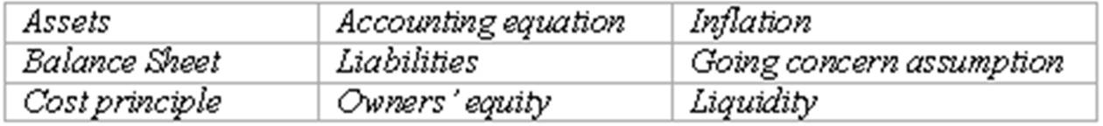  Each of the following statements may (or may not) describe one of these technical terms. In the space provided below each statement, indicate the accounting term described, or answer "None" if the statement does not correctly describe any of the terms. Do not use a term more than once.  (A.) Having the financial ability to pay debts as they become due.  (B.) An assumption that a business will operate in the foreseeable future.  (C.) Economic resources owned by businesses that are expected to benefit future operations.  (D.) The debts or obligations of a business organization.  (E.) Assets = Liabilities + Owners' Equity  (F.) The principle which states that assets are valued in the balance sheet at their historical cost.  (G.) A residual amount equal to assets minus liabilities.

130. | Accounting equation  (A.) During the current year, the assets of Duffy Stationery increased by $650,000 and the liabilities decreased by $340,000. What was the change in owners' equity during the year?  (B.) The owners' equity of Graham Interiors appears on the balance sheet as $720,000 and is equal to one-fourth of total assets. Compute the amount of total liabilities.  (C.) At the end of the year, the owners' equity in Scott Mfg. amounted to $845,000. During 2014, the assets of the business increased by $515,000 and the liabilities increased by $205,000. The owners' equity at the beginning of 2014 was how much?

131. | Effects of transactions on elements of the accounting equation  Some of the transactions carried out by Tudor Wholesale during the first month of the company's operations are listed below. You are to determine the effect of each transaction on the total assets, the total liabilities, and the owners' equity. Prepare your answer in columnar form, identifying each transaction by letter and using the symbols (+) for increase, (-) for decrease, and (NC) for no change. An answer is provided for the first transaction to serve as an example.  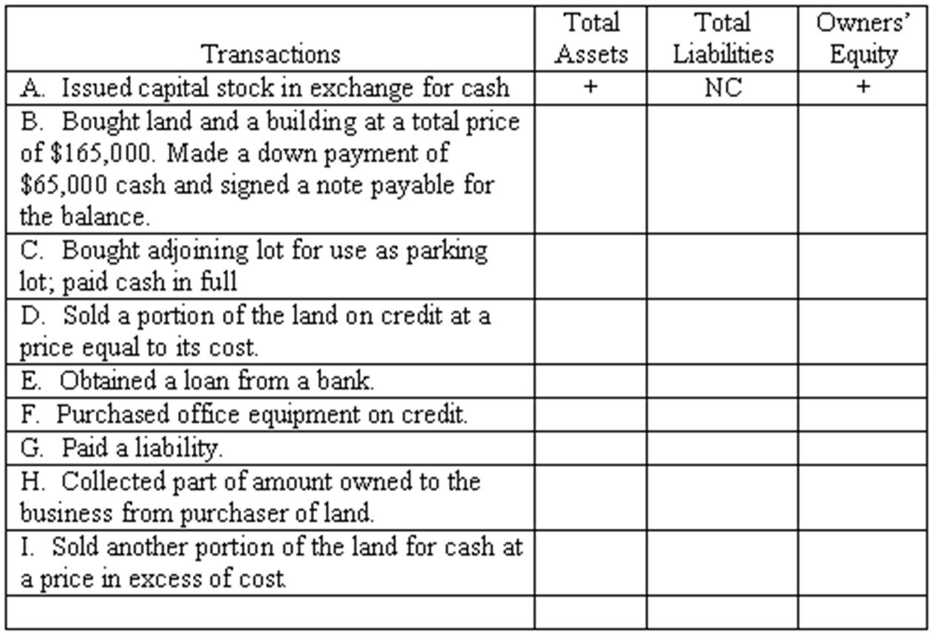

132. | Effects of transactions on elements of the accounting equation  Some of the transactions carried out by Tsang Company during the first month of the company's operations are listed below. You are to determine the dollar effect of each transaction on the total assets, the total liabilities, and the owners' equity of Tsang Company. Use the symbols (+) for increase, (-) for decrease, and (NC) for no change. An answer is provided for the first transaction to serve as an example.  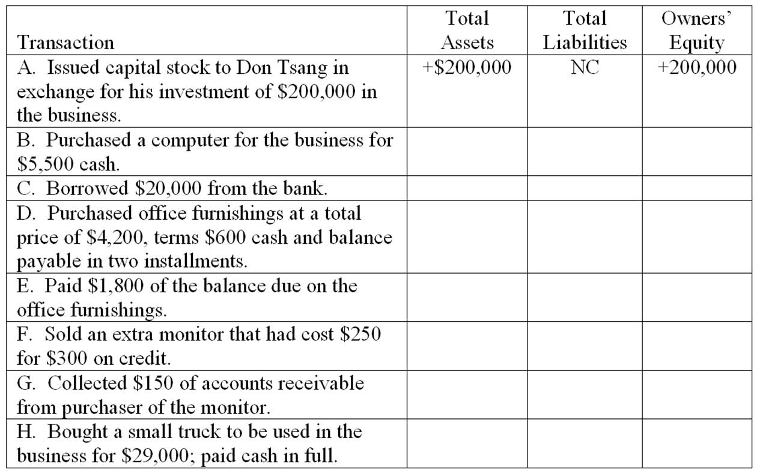

133. | List the following accounts in the order that they would appear in a balance sheet.  Capital Stock  Equipment  Accounts Receivable  Retained Earnings  Revenue  Accounts Payable  Cash  Rent Expense

134. | Computation of assets, liabilities, and owners' equity after a series of transactions  On April 30, 2014, the balance sheet of China Collectibles showed total assets of $700,000, total liabilities of $400,000, and owners' equity of $300,000. The following transactions occurred in May of 2014:  (1) Capital stock was issued in exchange for $165,000 cash.  (2) The business purchased equipment for $360,000, paying $160,000 cash and issuing a note payable for $200,000.  (3) The business paid $70,000 of its accounts payable.  (4) The business collected $54,000 of its accounts receivable.  Compute the following as of May 31, 2014:  (A.) Total assets $____________  (B.) Total liabilities $____________  (C.) Owners' equity $____________

135. | Computation of assets, liabilities, and owners' equity after a series of transactions  The December 31, 2014 balance sheet of Charles Realty reported total assets of $900,000, total liabilities of $350,000, and owners' equity of $550,000. The following transactions occurred in January of 2014:  (1) The business purchased land for $250,000, paying $100,000 cash and issuing a note payable for the balance.  (2) The business collected accounts receivable totaling $45,000.  (3) The business sold land costing $50,000 for $60,000 cash.  (4) The business paid $50,000 of the note payable.  Compute the following at January 31, 2014:  (A.) Total assets $___________  (B.) Total liabilities $___________  (C.) Owners' equity $___________

136. | Preparation of balance sheet  Prepare the balance sheet as of December 31, 2014, for Gamma Company, from the following list of items which are arranged in random order. You must compute the amount for accounts payable to complete the balance sheet.  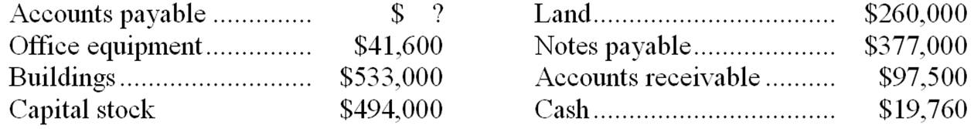

137. | Preparation of balance sheet after a series of transactions  The balance sheet was as follows for Custom Ceramics on February 1, 2014:  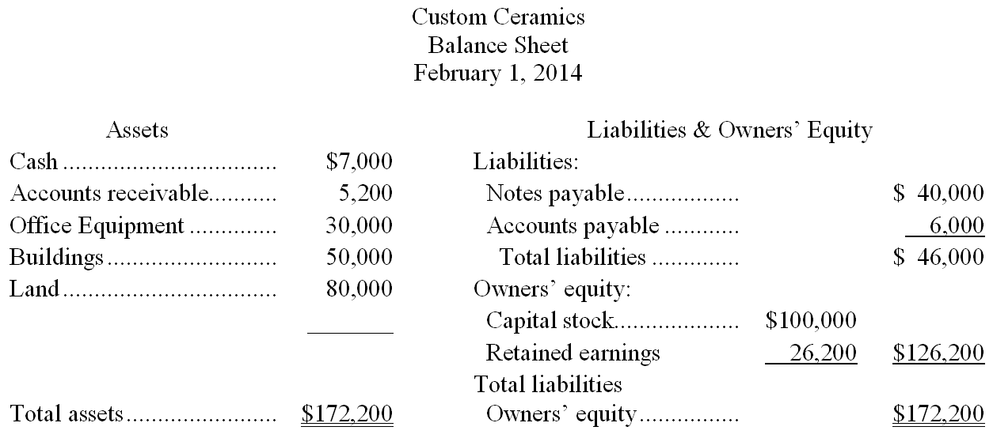  During the first week of February, the following transactions occurred:  * The business used cash to pay off $5,000 of its accounts payable. (No payment was made on the notes payable.)  * Additional capital stock was issued to Joan Custom for $15,000 cash.  * Equipment was purchased on credit for $1,800.  * The business collected $4,000 cash from accounts receivable.  Complete the balance sheet for Custom Ceramics as of February 8, 2014.  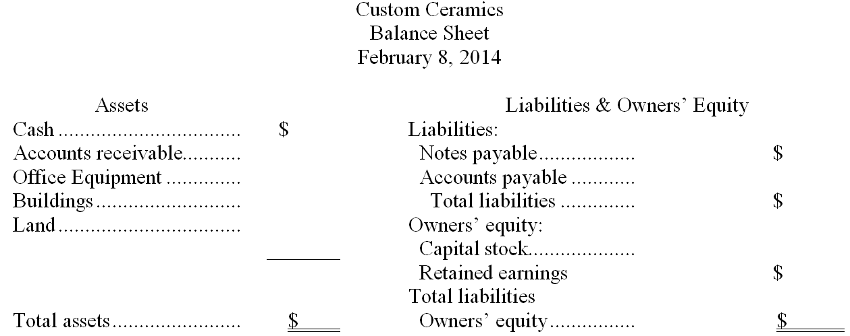

138. | Completion of balance sheet  Use the following information to complete the balance sheet of Adelphi Construction as of December 31, 2014.  (1) The company was organized on January 1, 2014 and has operated for the full year 2014.  (2) Earnings were $275,000 and dividends of $70,000 were paid to stockholders.  (3) Cash and accounts receivable together amount to one and one-half times as much as notes payable.  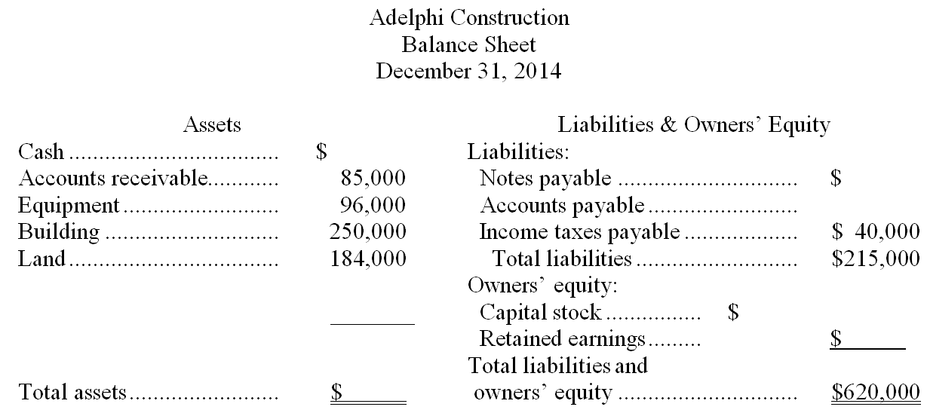

139. | Completion of balance sheet  Use the following information to complete the December 31, 2014 balance sheet of Copper Supplies Company.  (1) Owners' equity as of January 1, 2014, totaled $175,000, which included capital stock of $150,000.  (2) Additional capital stock was issued during 2014 in exchange for $40,000 cash.  (3) Net income for 2014 amounted to $200,000; no dividends were paid during 2014.  (4) Cash and accounts receivable together amount to 3 times as much as accounts payable.  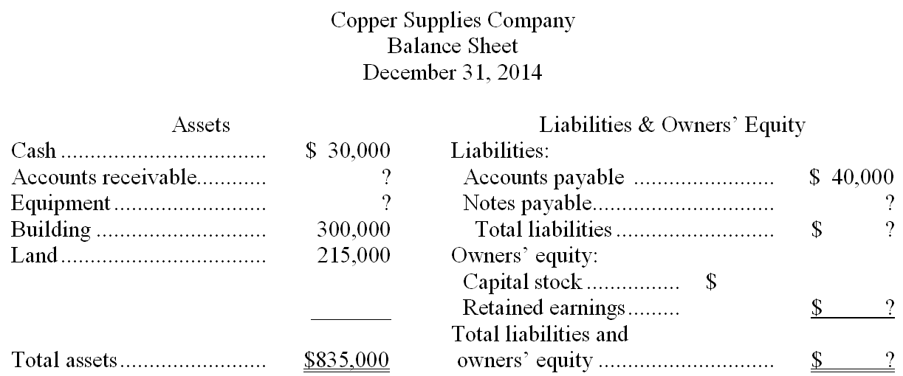

140. | Effects of transactions on balance sheet items  Show the effect of each of the seven listed transactions on the balance sheet items of Distinctive Draperies. Indicate the new balances after the transaction of May 2 and each subsequent transaction. The effects of the May 1 transaction are already filled in to provide you with an example.  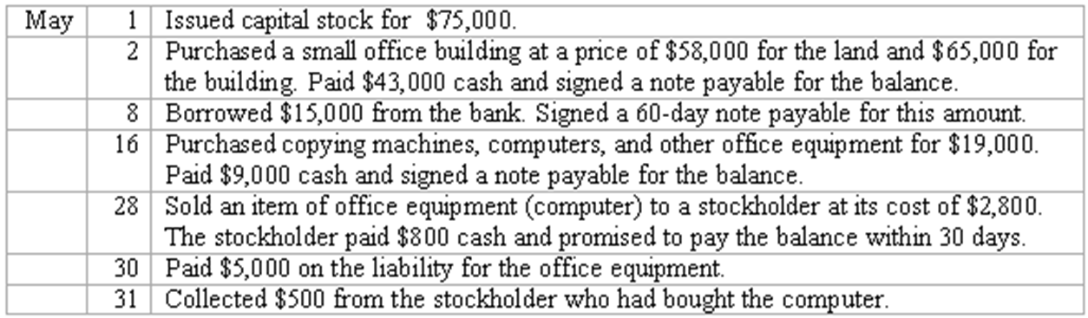  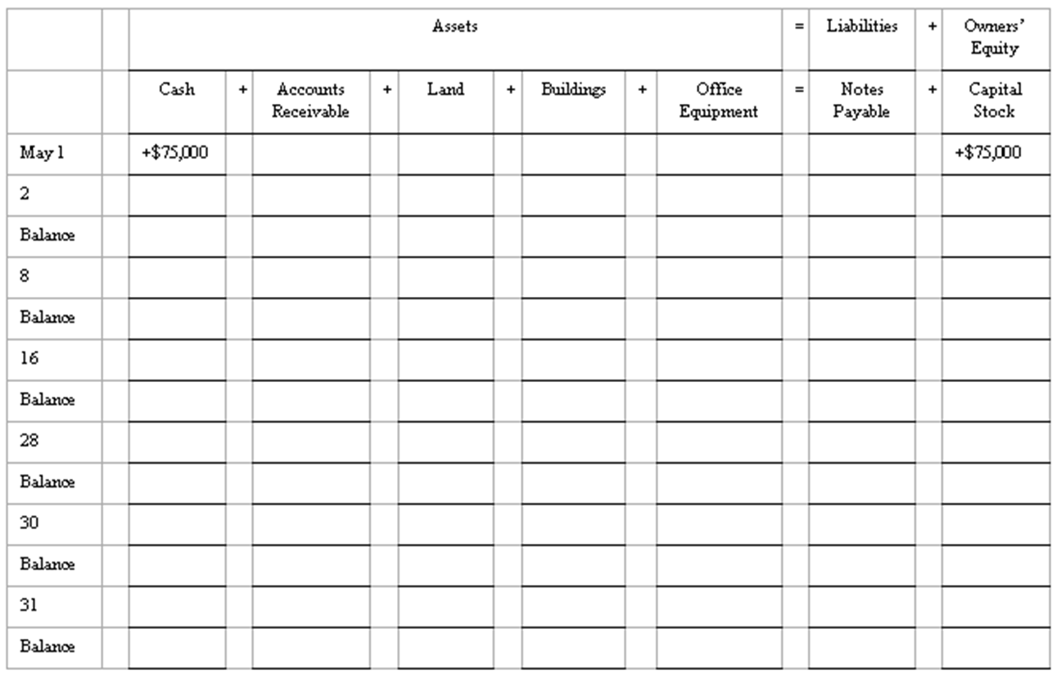

141. | Effects of transactions on balance sheet items  Show the effect of each of the six listed transactions on the balance sheet items of Renaissance Investment Services, Inc. Indicate the new balances after the transaction of November 2 and each subsequent transaction. The effects of the November 1 transaction are already filled in to provide you with an example.  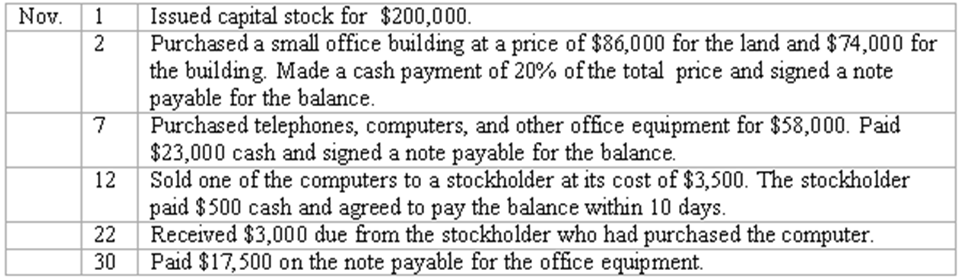  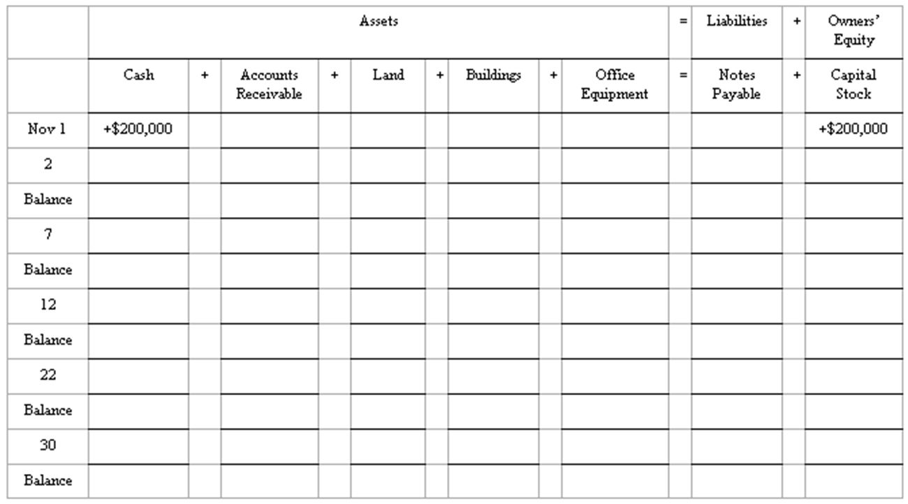

142. | An inexperienced accounting intern at Tasso Company prepared the following income statement for the month of July 2014:  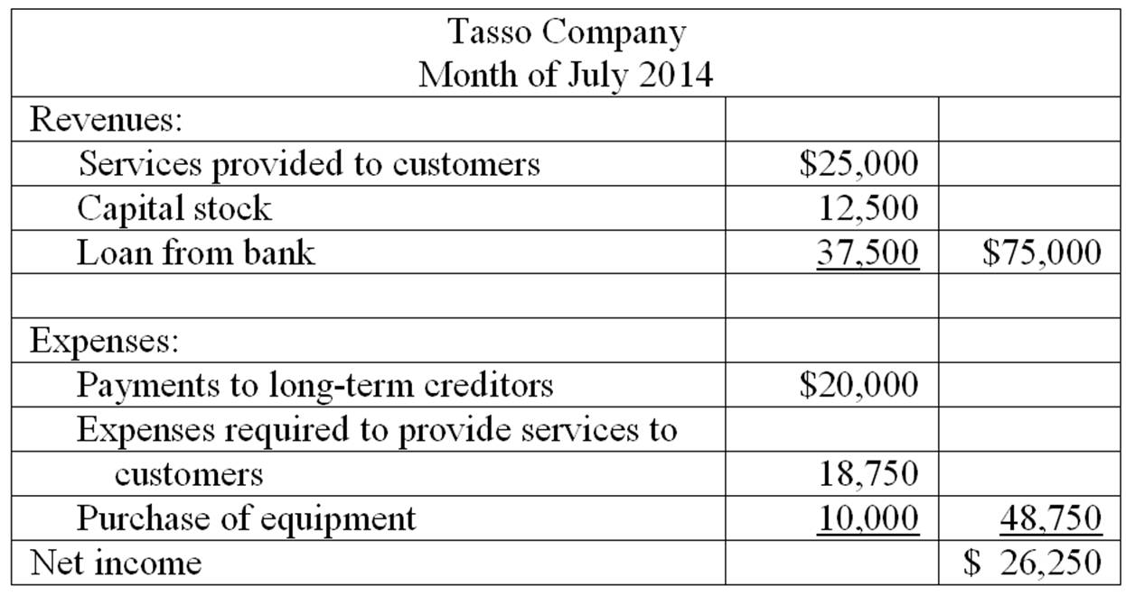  Instructions: Prepare a revised income statement in accordance with generally accepted accounting principles.

143. | From the following accounts and amounts prepare a balance sheet for the Swell Company for December 31, 2014. You must compute the amount for retained earnings to complete the balance sheet.  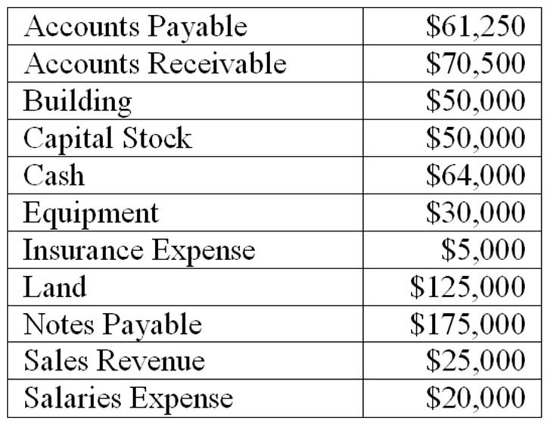

144. | Forms of Business Organization  State and describe the three most common forms of business organizations in the United States.

Chapter 02 Basic Financial Statements Answer Key
True / False Questions
1. | The sale of additional shares of capital stock will cause treasury stock to increase.  FALSE

AACSB: Reflective Thinking
AICPA BB: Resource Management
AICPA FN: Measurement
Accessibility: Keyboard Navigation
Blooms: Understand
Difficulty: 2 Medium
Learning Objective: 02-01 Explain the nature and general purposes of financial statements.
Topic: A Starting Point: Statement of Financial Position

2. | A business entity is regarded as separate from the personal activities of its owners whether it is a sole proprietorship, a partnership, or a corporation.  TRUE

AACSB: Reflective Thinking
AICPA BB: Legal
AICPA FN: Reporting
Accessibility: Keyboard Navigation
Blooms: Understand
Difficulty: 1 Easy
Learning Objective: 02-02 Explain certain accounting principles that are important for an understanding of financial statements and how professional judgment by accountants may affect the application of those principles.
Topic: A Starting Point: Statement of Financial Position

3. | Assets need not always have physical characteristics as do buildings, machinery, or inventory.  TRUE

AACSB: Reflective Thinking
AICPA BB: Critical Thinking
AICPA FN: Measurement
Accessibility: Keyboard Navigation
Blooms: Understand
Difficulty: 1 Easy
Learning Objective: 02-02 Explain certain accounting principles that are important for an understanding of financial statements and how professional judgment by accountants may affect the application of those principles.
Topic: A Starting Point: Statement of Financial Position

4. | The going concern principle assumes that the business will continue indefinitely.  TRUE

AACSB: Reflective Thinking
AICPA BB: Critical Thinking
AICPA FN: Measurement
Accessibility: Keyboard Navigation
Blooms: Understand
Difficulty: 1 Easy
Learning Objective: 02-02 Explain certain accounting principles that are important for an understanding of financial statements and how professional judgment by accountants may affect the application of those principles.
Topic: A Starting Point: Statement of Financial Position

5. | Notes payable and accounts payable both require a company to pay an amount owed by a certain date. Notes payable generally have interest, while accounts payable generally do not.  TRUE

AACSB: Reflective Thinking
AICPA BB: Resource Management
AICPA FN: Measurement
Accessibility: Keyboard Navigation
Blooms: Understand
Difficulty: 1 Easy
Learning Objective: 02-02 Explain certain accounting principles that are important for an understanding of financial statements and how professional judgment by accountants may affect the application of those principles.
Topic: A Starting Point: Statement of Financial Position

6. | Any business event that might affect the future profitability of a business should be reported in its balance sheet.  FALSE

AACSB: Reflective Thinking
AICPA BB: Critical Thinking
AICPA FN: Reporting
Accessibility: Keyboard Navigation
Blooms: Understand
Difficulty: 2 Medium
Learning Objective: 02-02 Explain certain accounting principles that are important for an understanding of financial statements and how professional judgment by accountants may affect the application of those principles.
Topic: A Starting Point: Statement of Financial Position

7. | The practice of showing assets on the balance sheet at their cost, rather than at their current market value is explained, in part, by the fact that cost is supported by objective evidence that can be verified by independent experts.  TRUE

AACSB: Reflective Thinking
AICPA BB: Critical Thinking
AICPA FN: Measurement
Accessibility: Keyboard Navigation
Blooms: Understand
Difficulty: 2 Medium
Learning Objective: 02-02 Explain certain accounting principles that are important for an understanding of financial statements and how professional judgment by accountants may affect the application of those principles.
Topic: A Starting Point: Statement of Financial Position

8. | Liabilities are usually listed in order of magnitude, from smallest dollar amount to largest dollar amount.  FALSE

AACSB: Reflective Thinking
AICPA BB: Critical Thinking
AICPA FN: Measurement
Accessibility: Keyboard Navigation
Blooms: Understand
Difficulty: 2 Medium
Learning Objective: 02-02 Explain certain accounting principles that are important for an understanding of financial statements and how professional judgment by accountants may affect the application of those principles.
Topic: A Starting Point: Statement of Financial Position

9. | The entity principle states that the affairs of the owners are not part of the financial operations of a business entity and should be separated.  TRUE

AACSB: Reflective Thinking
AICPA BB: Critical Thinking
AICPA FN: Measurement
Accessibility: Keyboard Navigation
Blooms: Remember
Difficulty: 2 Medium
Learning Objective: 02-02 Explain certain accounting principles that are important for an understanding of financial statements and how professional judgment by accountants may affect the application of those principles.
Topic: A Starting Point: Statement of Financial Position

10. | The accounting equation may be stated as "assets minus liabilities equals owners' equity."  TRUE

AACSB: Reflective Thinking
AICPA BB: Critical Thinking
AICPA FN: Measurement
Accessibility: Keyboard Navigation
Blooms: Understand
Difficulty: 1 Easy
Learning Objective: 02-03 Demonstrate how certain business transactions affect the elements of the accounting equation: Assets = Liabilities + Owners' Equity.
Topic: A Starting Point: Statement of Financial Position

11. | Total assets plus total liabilities must equal total owners' equity.  FALSE

AACSB: Reflective Thinking
AICPA BB: Critical Thinking
AICPA FN: Measurement
Accessibility: Keyboard Navigation
Blooms: Understand
Difficulty: 1 Easy
Learning Objective: 02-03 Demonstrate how certain business transactions affect the elements of the accounting equation: Assets = Liabilities + Owners' Equity.
Topic: A Starting Point: Statement of Financial Position

12. | A transaction that causes an increase in an asset may also cause a decrease in another asset, an increase in a liability, or an increase in owners' equity.  TRUE

AACSB: Reflective Thinking
AICPA BB: Critical Thinking
AICPA FN: Measurement
Accessibility: Keyboard Navigation
Blooms: Understand
Difficulty: 2 Medium
Learning Objective: 02-03 Demonstrate how certain business transactions affect the elements of the accounting equation: Assets = Liabilities + Owners' Equity.
Topic: A Starting Point: Statement of Financial Position

13. | The collection of an account receivable will cause total assets to decrease.  FALSE

AACSB: Reflective Thinking
AICPA BB: Critical Thinking
AICPA FN: Measurement
Accessibility: Keyboard Navigation
Blooms: Understand
Difficulty: 2 Medium
Learning Objective: 02-03 Demonstrate how certain business transactions affect the elements of the accounting equation: Assets = Liabilities + Owners' Equity.
Topic: A Starting Point: Statement of Financial Position

14. | The payment of a liability causes an increase in owners' equity.  FALSE

AACSB: Reflective Thinking
AICPA BB: Critical Thinking
AICPA FN: Measurement
Accessibility: Keyboard Navigation
Blooms: Understand
Difficulty: 2 Medium
Learning Objective: 02-03 Demonstrate how certain business transactions affect the elements of the accounting equation: Assets = Liabilities + Owners' Equity.
Topic: A Starting Point: Statement of Financial Position

15. | When a business borrows money from a bank, the immediate effect is an increase in total assets and a decrease in liabilities or owners' equity.  FALSE

AACSB: Reflective Thinking
AICPA BB: Critical Thinking
AICPA FN: Measurement
Accessibility: Keyboard Navigation
Blooms: Understand
Difficulty: 2 Medium
Learning Objective: 02-03 Demonstrate how certain business transactions affect the elements of the accounting equation: Assets = Liabilities + Owners' Equity.
Topic: A Starting Point: Statement of Financial Position

16. | The purchase of an asset, such as office equipment, for cash will cause owners' equity to decrease.  FALSE

AACSB: Reflective Thinking
AICPA BB: Critical Thinking
AICPA FN: Measurement
Accessibility: Keyboard Navigation
Blooms: Understand
Difficulty: 2 Medium
Learning Objective: 02-03 Demonstrate how certain business transactions affect the elements of the accounting equation: Assets = Liabilities + Owners' Equity.
Topic: A Starting Point: Statement of Financial Position

17. | Total assets must always equal total liabilities plus total owners' equity.  TRUE

AACSB: Reflective Thinking
AICPA BB: Critical Thinking
AICPA FN: Measurement
Accessibility: Keyboard Navigation
Blooms: Understand
Difficulty: 1 Easy
Learning Objective: 02-03 Demonstrate how certain business transactions affect the elements of the accounting equation: Assets = Liabilities + Owners' Equity.
Topic: A Starting Point: Statement of Financial Position

18. | If a company purchases equipment with cash, its total assets will increase.  FALSE

AACSB: Reflective Thinking
AICPA BB: Critical Thinking
AICPA FN: Measurement
Accessibility: Keyboard Navigation
Blooms: Understand
Difficulty: 1 Easy
Learning Objective: 02-03 Demonstrate how certain business transactions affect the elements of the accounting equation: Assets = Liabilities + Owners' Equity.
Topic: A Starting Point: Statement of Financial Position

19. | If a company purchases equipment by issuing a note payable, its total assets will not change.  FALSE

AACSB: Reflective Thinking
AICPA BB: Critical Thinking
AICPA FN: Measurement
Accessibility: Keyboard Navigation
Blooms: Understand
Difficulty: 2 Medium
Learning Objective: 02-03 Demonstrate how certain business transactions affect the elements of the accounting equation: Assets = Liabilities + Owners' Equity.
Topic: A Starting Point: Statement of Financial Position

20. | A net profit results from having more revenues than liabilities.  FALSE

AACSB: Reflective Thinking
AICPA BB: Critical Thinking
AICPA FN: Measurement
Accessibility: Keyboard Navigation
Blooms: Understand
Difficulty: 1 Easy
Learning Objective: 02-05 Explain how the income statement reports an enterprise's financial performance for a period of time in terms of the relationship of revenues and expenses.
Topic: Income Statement

21. | A statement of cash flows reports revenue and expense activities for a specific time period such as one month or one year.  FALSE

AACSB: Reflective Thinking
AICPA BB: Critical Thinking
AICPA FN: Reporting
Accessibility: Keyboard Navigation
Blooms: Remember
Difficulty: 1 Easy
Learning Objective: 02-06 Explain how the statement of cash flows presents the change in cash for a period of time in terms of the company's operating; investing; and financing activities.
Topic: Statement of Cash Flows

22. | It is not unusual for an entity to report a significant increase in cash from operating activities, but a decrease in the total amount of cash.  TRUE

AACSB: Reflective Thinking
AICPA BB: Critical Thinking
AICPA FN: Measurement
Accessibility: Keyboard Navigation
Blooms: Understand
Difficulty: 2 Medium
Learning Objective: 02-06 Explain how the statement of cash flows presents the change in cash for a period of time in terms of the company's operating; investing; and financing activities.
Topic: Statement of Cash Flows

23. | The statement of cash flows provides a link between two balance sheets by showing how net income (or loss) has changed owners' equity from one balance sheet date to the next.  FALSE

AACSB: Reflective Thinking
AICPA BB: Critical Thinking
AICPA FN: Measurement
Accessibility: Keyboard Navigation
Blooms: Understand
Difficulty: 2 Medium
Learning Objective: 02-06 Explain how the statement of cash flows presents the change in cash for a period of time in terms of the company's operating; investing; and financing activities.
Topic: Statement of Cash Flows

24. | Articulation between the financial statements means that they relate closely to each other on the basis of the same underlying transaction information.  TRUE

AACSB: Reflective Thinking
AICPA BB: Critical Thinking
AICPA FN: Measurement
Accessibility: Keyboard Navigation
Blooms: Remember
Difficulty: 2 Medium
Learning Objective: 02-07 Explain how the statement of financial position (balance sheet); income statement; and statement of cash flows relate to each other.
Topic: Relationships among Financial Statements

25. | Limited liability means that owners of a business are only liable for the debts of the business up to the amounts they can afford.  FALSE

AACSB: Reflective Thinking
AICPA BB: Legal
AICPA FN: Measurement
Accessibility: Keyboard Navigation
Blooms: Remember
Difficulty: 2 Medium
Learning Objective: 02-08 Explain common forms of business ownership-sole proprietorship; partnership; and corporation-and demonstrate how they differ in terms of their statements of financial position.
Topic: Forms of Business Organization

26. | In a business organized as a corporation, it is not necessary to list the equity of each stockholder on the balance sheet.  TRUE

AACSB: Reflective Thinking
AICPA BB: Legal
AICPA FN: Reporting
Accessibility: Keyboard Navigation
Blooms: Understand
Difficulty: 2 Medium
Learning Objective: 02-08 Explain common forms of business ownership-sole proprietorship; partnership; and corporation-and demonstrate how they differ in terms of their statements of financial position.
Topic: Forms of Business Organization

27. | The owner of a sole proprietorship is personally liable for the debts of the business, whereas the stockholders of a corporation are not personally liable for the debts of the business.  TRUE

AACSB: Reflective Thinking
AICPA BB: Legal
AICPA FN: Measurement
Accessibility: Keyboard Navigation
Blooms: Remember
Difficulty: 2 Medium
Learning Objective: 02-08 Explain common forms of business ownership-sole proprietorship; partnership; and corporation-and demonstrate how they differ in terms of their statements of financial position.
Topic: Forms of Business Organization

28. | Window dressing occurs when management attempts to make a company look financially stronger than it actually is.  TRUE

AACSB: Ethics
AICPA BB: Legal
AICPA FN: Reporting
Accessibility: Keyboard Navigation
Blooms: Remember
Difficulty: 1 Easy
Learning Objective: 02-09 Discuss the importance of financial statements to a company and its investors and creditors and why management may take steps to improve the appearance of the company in its financial statements.
Topic: The Use of Financial Statements by External Parties

29. | Decision makers outside the organization base their credit decisions on weekly, or even daily, financial statements.  FALSE

AACSB: Ethics
AICPA BB: Legal
AICPA FN: Reporting
Accessibility: Keyboard Navigation
Blooms: Remember
Difficulty: 1 Easy
Learning Objective: 02-09 Discuss the importance of financial statements to a company and its investors and creditors and why management may take steps to improve the appearance of the company in its financial statements.
Topic: The Use of Financial Statements by External Parties

30. | The major outgrowth from business failures and allegations of fraudulent financial reporting during the 1990's was the passage of the Securities and Exchange Act.  FALSE

AACSB: Ethics
AICPA BB: Legal
AICPA FN: Reporting
Accessibility: Keyboard Navigation
Blooms: Remember
Difficulty: 1 Easy
Learning Objective: 02-09 Discuss the importance of financial statements to a company and its investors and creditors and why management may take steps to improve the appearance of the company in its financial statements.
Topic: The Use of Financial Statements by External Parties

Multiple Choice Questions
31. | Which of the following is the primary objective of an income statement?  A. Providing managers with detailed information about where the enterprise stands at a specific date.  B. Providing users outside the business organization with information about the company's financial position and operating results.  C. Reporting to the Internal Revenue Service the company's taxable income.  D. Indicating to investors in a particular company the current market values of their investments.

AACSB: Reflective Thinking
AICPA BB: Critical Thinking
AICPA FN: Reporting
Accessibility: Keyboard Navigation
Blooms: Remember
Difficulty: 2 Medium
Learning Objective: 02-01 Explain the nature and general purposes of financial statements.
Topic: Introduction to Financial Statements

32. | Which of the following describes the proper form of a balance sheet?  A. The heading sets forth the period of time covered.  B. Cash is always the first asset listed, followed by permanent assets (such as land and buildings), and finally by assets such as receivables and supplies.  C. Liabilities are listed before owners' equity.  D. A subtotal for total assets plus total liabilities is shown.

AACSB: Reflective Thinking
AICPA BB: Critical Thinking
AICPA FN: Reporting
Accessibility: Keyboard Navigation
Blooms: Remember
Difficulty: 2 Medium
Learning Objective: 02-01 Explain the nature and general purposes of financial statements.
Topic: A Starting Point: Statement of Financial Position

33. | A balance sheet is designed to show:  A. How much a business is worth.  B. The profitability of the business during the current year.  C. The assets, liabilities, and owners' equity of a business as of a particular date.  D. The cost of replacing the assets and of paying off the liabilities at December 31.

AACSB: Reflective Thinking
AICPA BB: Critical Thinking
AICPA FN: Reporting
Accessibility: Keyboard Navigation
Blooms: Remember
Difficulty: 2 Medium
Learning Objective: 02-01 Explain the nature and general purposes of financial statements.
Topic: A Starting Point: Statement of Financial Position

34. | Blue Wholesale Shirt Co. sold shirts to Pink Retail Shoppe. The owner of Pink Retail said she would pay Blue at a later date, which Blue Wholesale agreed to. Blue Wholesale Shirt Co. is considered to be a:  A. borrower.  B. liability.  C. creditor.  D. debtor.

AACSB: Reflective Thinking
AICPA BB: Critical Thinking
AICPA FN: Measurement
Accessibility: Keyboard Navigation
Blooms: Understand
Difficulty: 2 Medium
Learning Objective: 02-02 Explain certain accounting principles that are important for an understanding of financial statements and how professional judgment by accountants may affect the application of those principles.
Topic: A Starting Point: Statement of Financial Position

35. | Which of the following best defines an asset?  A. Something with physical form that is valued at cost in the accounting records.  B. An economic resource owned by a business and expected to benefit future operations.  C. An economic resource representing cash or the right to receive cash in the near future.  D. Something owned by a business that has a ready market value.

AACSB: Reflective Thinking
AICPA BB: Critical Thinking
AICPA FN: Measurement
Accessibility: Keyboard Navigation
Blooms: Remember
Difficulty: 2 Medium
Learning Objective: 02-02 Explain certain accounting principles that are important for an understanding of financial statements and how professional judgment by accountants may affect the application of those principles.
Topic: A Starting Point: Statement of Financial Position

36. | From an accounting viewpoint, when is a business considered as an entity separate from its owner(s)?  A. Only when organized as a sole proprietorship.  B. Only when organized as a partnership.  C. Only when organized as a corporation.  D. A business is always considered as an accounting entity separate from the activities of the owner(s).

AACSB: Reflective Thinking
AICPA BB: Legal
AICPA FN: Decision Making
Accessibility: Keyboard Navigation
Blooms: Understand
Difficulty: 1 Easy
Learning Objective: 02-02 Explain certain accounting principles that are important for an understanding of financial statements and how professional judgment by accountants may affect the application of those principles.
Topic: A Starting Point: Statement of Financial Position

37. | The accounting principle that assumes that a company will operate in the foreseeable future is:  A. Going concern.  B. Objectivity.  C. Liquidity.  D. Disclosure.

AACSB: Reflective Thinking
AICPA BB: Critical Thinking
AICPA FN: Measurement
Accessibility: Keyboard Navigation
Blooms: Understand
Difficulty: 1 Easy
Learning Objective: 02-02 Explain certain accounting principles that are important for an understanding of financial statements and how professional judgment by accountants may affect the application of those principles.
Topic: A Starting Point: Statement of Financial Position

38. | The valuation of assets in the balance sheet is based primarily upon:  A. What it would cost to replace the assets.  B. Cost, because cost is usually factual and verifiable.  C. Current fair market value as established by independent appraisers.  D. Cost, because in the event of liquidation, the assets would be sold at an amount equal to their original cost.

AACSB: Reflective Thinking
AICPA BB: Critical Thinking
AICPA FN: Reporting
Accessibility: Keyboard Navigation
Blooms: Understand
Difficulty: 2 Medium
Learning Objective: 02-02 Explain certain accounting principles that are important for an understanding of financial statements and how professional judgment by accountants may affect the application of those principles.
Topic: A Starting Point: Statement of Financial Position

39. | Which of the following is not a generally accepted accounting principle relating to the valuation of assets?  A. The cost principle - in general, assets are valued at cost, rather than at estimated market values.  B. The objectivity principle - accountants prefer to use objective, rather than subjective, information as the basis for accounting information.  C. The safety principle - assets are valued at no more than the value for which they are insured.  D. The going-concern assumption - one reason for valuing assets such as buildings and equipment at cost rather than at their current market values is the assumption that the business will use these assets rather than sell them.

AACSB: Reflective Thinking
AICPA BB: Critical Thinking
AICPA FN: Measurement
Accessibility: Keyboard Navigation
Blooms: Understand
Difficulty: 2 Medium
Learning Objective: 02-02 Explain certain accounting principles that are important for an understanding of financial statements and how professional judgment by accountants may affect the application of those principles.
Topic: A Starting Point: Statement of Financial Position

40. | Each year, the accountant for Southern Real Estate Company adjusts the recorded value of each asset to its market value. Using these market value figures on the balance sheet violates:  A. The accounting equation.  B. The stable-dollar assumption.  C. The business entity concept.  D. The cost principle.

AACSB: Reflective Thinking
AICPA BB: Critical Thinking
AICPA FN: Measurement
Accessibility: Keyboard Navigation
Blooms: Understand
Difficulty: 2 Medium
Learning Objective: 02-02 Explain certain accounting principles that are important for an understanding of financial statements and how professional judgment by accountants may affect the application of those principles.
Topic: A Starting Point: Statement of Financial Position

41. | The owner of Westhampton Fish Eatery purchased a new car for his daughter who is away at college at a cost of $43,000 and reported this amount as Delivery Vehicle in the restaurant's balance sheet. The reporting of this item in this manner violated the:  A. Cost principle.  B. Business entity concept.  C. Objectivity principle.  D. Going-concern assumption.

AACSB: Reflective Thinking
AICPA BB: Critical Thinking
AICPA FN: Reporting
Accessibility: Keyboard Navigation
Blooms: Understand
Difficulty: 2 Medium
Learning Objective: 02-02 Explain certain accounting principles that are important for an understanding of financial statements and how professional judgment by accountants may affect the application of those principles.
Topic: A Starting Point: Statement of Financial Position

42. | Eton Corporation purchased land in 1998 for $190,000. In 2014, it purchased a nearly identical parcel of land for $430,000. In its 2014 balance sheet, Eton valued these two parcels of land at a combined value of $860,000. Reporting the land in this manner violated the:  A. Cost principle.  B. Principle of the business entity.  C. Objectivity principle.  D. Going-concern assumption.

AACSB: Reflective Thinking
AICPA BB: Critical Thinking
AICPA FN: Measurement
Accessibility: Keyboard Navigation
Blooms: Understand
Difficulty: 2 Medium
Learning Objective: 02-02 Explain certain accounting principles that are important for an understanding of financial statements and how professional judgment by accountants may affect the application of those principles.
Topic: A Starting Point: Statement of Financial Position

43. | Bob Bertolucci, owner of Bob's Bazaar, also owns a personal residence that costs $575,000. The market value of his residence is $725,000. During preparation of the financial statements for Bob's Bazaar, the accounting principle most relevant to the presentation of Bob's home is:  A. The concept of the business entity.  B. The cost principle.  C. The going-concern assumption.  D. The objectivity principle.

AACSB: Reflective Thinking
AICPA BB: Critical Thinking
AICPA FN: Reporting
Accessibility: Keyboard Navigation
Blooms: Understand
Difficulty: 2 Medium
Learning Objective: 02-02 Explain certain accounting principles that are important for an understanding of financial statements and how professional judgment by accountants may affect the application of those principles.
Topic: A Starting Point: Statement of Financial Position

44. | Which of the following will not cause a change in the owners' equity of a business?  A. Purchase of land with cash.  B. Withdrawal of cash by the owner.  C. Sale of land at a profit.  D. Losses from unprofitable operations.

AACSB: Reflective Thinking
AICPA BB: Critical Thinking
AICPA FN: Measurement
Accessibility: Keyboard Navigation
Blooms: Understand
Difficulty: 2 Medium
Learning Objective: 02-03 Demonstrate how certain business transactions affect the elements of the accounting equation: Assets = Liabilities + Owners' Equity.
Topic: A Starting Point: Statement of Financial Position

45. | Which of the following is correct when a corporation uses cash to pay for an expense?  A. Total assets will decrease.  B. Retained earnings will increase.  C. Owners' equity will increase.  D. Liabilities will increase.

AACSB: Reflective Thinking
AICPA BB: Critical Thinking
AICPA FN: Measurement
Accessibility: Keyboard Navigation
Blooms: Understand
Difficulty: 2 Medium
Learning Objective: 02-03 Demonstrate how certain business transactions affect the elements of the accounting equation: Assets = Liabilities + Owners' Equity.
Topic: A Starting Point: Statement of Financial Position

46. | Deerpark Corporation recently borrowed $70,000 cash from its bank. Which of the following was unaffected by this transaction?  A. Assets.  B. Liabilities.  C. Owners' equity.  D. Cash.

AACSB: Analytic
AICPA BB: Critical Thinking
AICPA FN: Measurement
Accessibility: Keyboard Navigation
Blooms: Understand
Difficulty: 2 Medium
Learning Objective: 02-03 Demonstrate how certain business transactions affect the elements of the accounting equation: Assets = Liabilities + Owners' Equity.
Topic: A Starting Point: Statement of Financial Position

47. | Which of the following transactions would cause an increase in both assets and owners' equity?  A. Investment of cash in the business by the owner.  B. Sale of land for a price less than its cost.  C. Borrowing money from a bank.  D. Sale of land for cash at a price equal to its cost.

AACSB: Analytic
AICPA BB: Critical Thinking
AICPA FN: Measurement
Accessibility: Keyboard Navigation
Blooms: Understand
Difficulty: 2 Medium
Learning Objective: 02-03 Demonstrate how certain business transactions affect the elements of the accounting equation: Assets = Liabilities + Owners' Equity.
Topic: A Starting Point: Statement of Financial Position

48. | A transaction caused an increase in both assets and owners' equity. This transaction could have been resulted from the:  A. Sale of services to a customer.  B. Sale of land for a price less than its cost.  C. Borrowing money from a bank.  D. Sale of land for cash at a price equal to its cost.

AACSB: Analytic
AICPA BB: Critical Thinking
AICPA FN: Measurement
Accessibility: Keyboard Navigation
Blooms: Understand
Difficulty: 2 Medium
Learning Objective: 02-03 Demonstrate how certain business transactions affect the elements of the accounting equation: Assets = Liabilities + Owners' Equity.
Topic: A Starting Point: Statement of Financial Position

49. | The amount of owners' equity in a business is not affected by:  A. The percentage of total assets held in cash.  B. The investments made in the business by the owner.  C. The profitability of the business.  D. The amount of dividends paid to stockholders.

AACSB: Reflective Thinking
AICPA BB: Critical Thinking
AICPA FN: Measurement
Accessibility: Keyboard Navigation
Blooms: Understand
Difficulty: 2 Medium
Learning Objective: 02-03 Demonstrate how certain business transactions affect the elements of the accounting equation: Assets = Liabilities + Owners' Equity.
Topic: A Starting Point: Statement of Financial Position

50. | Decreases in owners' equity are caused by:  A. Purchases of assets and payment of liabilities.  B. Purchases of assets and incurrence of liabilities.  C. Payment of liabilities and unprofitable operations.  D. Distributions of assets to the owners and unprofitable operations.

AACSB: Reflective Thinking
AICPA BB: Critical Thinking
AICPA FN: Measurement
Accessibility: Keyboard Navigation
Blooms: Understand
Difficulty: 2 Medium
Learning Objective: 02-03 Demonstrate how certain business transactions affect the elements of the accounting equation: Assets = Liabilities + Owners' Equity.
Topic: A Starting Point: Statement of Financial Position

51. | Which of the following transactions would cause a change in owners' equity?  A. Repayment of the principal on a bank loan.  B. Purchase of a delivery truck on credit.  C. Sale of land on credit for a price above cost.  D. Borrowing money from a bank.

AACSB: Reflective Thinking
AICPA BB: Critical Thinking
AICPA FN: Measurement
Accessibility: Keyboard Navigation
Blooms: Understand
Difficulty: 2 Medium
Learning Objective: 02-03 Demonstrate how certain business transactions affect the elements of the accounting equation: Assets = Liabilities + Owners' Equity.
Topic: A Starting Point: Statement of Financial Position

52. | On the statement of financial position, assets are normally presented in and liabilities are usually presented in:  A. Their order of permanence; the order in which they become due.  B. The order in which they become due; their order of permanence.  C. Order of profitability; order of liquidity.  D. Order of liquidity; order of profitability.

AACSB: Analytic
AICPA BB: Critical Thinking
AICPA FN: Measurement
Accessibility: Keyboard Navigation
Blooms: Understand
Difficulty: 2 Medium
Learning Objective: 02-03 Demonstrate how certain business transactions affect the elements of the accounting equation: Assets = Liabilities + Owners' Equity.
Topic: A Starting Point: Statement of Financial Position

53. | Which of the following assets would most likely be listed last on a statement of financial position?  A. Land.  B. Cash.  C. Accounts receivable.  D. Equipment.

AACSB: Analytic
AICPA BB: Critical Thinking
AICPA FN: Measurement
Accessibility: Keyboard Navigation
Blooms: Understand
Difficulty: 2 Medium
Learning Objective: 02-03 Demonstrate how certain business transactions affect the elements of the accounting equation: Assets = Liabilities + Owners' Equity.
Topic: A Starting Point: Statement of Financial Position

54. | Which of the following liabilities would most likely be listed last on a statement of financial position?  A. Bonds payable, due in 20 years.  B. Accounts payable.  C. Note payable, due in 3 years.  D. Income taxes payable.

AACSB: Analytic
AICPA BB: Critical Thinking
AICPA FN: Measurement
Accessibility: Keyboard Navigation
Blooms: Understand
Difficulty: 2 Medium
Learning Objective: 02-03 Demonstrate how certain business transactions affect the elements of the accounting equation: Assets = Liabilities + Owners' Equity.
Topic: A Starting Point: Statement of Financial Position

55. | If a transaction causes an asset account to decrease, which of the following related effects may occur?  A. An increase of equal amount in an owners' equity account.  B. An increase in a liability account.  C. An increase of equal amount in another asset account.  D. An increase in the combined total of liabilities and owners' equity.

AACSB: Analytic
AICPA BB: Critical Thinking
AICPA FN: Measurement
Accessibility: Keyboard Navigation
Blooms: Understand
Difficulty: 2 Medium
Learning Objective: 02-03 Demonstrate how certain business transactions affect the elements of the accounting equation: Assets = Liabilities + Owners' Equity.
Topic: A Starting Point: Statement of Financial Position

56. | A payment of a business debt not including interest:  A. Decreases total assets.  B. Increases total liabilities.  C. Increases the owners' equity in the business.  D. Decreases the owners' equity in the business.

AACSB: Analytic
AICPA BB: Critical Thinking
AICPA FN: Measurement
Accessibility: Keyboard Navigation
Blooms: Understand
Difficulty: 2 Medium
Learning Objective: 02-03 Demonstrate how certain business transactions affect the elements of the accounting equation: Assets = Liabilities + Owners' Equity.
Topic: A Starting Point: Statement of Financial Position

57. | If total assets equal $270,000 and total liabilities equal $202,500, the total owners' equity must equal:  A. $472,500.  B. $67,500.  C. $270,000.  D. Cannot be determined from the information given.  $270,000 - $202,500 = $67,500

AACSB: Analytic
AICPA BB: Critical Thinking
AICPA FN: Measurement
Accessibility: Keyboard Navigation
Blooms: Apply
Difficulty: 2 Medium
Learning Objective: 02-03 Demonstrate how certain business transactions affect the elements of the accounting equation: Assets = Liabilities + Owners' Equity.
Topic: A Starting Point: Statement of Financial Position

58. | If total assets equal $345,000 and total owners' equity equal $120,000, then total liabilities must equal:  A. $465,000.  B. $225,000.  C. $120,000.  D. Cannot be determined from the information given.  $345,000 - $120,000 = $225,000

AACSB: Analytic
AICPA BB: Critical Thinking
AICPA FN: Measurement
Accessibility: Keyboard Navigation
Blooms: Apply
Difficulty: 2 Medium
Learning Objective: 02-03 Demonstrate how certain business transactions affect the elements of the accounting equation: Assets = Liabilities + Owners' Equity.
Topic: A Starting Point: Statement of Financial Position

59. | Owners' equity in a business increases as a result of which of the following?  A. Payments of cash to the owners.  B. Losses from unprofitable operation of the business.  C. Earnings from profitable operation of the business.  D. Borrowing from a commercial bank.

AACSB: Reflective Thinking
AICPA BB: Critical Thinking
AICPA FN: Measurement
Accessibility: Keyboard Navigation
Blooms: Understand
Difficulty: 2 Medium
Learning Objective: 02-04 Explain how the statement of financial position; often referred to as the balance sheet; is an expansion of the basic accounting equation.
Topic: A Starting Point: Statement of Financial Position

60. | Owners' equity in a business decreases as a result of which of the following?  A. Investments of cash by the owners.  B. Profits from operating the business.  C. Losses from unprofitable operation of the business.  D. Repaying a loan to a commercial bank.

AACSB: Reflective Thinking
AICPA BB: Critical Thinking
AICPA FN: Measurement
Accessibility: Keyboard Navigation
Blooms: Understand
Difficulty: 2 Medium
Learning Objective: 02-04 Explain how the statement of financial position; often referred to as the balance sheet; is an expansion of the basic accounting equation.
Topic: A Starting Point: Statement of Financial Position

61. | To appear in a balance sheet of a business entity, an asset need not:  A. Be an economic resource.  B. Have a ready market value.  C. Be expected to benefit future operations.  D. Be owned by the business.

AACSB: Reflective Thinking
AICPA BB: Critical Thinking
AICPA FN: Measurement
AICPA FN: Reporting
Accessibility: Keyboard Navigation
Blooms: Remember
Difficulty: 2 Medium
Learning Objective: 02-04 Explain how the statement of financial position; often referred to as the balance sheet; is an expansion of the basic accounting equation.
Topic: A Starting Point: Statement of Financial Position

62. | A balance sheet:  A. Provides owners, investors, and other interested parties with all the financial information they need to evaluate the financial strength, profitability, and future prospects of a given business entity.  B. Shows the current market value of the owners' equity in the business at the balance sheet date.  C. Assists creditors in evaluating the debt-paying ability of a business by showing the assets and liabilities of the business combined with those of its owner (or owners).  D. Shows the assets, liabilities, and owners' equity of a business entity, valued in conformity with generally accepted accounting principles.

AACSB: Reflective Thinking
AICPA BB: Critical Thinking
AICPA FN: Reporting
Accessibility: Keyboard Navigation
Blooms: Understand
Difficulty: 2 Medium
Learning Objective: 02-04 Explain how the statement of financial position; often referred to as the balance sheet; is an expansion of the basic accounting equation.
Topic: A Starting Point: Statement of Financial Position

63. | Which of the following is correct if a company purchases equipment for $70,000 cash?  A. Total assets will increase by $70,000.  B. Total assets will decrease by $70,000.  C. Total assets will remain the same.  D. The company's total owners' equity will decrease.

AACSB: Analytic
AICPA BB: Critical Thinking
AICPA FN: Measurement
Accessibility: Keyboard Navigation
Blooms: Apply
Difficulty: 2 Medium
Learning Objective: 02-04 Explain how the statement of financial position; often referred to as the balance sheet; is an expansion of the basic accounting equation.
Topic: A Starting Point: Statement of Financial Position

64. | If a company purchases equipment for $65,000 by issuing a note payable:  A. Total assets will increase by $65,000.  B. Total assets will decrease by $65,000.  C. Total assets will remain the same.  D. The company's total owners' equity will decrease.

AACSB: Analytic
AICPA BB: Critical Thinking
AICPA FN: Measurement
Accessibility: Keyboard Navigation
Blooms: Apply
Difficulty: 2 Medium
Learning Objective: 02-04 Explain how the statement of financial position; often referred to as the balance sheet; is an expansion of the basic accounting equation.
Topic: A Starting Point: Statement of Financial Position

65. | If a company has a profit:  A. Assets will be equal to liabilities plus owners' equity.  B. Assets will be less than liabilities plus owners' equity.  C. Assets will be greater than liabilities plus owners' equity.  D. Owners' equity will be greater than its assets.

AACSB: Reflective Thinking
AICPA BB: Critical Thinking
AICPA FN: Measurement
Accessibility: Keyboard Navigation
Blooms: Understand
Difficulty: 2 Medium
Learning Objective: 02-04 Explain how the statement of financial position; often referred to as the balance sheet; is an expansion of the basic accounting equation.
Topic: A Starting Point: Statement of Financial Position

66. | Capital stock represents:  A. The amount invested in the business by stockholders when shares of stock were initially issued by a corporation.  B. The owners' equity for a business organized as a corporation.  C. The owners' equity accumulated through profitable operations that have not been paid out as dividends.  D. The price paid by the current owners to acquire shares of stock in the corporation, regardless of whether they bought the shares directly from the corporation or from another stockholder.

AACSB: Reflective Thinking
AICPA BB: Legal
AICPA FN: Measurement
Accessibility: Keyboard Navigation
Blooms: Remember
Difficulty: 2 Medium
Learning Objective: 02-04 Explain how the statement of financial position; often referred to as the balance sheet; is an expansion of the basic accounting equation.
Topic: A Starting Point: Statement of Financial Position

67. | The balance sheet item that represents the portion of owners' equity resulting from profitable operations of the business is:  A. Accounts receivable.  B. Cash.  C. Capital stock.  D. Retained earnings.

AACSB: Reflective Thinking
AICPA BB: Critical Thinking
AICPA FN: Reporting
Accessibility: Keyboard Navigation
Blooms: Remember
Difficulty: 2 Medium
Learning Objective: 02-04 Explain how the statement of financial position; often referred to as the balance sheet; is an expansion of the basic accounting equation.
Topic: A Starting Point: Statement of Financial Position

68. | Retained earnings appears on:  A. The income statement.  B. The balance sheet.  C. The statement of cash flows.  D. All three of the financial statements.

AACSB: Reflective Thinking
AICPA BB: Critical Thinking
AICPA FN: Reporting
Accessibility: Keyboard Navigation
Blooms: Understand
Difficulty: 1 Easy
Learning Objective: 02-04 Explain how the statement of financial position; often referred to as the balance sheet; is an expansion of the basic accounting equation.
Topic: A Starting Point: Statement of Financial Position

At December 31, 2014, the accounting records of Braun Corporation contain the following items:

69. | Refer to the information above. If Capital Stock is $260,000, what is the December 31, 2014 cash balance?  A. $86,000.  B. $94,000.  C. $46,000.  D. $686,000.  A/P ($16,000) + N/P ($190,000) + Capital Stock ($260,000) + R.E. ($160,000) = $626,000  Cash (?) + A/R ($40,000) + Land ($240,000) + Building ($180,000) + Equipment ($120,000) = $626,000  Cash = $46,000

AACSB: Analytic
AICPA BB: Critical Thinking
AICPA FN: Measurement
AICPA FN: Reporting
Blooms: Apply
Difficulty: 2 Medium
Learning Objective: 02-04 Explain how the statement of financial position; often referred to as the balance sheet; is an expansion of the basic accounting equation.
Topic: A Starting Point: Statement of Financial Position

70. | Refer to the information above. If Capital Stock is $320,000, total assets of Braun Corporation at December 31, 2014, amounts to:  A. $686,000.  B. $926,000.  C. $726,000.  D. $106,000.  A/P ($16,000) + N/P ($190,000) + Capital Stock ($320,000) + R.E. ($160,000) = $686,000  Total Assets = $686,000

AACSB: Analytic
AICPA BB: Critical Thinking
AICPA FN: Measurement
AICPA FN: Reporting
Blooms: Apply
Difficulty: 2 Medium
Learning Objective: 02-04 Explain how the statement of financial position; often referred to as the balance sheet; is an expansion of the basic accounting equation.
Topic: A Starting Point: Statement of Financial Position

71. | Refer to the information above. If Cash at December 31, 2014, is $86,000, Capital Stock is:  A. $260,000.  B. $300,000.  C. $620,000.  D. $168,000.  Cash ($86,000) + A/R ($40,000) + Land ($240,000) + Building ($180,000) + Equipment ($120,000) = $666,000  A/P ($16,000) + N/P ($190,000) + Capital Stock (?) + R.E. ($160,000) = $666,000  Capital Stock = $300,000

AACSB: Analytic
AICPA BB: Critical Thinking
AICPA FN: Measurement
AICPA FN: Reporting
Blooms: Apply
Difficulty: 2 Medium
Learning Objective: 02-04 Explain how the statement of financial position; often referred to as the balance sheet; is an expansion of the basic accounting equation.
Topic: A Starting Point: Statement of Financial Position

72. | Refer to the information above. If Cash at December 31, 2014, is $26,000, total owners' equity is:  A. $160,000.  B. $366,000.  C. $606,000.  D. $400,000.  Cash ($26,000) + A/R ($40,000) + Land ($240,000) + Building ($180,000) + Equipment ($120,000) = $606,000  A/P ($16,000) + N/P ($190,000) + Capital Stock (?) + R.E. ($160,000) = $606,000  Capital Stock = ($240,000) + R. E. ($160,000) = $400,000  Total Owners' Equity = $400,000

AACSB: Analytic
AICPA BB: Critical Thinking
AICPA FN: Measurement
AICPA FN: Reporting
Blooms: Apply
Difficulty: 2 Medium
Learning Objective: 02-04 Explain how the statement of financial position; often referred to as the balance sheet; is an expansion of the basic accounting equation.
Topic: A Starting Point: Statement of Financial Position

73. | Refer to the information above. If Cash at December 31, 2014, is $66,000, total assets amounts to:  A. $606,000.  B. $806,000.  C. $662,000.  D. $646,000.  Cash ($66,000) + A/R ($40,000) + Land ($240,000) + Building ($180,000) + Equipment ($120,000) = $646,000  Total Assets = $646,000

AACSB: Analytic
AICPA BB: Critical Thinking
AICPA FN: Measurement
AICPA FN: Reporting
Blooms: Apply
Difficulty: 2 Medium
Learning Objective: 02-04 Explain how the statement of financial position; often referred to as the balance sheet; is an expansion of the basic accounting equation.
Topic: A Starting Point: Statement of Financial Position

At December 31, 2014, the accounting records of Hercules Manufacturing, Inc. contain the following items:

74. | Refer to the information above. If total assets of Hercules Manufacturing, Inc. are $556,000, Equipment is carried in Hercules Manufacturing accounting records at:  A. $377,000.  B. $179,000.  C. $150,000.  D. $90,000.  Cash ($7,000) + A/R ($30,000) + Land ($90,000) + Building ($250,000) + Equipment (?) = $556,000  Equipment = $179,000

AACSB: Analytic
AICPA BB: Critical Thinking
AICPA FN: Measurement
AICPA FN: Reporting
Blooms: Apply
Difficulty: 2 Medium
Learning Objective: 02-04 Explain how the statement of financial position; often referred to as the balance sheet; is an expansion of the basic accounting equation.
Topic: A Starting Point: Statement of Financial Position

75. | Refer to the information above. If total assets of Hercules Manufacturing, Inc. are $556,000, Retained Earnings at December 31, 2014, must be:  A. $811,000.  B. $180,000.  C. $221,000.  D. $335,000.  A/P ($12,000) + N/P ($135,000) + Capital Stock ($188,000) + R.E.(?) = $556,000  Retained Earnings = $221,000

AACSB: Analytic
AICPA BB: Critical Thinking
AICPA FN: Measurement
AICPA FN: Reporting
Blooms: Apply
Difficulty: 2 Medium
Learning Objective: 02-04 Explain how the statement of financial position; often referred to as the balance sheet; is an expansion of the basic accounting equation.
Topic: A Starting Point: Statement of Financial Position

76. | Refer to the information above. If Retained Earnings at December 31, 2014, is $140,000, total assets amounts to:  A. $98,000.  B. $377,000.  C. $475,000.  D. $188,000.  A/P ($12,000) + N/P ($135,000) + Capital Stock ($188,000) + R.E. ($140,000) = $475,000  Total assets = $475,000

AACSB: Analytic
AICPA BB: Critical Thinking
AICPA FN: Measurement
AICPA FN: Reporting
Blooms: Apply
Difficulty: 2 Medium
Learning Objective: 02-04 Explain how the statement of financial position; often referred to as the balance sheet; is an expansion of the basic accounting equation.
Topic: A Starting Point: Statement of Financial Position

77. | Refer to the information above. If Retained Earnings at December 31, 2014, is $100,000, Equipment is carried in Hercules Manufacturing, Inc. accounting records at:  A. $42,000.  B. $58,000.  C. $43,500.  D. $345,000.  A/P ($12,000) + N/P ($135,000) + Capital Stock ($188,000) + R.E. ($100,000) = $435,000  Cash ($7,000) + A/R ($30,000) + Land ($90,000) + Building ($250,000) + Equipment (?) = $435,000  Equipment = $58,000

AACSB: Analytic
AICPA BB: Critical Thinking
AICPA FN: Measurement
AICPA FN: Reporting
Blooms: Apply
Difficulty: 2 Medium
Learning Objective: 02-04 Explain how the statement of financial position; often referred to as the balance sheet; is an expansion of the basic accounting equation.
Topic: A Starting Point: Statement of Financial Position

78. | Refer to the information above. Assume that the Equipment shown above was acquired by the business five years ago and has a book value of $156,000, but has a current appraised value of $200,000. Hercules Manufacturing's Retained Earnings at December 31, 2014, amounts to:  A. $533,000.  B. $345,000.  C. $198,000.  D. $356,000.  Cash ($7,000) + A/R ($30,000) + Land ($90,000) + Building ($250,000) + Equipment ($156,000) = $533,000  A/P ($12,000) + N/P ($135,000) + Capital Stock ($188,000) + R.E.(?) = $533,000  Retained Earnings = $198,000

AACSB: Analytic
AICPA BB: Critical Thinking
AICPA FN: Measurement
AICPA FN: Reporting
Blooms: Apply
Difficulty: 2 Medium
Learning Objective: 02-04 Explain how the statement of financial position; often referred to as the balance sheet; is an expansion of the basic accounting equation.
Topic: A Starting Point: Statement of Financial Position

At December 31, 2014 the accounting records of Gordon, Inc. contain the following items:

79. | Refer to the information above. If the Notes Payable is $10,000, the December 31, 2014 cash balance is:  A. $60,000.  B. $160,000.  C. $30,000.  D. $20,000.  A/P ($2,500) + N/P ($10,000) + Capital Stock ($12,500) + R.E. ($125,000) = $150,000  Cash (?) + A/R ($18,750) + Land ($30,000) + Building ($31,250) + Equipment ($40,000) = $150,000  Cash = $30,000

AACSB: Analytic
AICPA BB: Critical Thinking
AICPA FN: Measurement
AICPA FN: Reporting
Blooms: Apply
Difficulty: 2 Medium
Learning Objective: 02-04 Explain how the statement of financial position; often referred to as the balance sheet; is an expansion of the basic accounting equation.
Topic: A Starting Point: Statement of Financial Position

80. | Refer to the information above. If the Notes Payable balance is $25,000, then the total assets of Gordon, Inc. at December 31, 2014 amount to:  A. $27,500.  B. $152,500.  C. $120,000.  D. $165,000.  A/P ($2,500) + N/P ($25,000) + Capital Stock ($12,500) + R.E. ($125,000) = $165,000  Total Assets = $165,000

AACSB: Analytic
AICPA BB: Critical Thinking
AICPA FN: Measurement
AICPA FN: Reporting
Blooms: Apply
Difficulty: 2 Medium
Learning Objective: 02-04 Explain how the statement of financial position; often referred to as the balance sheet; is an expansion of the basic accounting equation.
Topic: A Starting Point: Statement of Financial Position

81. | Refer to the information above. If the Cash balance at December 31, 2014 is $67,500, the Notes Payable balance is:  A. $118,750.  B. $47,500.  C. $137,500.  D. $140,000.  Cash ($67,500) + A/R ($18,750) + Land ($30,000) + Building ($31,250) + Equipment ($40,000) = $187,500  A/P ($2,500) + N/P (?) + Capital Stock ($12,500) + R.E. ($125,000) = $187,500  Notes Payable = $47,500

AACSB: Analytic
AICPA BB: Critical Thinking
AICPA FN: Measurement
AICPA FN: Reporting
Blooms: Apply
Difficulty: 2 Medium
Learning Objective: 02-04 Explain how the statement of financial position; often referred to as the balance sheet; is an expansion of the basic accounting equation.
Topic: A Starting Point: Statement of Financial Position

82. | Refer to the information above. If the Cash balance at December 31, 2014 is $62,500 then Total Liabilities amounts to:  A. $42,500.  B. $140,000.  C. $45,000.  D. $182,500.  Cash ($62,500) + A/R ($18,750) + Land ($30,000) + Building ($31,250) + Equipment ($40,000) = $182,500  A/P ($2,500) + N/P (?) + Capital Stock ($12,500) + R.E. ($125,000) = $182,500  $2,500 (Accounts Payable) + $42,500 (Notes Payable) = $45,000  Total Liabilities = $45,000

AACSB: Analytic
AICPA BB: Critical Thinking
AICPA FN: Measurement
AICPA FN: Reporting
Blooms: Apply
Difficulty: 2 Medium
Learning Objective: 02-04 Explain how the statement of financial position; often referred to as the balance sheet; is an expansion of the basic accounting equation.
Topic: A Starting Point: Statement of Financial Position

83. | Which of the following is correct if at the end of Crystal Imports' first year of operations, Assets are $800,000 and Owners' Equity is $720,000?  A. The owner(s) must have invested $800,000 to start the business.  B. The business must be operating profitably.  C. Liabilities are $80,000.  D. Liabilities are $1,520,000.  $800,000(Assets) - $720,000(Owners' Equity) = $80,000 (Liabilities)

AACSB: Analytic
AICPA BB: Critical Thinking
AICPA FN: Measurement
Accessibility: Keyboard Navigation
Blooms: Apply
Difficulty: 2 Medium
Learning Objective: 02-04 Explain how the statement of financial position; often referred to as the balance sheet; is an expansion of the basic accounting equation.
Topic: A Starting Point: Statement of Financial Position

84. | During the current year, the assets of Wheatley's increased by $362,000, and the liabilities increased by $260,000. The owners' equity in the business must have:  A. Decreased by $102,000.  B. Decreased by $622,000.  C. Increased by $102,000.  D. Increased by $622,000.  $362,000 - $260,000 = $102,000

AACSB: Analytic
AICPA BB: Critical Thinking
AICPA FN: Measurement
Accessibility: Keyboard Navigation
Blooms: Apply
Difficulty: 2 Medium
Learning Objective: 02-04 Explain how the statement of financial position; often referred to as the balance sheet; is an expansion of the basic accounting equation.
Topic: A Starting Point: Statement of Financial Position

85. | The total liabilities of Hogan's Company on the balance sheet are $270,000; this amount is equal to three-fourths of the total assets. What is the amount of owners' equity?  A. $202,500.  B. $90,000.  C. $360,000.  D. $630,000.  ¾ Assets = $270,000  Assets = $360,000; Owners' Equity = ($360,000) Assets - ($270,000) Liabilities = $90,000

AACSB: Analytic
AICPA BB: Critical Thinking
AICPA FN: Measurement
AICPA FN: Reporting
Accessibility: Keyboard Navigation
Blooms: Apply
Difficulty: 2 Medium
Learning Objective: 02-04 Explain how the statement of financial position; often referred to as the balance sheet; is an expansion of the basic accounting equation.
Topic: A Starting Point: Statement of Financial Position

86. | Thirty percent of the total assets of Shanahan Corporation have been financed through borrowing. The total liabilities of the company are $600,000. What is the amount of owners' equity?  A. $180,000.  B. $2,000,000.  C. $1,400,000.  D. $2,600,000.  30% Assets = $600,000  Assets = $2,000,000; Owners' Equity = ($2,000,000) Assets - ($600,000) Liabilities = $1,400,000

AACSB: Analytic
AICPA BB: Critical Thinking
AICPA FN: Measurement
AICPA FN: Reporting
Accessibility: Keyboard Navigation
Blooms: Apply
Difficulty: 2 Medium
Learning Objective: 02-04 Explain how the statement of financial position; often referred to as the balance sheet; is an expansion of the basic accounting equation.
Topic: A Starting Point: Statement of Financial Position

87. | A transaction caused a $60,000 increase in both assets and total liabilities. This transaction could have been which of the following?  A. Purchase for office equipment for $60,000 cash.  B. Purchase of office equipment for $120,000, paying $60,000 cash and issuing a note payable for the balance.  C. Repayment of a $60,000 bank loan.  D. Investment of $60,000 cash in the business by the owner.

AACSB: Analytic
AICPA BB: Critical Thinking
AICPA FN: Measurement
Accessibility: Keyboard Navigation
Blooms: Apply
Difficulty: 2 Medium
Learning Objective: 02-04 Explain how the statement of financial position; often referred to as the balance sheet; is an expansion of the basic accounting equation.
Topic: A Starting Point: Statement of Financial Position

88. | If $9,600 cash and a $31,000 note payable are given in exchange for some office machines to be used in a business:  A. Total assets are increased.  B. Total liabilities are decreased.  C. Total assets are decreased.  D. The owners' equity is increased.

AACSB: Analytic
AICPA BB: Critical Thinking
AICPA FN: Measurement
Accessibility: Keyboard Navigation
Blooms: Apply
Difficulty: 2 Medium
Learning Objective: 02-04 Explain how the statement of financial position; often referred to as the balance sheet; is an expansion of the basic accounting equation.
Topic: A Starting Point: Statement of Financial Position

89. | If during the current year, liabilities of Corbett's Store increased by $220,000 and owners' equity increased by $160,000, then:  A. Assets at the end of the year total $380,000.  B. Assets at the end of the year total $60,000.  C. Assets increased during the year by $380,000.  D. Assets decreased during the year by $60,000.  $220,000 + $160,000 = $380,000

AACSB: Analytic
AICPA BB: Critical Thinking
AICPA FN: Measurement
Accessibility: Keyboard Navigation
Blooms: Apply
Difficulty: 2 Medium
Learning Objective: 02-04 Explain how the statement of financial position; often referred to as the balance sheet; is an expansion of the basic accounting equation.
Topic: A Starting Point: Statement of Financial Position

90. | If during the current year, liabilities of Hayden Travel decreased by $50,000 and owners' equity increased by $75,000, then:  A. Assets at the end of the year total $125,000.  B. Assets at the end of the year total $25,000.  C. Assets increased during the year by $25,000.  D. Assets decreased during the year by $125,000.  $75,000 - $50,000 = $25,000

AACSB: Analytic
AICPA BB: Critical Thinking
AICPA FN: Measurement
Accessibility: Keyboard Navigation
Blooms: Apply
Difficulty: 2 Medium
Learning Objective: 02-04 Explain how the statement of financial position; often referred to as the balance sheet; is an expansion of the basic accounting equation.
Topic: A Starting Point: Statement of Financial Position

91. | At the end of the current year, the owners' equity in Barclay Bakery is $246,000. During the year, the assets of the business had increased by $120,000 and the liabilities had increased by $72,000. Owners' equity at the beginning of the year must have been:  A. $198,000.  B. $174,000.  C. $284,000.  D. $438,000.  $120,000 - $72,000 = $48,000  $246,000 - $48,000 = $198,000

AACSB: Analytic
AICPA BB: Critical Thinking
AICPA FN: Measurement
Accessibility: Keyboard Navigation
Blooms: Apply
Difficulty: 3 Hard
Learning Objective: 02-04 Explain how the statement of financial position; often referred to as the balance sheet; is an expansion of the basic accounting equation.
Topic: A Starting Point: Statement of Financial Position

92. | At the end of the current year, the owners' equity in Durante Co. is $360,000. During the year, the assets of the business had increased by $68,000 and the liabilities had increased by $118,000. Owners' equity at the beginning of the year must have been:  A. $410,000.  B. $310,000.  C. $546,000.  D. $174,000.  $68,000 - $118,000 = ($50,000)  $360,000 - ($50,000) = $410,000

AACSB: Analytic
AICPA BB: Critical Thinking
AICPA FN: Measurement
Accessibility: Keyboard Navigation
Blooms: Apply
Difficulty: 3 Hard
Learning Objective: 02-04 Explain how the statement of financial position; often referred to as the balance sheet; is an expansion of the basic accounting equation.
Topic: A Starting Point: Statement of Financial Position

93. | During the current year, the assets of Quality Stairs increased by $175,000 and the liabilities decreased by $15,000. If the owners' equity in the business is $475,000 at the end of the year, the owners' equity at the beginning of the year must have been:  A. $335,000.  B. $285,000.  C. $665,000.  D. $615,000.  $175,000 + $15,000 = $190,000  $475,000 - $190,000 = $285,000

AACSB: Analytic
AICPA BB: Critical Thinking
AICPA FN: Measurement
Accessibility: Keyboard Navigation
Blooms: Apply
Difficulty: 3 Hard
Learning Objective: 02-04 Explain how the statement of financial position; often referred to as the balance sheet; is an expansion of the basic accounting equation.
Topic: A Starting Point: Statement of Financial Position

94. | An expense is best defined as:  A. Any payment of cash for the benefit of the company.  B. Past, present, or future payments of cash required to generate revenues.  C. Past payments of cash required to generate revenues.  D. Future payments of cash required to generate revenues.

AACSB: Reflective Thinking
AICPA BB: Critical Thinking
AICPA FN: Measurement
Accessibility: Keyboard Navigation
Blooms: Remember
Difficulty: 2 Medium
Learning Objective: 02-05 Explain how the income statement reports an enterprise's financial performance for a period of time in terms of the relationship of revenues and expenses.
Topic: Income Statement

95. | A revenue transaction will result in all of the following except:  A. An increase in assets.  B. An increase in owners' equity.  C. A positive cash flow in either the past, present, or future.  D. An increase in liabilities.

AACSB: Reflective Thinking
AICPA BB: Critical Thinking
AICPA FN: Measurement
Accessibility: Keyboard Navigation
Blooms: Understand
Difficulty: 2 Medium
Learning Objective: 02-05 Explain how the income statement reports an enterprise's financial performance for a period of time in terms of the relationship of revenues and expenses.
Topic: Income Statement

Astoria Co. had the following transactions during the month of August 2014:
* Cash received from bank loans was $20,000.
* Dividends of $9,500 were paid to stockholders in cash.
* Revenues earned and received in cash amounted to $33,500.
* Expenses incurred and paid were $26,000.

96. | Refer to the information above. What amount of net income will be reported on an income statement for the month of August?  A. $20,000.  B. $7,500.  C. $0.  D. $33,500.  $33,500 - $26,000 = $7,500

AACSB: Analytic
AICPA BB: Critical Thinking
AICPA FN: Measurement
AICPA FN: Reporting
Accessibility: Keyboard Navigation
Blooms: Analyze
Difficulty: 2 Medium
Learning Objective: 02-05 Explain how the income statement reports an enterprise's financial performance for a period of time in terms of the relationship of revenues and expenses.
Topic: Income Statement

97. | Refer to the information above. At the beginning of August, 2014, owners' equity in Astoria was $160,000. Given the transactions of August, what will be the owners' equity be at the end of the month?  A. $167,500.  B. $150,500.  C. $193,500.  D. $158,000.  $160,000 (Beginning Owners' Equity) + $7,500 (Net income) - $9,500 (Dividends)  Ending Owners' Equity = $158,000

AACSB: Analytic
AICPA BB: Critical Thinking
AICPA FN: Measurement
AICPA FN: Reporting
Accessibility: Keyboard Navigation
Blooms: Analyze
Difficulty: 2 Medium
Learning Objective: 02-04 Explain how the statement of financial position; often referred to as the balance sheet; is an expansion of the basic accounting equation.
Topic: A Starting Point: Statement of Financial Position

98. | Refer to the information above. For the month of August, net cash flows from operating activities for Astoria were:  A. $33,500.  B. $7,500.  C. $20,000.  D. $26,000.  $33,500 - $26,000 = $7,500

AACSB: Analytic
AICPA BB: Critical Thinking
AICPA FN: Measurement
AICPA FN: Reporting
Accessibility: Keyboard Navigation
Blooms: Analyze
Difficulty: 2 Medium
Learning Objective: 02-06 Explain how the statement of cash flows presents the change in cash for a period of time in terms of the company's operating; investing; and financing activities.
Topic: Statement of Cash Flows

Waldorf Co. had the following transactions during the month of October 2014:
* Cash received from bank loans was $60,000.
* Dividends of $18,500 were paid to stockholders in cash.
* Revenues earned and received in cash amounted to $100,500.
* Expenses incurred and paid were $78,000.

99. | Refer to the information above. What amount of net income will be reported on an income statement for the month of October?  A. $18,500.  B. $22,500.  C. $78,000.  D. $100,500.  $100,500 - $78,000 = $22,500

AACSB: Analytic
AICPA BB: Critical Thinking
AICPA FN: Measurement
AICPA FN: Reporting
Accessibility: Keyboard Navigation
Blooms: Analyze
Difficulty: 2 Medium
Learning Objective: 02-05 Explain how the income statement reports an enterprise's financial performance for a period of time in terms of the relationship of revenues and expenses.
Topic: Income Statement

100. | Refer to the information above. At the beginning of October, owners' equity in Waldorf was $480,000. Given the transactions of October, 2014, what will be the owners' equity at the end of the month?  A. $480,000.  B. $484,000.  C. $502,500.  D. $580,500.  $480,000 (Beginning Owners' Equity) + $22,500 (Net income) - $18,500 (Dividends)  Ending Owners' Equity = $484,000

AACSB: Analytic
AICPA BB: Critical Thinking
AICPA FN: Measurement
AICPA FN: Reporting
Accessibility: Keyboard Navigation
Blooms: Analyze
Difficulty: 2 Medium
Learning Objective: 02-04 Explain how the statement of financial position; often referred to as the balance sheet; is an expansion of the basic accounting equation.
Topic: A Starting Point: Statement of Financial Position

101. | Refer to the information above. For the month of October, net cash flows from operating activities for Waldorf were:  A. $18,500.  B. $22,500.  C. $78,000.  D. $100,500.  $100,500 - $78,000 = $22,500

AACSB: Analytic
AICPA BB: Critical Thinking
AICPA FN: Measurement
AICPA FN: Reporting
Accessibility: Keyboard Navigation
Blooms: Analyze
Difficulty: 2 Medium
Learning Objective: 02-06 Explain how the statement of cash flows presents the change in cash for a period of time in terms of the company's operating; investing; and financing activities.
Topic: Statement of Cash Flows

102. | Which of the following activities is not a category into which cash flows are classified?  A. Marketing activities.  B. Operating activities.  C. Financing activities.  D. Investing activities.

AACSB: Reflective Thinking
AICPA BB: Critical Thinking
AICPA FN: Reporting
Accessibility: Keyboard Navigation
Blooms: Remember
Difficulty: 1 Easy
Learning Objective: 02-06 Explain how the statement of cash flows presents the change in cash for a period of time in terms of the company's operating; investing; and financing activities.
Topic: Statement of Cash Flows

103. | A strong statement of cash flows indicates that significant cash is being generated by:  A. Operating activities.  B. Financing activities.  C. Investing activities.  D. Effective tax planning.

AACSB: Analytic
AICPA BB: Critical Thinking
AICPA FN: Measurement
Accessibility: Keyboard Navigation
Blooms: Understand
Difficulty: 2 Medium
Learning Objective: 02-06 Explain how the statement of cash flows presents the change in cash for a period of time in terms of the company's operating; investing; and financing activities.
Topic: Statement of Cash Flows

104. | During the month of May, Henderson Company had the following transactions:  * Revenues of $60,000 were earned and received in cash.  * Bank loans of $9,000 were paid off.  * Equipment of $20,000 was purchased.  * Expenses of $36,800 were paid.  * Stockholders purchased additional shares for $22,000 cash.  A statement of cash flows for May would report net cash flows from operating activities of:  A. $60,000.  B. $16,200.  C. $23,200.  D. $20,000.  $60,000 - $36,800 = $23,200

AACSB: Analytic
AICPA BB: Critical Thinking
AICPA FN: Measurement
AICPA FN: Reporting
Accessibility: Keyboard Navigation
Blooms: Apply
Difficulty: 2 Medium
Learning Objective: 02-06 Explain how the statement of cash flows presents the change in cash for a period of time in terms of the company's operating; investing; and financing activities.
Topic: Statement of Cash Flows

During the month of August, Boyce Company had the following transactions:
* Revenues of $120,000 were earned and received in cash.
* Bank loans of $18,000 were paid off.
* Equipment of $40,000 was purchased with cash.
* Expenses of $73,600 were paid.
* Stockholders purchased additional shares for $44,000 cash.

105. | Refer to the information above. A statement of cash flows for August, would report net cash flows from operating activities of:  A. $26,000.  B. $32,400.  C. $40,000.  D. $46,400.  Cash revenues $120,000 - cash expenses $73,600 = $46,400

AACSB: Analytic
AICPA BB: Critical Thinking
AICPA FN: Measurement
AICPA FN: Reporting
Accessibility: Keyboard Navigation
Blooms: Apply
Difficulty: 2 Medium
Learning Objective: 02-06 Explain how the statement of cash flows presents the change in cash for a period of time in terms of the company's operating; investing; and financing activities.
Topic: Statement of Cash Flows

106. | Refer to the information above. A statement of cash flows for August, would report net cash flows from financing activities of:  A. $26,000.  B. $32,400.  C. $40,000.  D. $46,400.  Issue of stock $44,000 - bank loan paid $18,000 = $26,000

AACSB: Analytic
AICPA BB: Critical Thinking
AICPA FN: Measurement
AICPA FN: Reporting
Accessibility: Keyboard Navigation
Blooms: Apply
Difficulty: 2 Medium
Learning Objective: 02-06 Explain how the statement of cash flows presents the change in cash for a period of time in terms of the company's operating; investing; and financing activities.
Topic: Statement of Cash Flows

107. | Refer to the information above. A statement of cash flows for August, would report net cash flows from investing activities of:  A. ($26,000).  B. $32,400.  C. ($40,000).  D. $46,400.  Equipment purchased = $40,000 used

AACSB: Analytic
AICPA BB: Critical Thinking
AICPA FN: Measurement
AICPA FN: Reporting
Accessibility: Keyboard Navigation
Blooms: Apply
Difficulty: 2 Medium
Learning Objective: 02-06 Explain how the statement of cash flows presents the change in cash for a period of time in terms of the company's operating; investing; and financing activities.
Topic: Statement of Cash Flows

108. | Refer to the information above. A statement of cash flows for August, would report an increase in cash of:  A. $26,000.  B. $32,400.  C. $40,000.  D. $46,400.  $46,400 + $26,000 - $40,000 = $32,400

AACSB: Analytic
AICPA BB: Critical Thinking
AICPA FN: Measurement
AICPA FN: Reporting
Accessibility: Keyboard Navigation
Blooms: Apply
Difficulty: 2 Medium
Learning Objective: 02-06 Explain how the statement of cash flows presents the change in cash for a period of time in terms of the company's operating; investing; and financing activities.
Topic: Statement of Cash Flows

During the month of February, Fadness Company had the following transactions:
* Revenues of $225,000 were earned and received in cash.
* Bank loans of $18,000 were paid off.
* New bank loans of $15,000 were incurred.
* Equipment of $40,000 was purchased with cash.
* Equipment was sold for its book value of $36,000. Cash was received.
* Expenses of $171,400 were paid.
* Stockholders purchased additional shares for $50,000 cash.

109. | Refer to the information above. A statement of cash flows for February, would report net cash flows from operating activities of:  A. $4,000.  B. $35,600.  C. $53,600.  D. $96,600.  Cash revenues $225,000 - cash expenses $171,400 = $53,600

AACSB: Analytic
AICPA BB: Critical Thinking
AICPA FN: Measurement
AICPA FN: Reporting
Accessibility: Keyboard Navigation
Blooms: Apply
Difficulty: 2 Medium
Learning Objective: 02-06 Explain how the statement of cash flows presents the change in cash for a period of time in terms of the company's operating; investing; and financing activities.
Topic: Statement of Cash Flows

110. | Refer to the information above. A statement of cash flows for February, would report net cash flows from financing activities of:  A. $4,000.  B. $47,000.  C. $83,000.  D. $96,600.  Issue of stock $50,000 + bank loan issued $15,000 - bank loan paid 18,000 = $47,000

AACSB: Analytic
AICPA BB: Critical Thinking
AICPA FN: Measurement
AICPA FN: Reporting
Accessibility: Keyboard Navigation
Blooms: Apply
Difficulty: 2 Medium
Learning Objective: 02-06 Explain how the statement of cash flows presents the change in cash for a period of time in terms of the company's operating; investing; and financing activities.
Topic: Statement of Cash Flows

111. | Refer to the information above. A statement of cash flows for February, would report net cash flows from investing activities of:  A. ($4,000).  B. $47,000.  C. $53,600.  D. $76,000.  Equipment purchased $40,000 - equipment sold $36,000 = $4,000 used

AACSB: Analytic
AICPA BB: Critical Thinking
AICPA FN: Measurement
AICPA FN: Reporting
Accessibility: Keyboard Navigation
Blooms: Apply
Difficulty: 2 Medium
Learning Objective: 02-06 Explain how the statement of cash flows presents the change in cash for a period of time in terms of the company's operating; investing; and financing activities.
Topic: Statement of Cash Flows

112. | Refer to the information above. A statement of cash flows for February, would report an increase in cash of:  A. $4,000.  B. $47,000.  C. $53,600.  D. $96,600.  $53,600 + $47,000 - $4,000 = $96,600

AACSB: Analytic
AICPA BB: Critical Thinking
AICPA FN: Measurement
AICPA FN: Reporting
Accessibility: Keyboard Navigation
Blooms: Apply
Difficulty: 2 Medium
Learning Objective: 02-06 Explain how the statement of cash flows presents the change in cash for a period of time in terms of the company's operating; investing; and financing activities.
Topic: Statement of Cash Flows

113. | If cash flows from operating activities is a positive amount, then:  A. The amount will be shown on the statement of cash flows in parentheses.  B. The company must have had a net profit for the year.  C. The company must have paid off more debts than it earned during the year.  D. The company may still have a decrease in the total amount of cash for the period.

AACSB: Reflective Thinking
AICPA BB: Critical Thinking
AICPA FN: Measurement
Accessibility: Keyboard Navigation
Blooms: Understand
Difficulty: 2 Medium
Learning Objective: 02-06 Explain how the statement of cash flows presents the change in cash for a period of time in terms of the company's operating; investing; and financing activities.
Topic: Statement of Cash Flows

114. | The change in owners' equity due to only revenue and expense transactions is explained by the:  A. Statement of cash flows.  B. Statement of financial position.  C. Income statement.  D. Tax return.

AACSB: Reflective Thinking
AICPA BB: Critical Thinking
AICPA FN: Measurement
Accessibility: Keyboard Navigation
Blooms: Remember
Difficulty: 2 Medium
Learning Objective: 02-07 Explain how the statement of financial position (balance sheet); income statement; and statement of cash flows relate to each other.
Topic: Relationships among Financial Statements

115. | Which one of the following is not considered as one of the three primary financial statements?  A. Balance sheet.  B. Income statement.  C. Statement of cash flows.  D. Statement of budgeting activities.

AACSB: Reflective Thinking
AICPA BB: Critical Thinking
AICPA FN: Reporting
Accessibility: Keyboard Navigation
Blooms: Remember
Difficulty: 1 Easy
Learning Objective: 02-07 Explain how the statement of financial position (balance sheet); income statement; and statement of cash flows relate to each other.
Topic: Relationships among Financial Statements

116. | The way in which financial statements relate is known as:  A. Solvency.  B. Objectivity.  C. Articulation.  D. Entity.

AACSB: Reflective Thinking
AICPA BB: Critical Thinking
AICPA FN: Measurement
Accessibility: Keyboard Navigation
Blooms: Remember
Difficulty: 1 Easy
Learning Objective: 02-07 Explain how the statement of financial position (balance sheet); income statement; and statement of cash flows relate to each other.
Topic: Relationships among Financial Statements

117. | Which business organization is recognized as a separate legal entity under the law?  A. Corporation.  B. Sole proprietorship.  C. Partnership.  D. All business organizations are separate legal entities.

AACSB: Reflective Thinking
AICPA BB: Critical Thinking
AICPA FN: Reporting
Accessibility: Keyboard Navigation
Blooms: Remember
Difficulty: 1 Easy
Learning Objective: 02-08 Explain common forms of business ownership-sole proprietorship; partnership; and corporation-and demonstrate how they differ in terms of their statements of financial position.
Topic: Forms of Business Organization

118. | Retained earnings is:  A. The positive cash flows of a company.  B. The net worth of a company.  C. The owners' equity that has accumulated as a result of profitable operations.  D. Equal to the total assets of a company.

AACSB: Reflective Thinking
AICPA BB: Critical Thinking
AICPA FN: Measurement
Accessibility: Keyboard Navigation
Blooms: Remember
Difficulty: 2 Medium
Learning Objective: 02-08 Explain common forms of business ownership-sole proprietorship; partnership; and corporation-and demonstrate how they differ in terms of their statements of financial position.
Topic: The Use of Financial Statements by External Parties

119. | Which of the following best describes liquidity?  A. The ability to increase the value of retained earnings.  B. The ability to pay the debts of the company as they become due.  C. Being able to buy everything the company requires for cash.  D. Purchasing everything the company requires on credit.

AACSB: Reflective Thinking
AICPA BB: Critical Thinking
AICPA FN: Measurement
Accessibility: Keyboard Navigation
Blooms: Remember
Difficulty: 2 Medium
Learning Objective: 02-08 Explain common forms of business ownership-sole proprietorship; partnership; and corporation-and demonstrate how they differ in terms of their statements of financial position.
Topic: The Use of Financial Statements by External Parties

120. | Profitability may be defined as:  A. The ability to pay the debts of the company as they become due.  B. The ability to increase retained earnings.  C. Distributing dividends out of retained earnings.  D. Having excess cash.

AACSB: Reflective Thinking
AICPA BB: Critical Thinking
AICPA FN: Measurement
Accessibility: Keyboard Navigation
Blooms: Remember
Difficulty: 2 Medium
Learning Objective: 02-08 Explain common forms of business ownership-sole proprietorship; partnership; and corporation-and demonstrate how they differ in terms of their statements of financial position.
Topic: The Use of Financial Statements by External Parties

121. | The principle of adequate disclosure means that a company should disclose:  A. Only the important monetary information.  B. All confidential information regarding the company.  C. Any financial facts that a reasonably informed person would consider necessary for the proper interpretation of the financial statements.  D. Only subsequent events.

AACSB: Reflective Thinking
AICPA BB: Critical Thinking
AICPA FN: Reporting
Accessibility: Keyboard Navigation
Blooms: Remember
Difficulty: 2 Medium
Learning Objective: 02-08 Explain common forms of business ownership-sole proprietorship; partnership; and corporation-and demonstrate how they differ in terms of their statements of financial position.
Topic: The Use of Financial Statements by External Parties

122. | Which of the following statements regarding liquidity and profitability is not true?  A. If a business is unable to pay its debts as they come due, it is operating unprofitably.  B. A business may be liquid, yet operate unprofitably for several years.  C. A business may operate profitably, yet be unable to meet its obligations.  D. In order to survive in the long-run, a business must both remain liquid and operate profitably.

AACSB: Reflective Thinking
AICPA BB: Critical Thinking
AICPA FN: Reporting
Accessibility: Keyboard Navigation
Blooms: Understand
Difficulty: 2 Medium
Learning Objective: 02-09 Discuss the importance of financial statements to a company and its investors and creditors and why management may take steps to improve the appearance of the company in its financial statements.
Topic: The Use of Financial Statements by External Parties

123. | The concept of adequate disclosure means that:  A. The accounting department of a business must inform management of the accounting principles used in preparing the financial statements.  B. The company must inform users of any significant facts necessary for proper interpretation of the financial statements, including events occurring after the financial statement date.  C. The independent auditors must disclose in the financial statements any and all errors detected in the company's accounting records.  D. The financial statements should include a comprehensive list of each transaction that occurred during the year.

AACSB: Reflective Thinking
AICPA BB: Critical Thinking
AICPA FN: Reporting
Accessibility: Keyboard Navigation
Blooms: Remember
Difficulty: 2 Medium
Learning Objective: 02-09 Discuss the importance of financial statements to a company and its investors and creditors and why management may take steps to improve the appearance of the company in its financial statements.
Topic: The Use of Financial Statements by External Parties

124. | According to the Sarbanes-Oxley Act, CEOs and CFOs must certify to the accuracy of their company's financial statements:  A. Monthly and Quarterly.  B. Quarterly and Annually.  C. Monthly and Annually.  D. CEOs and CFOs are not required to certify to the company's financial statement; only CPA's do.

AACSB: Ethics
AICPA BB: Legal
AICPA FN: Reporting
Accessibility: Keyboard Navigation
Blooms: Remember
Difficulty: 2 Medium
Learning Objective: 02-09 Discuss the importance of financial statements to a company and its investors and creditors and why management may take steps to improve the appearance of the company in its financial statements.
Topic: The Use of Financial Statements by External Parties

125. | A strong statement of financial position shows:  A. Large amounts of liquid assets relative to the liabilities due in the near future.  B. Large amounts of debt relative to stockholders' equity.  C. That cash is being generated by operations.  D. That profits are being generated by operations.

AACSB: Ethics
AICPA BB: Legal
AICPA FN: Reporting
Accessibility: Keyboard Navigation
Blooms: Remember
Difficulty: 2 Medium
Learning Objective: 02-09 Discuss the importance of financial statements to a company and its investors and creditors and why management may take steps to improve the appearance of the company in its financial statements.
Topic: The Use of Financial Statements by External Parties

Essay Questions
126. | Financial statements  A set of financial statements includes three related accounting reports, or statements. In the space provided, list the names of three primary statements, and give a brief description of the accounting information contained in each.  * Balance sheet. A report showing at a specific date the financial position of the company by reporting the assets (resources) that it owns, the liabilities (debts) that it owes, and the amount of the owners' equity in the business.  * Income statement. A report indicating the profitability (or net income) of the business over a specific time period.  * Statement of cash flows. A report summarizing the cash receipts and cash payments of the business over the same time period covered by the income statement. The cash flows from three activities are presented on the statement. In order of presentation, they include: (1) operating activities; (2) investing activities; and (3) financing activities.

AACSB: Reflective Thinking
AICPA BB: Critical Thinking
AICPA FN: Reporting
Blooms: Understand
Difficulty: 2 Medium
Learning Objective: 02-01 Explain the nature and general purposes of financial statements.
Topic: Introduction to Financial Statements

127. | Development of generally accepted accounting principles  (A.) What is meant by the phrase "generally accepted accounting principles"?  (B.) Explain the concept of the business entity and how it relates to generally accepted accounting principles.  (A.) Generally accepted accounting principles are the concepts, standards, or rules used in the preparation of financial statements.  (B.) Generally accepted accounting principles require that financial statements describe the activities of a specific economic entity, which is an economic unit that engages in identifiable business activities.

AACSB: Ethics
AICPA BB: Critical Thinking
AICPA FN: Reporting
Blooms: Remember
Difficulty: 2 Medium
Learning Objective: 02-02 Explain certain accounting principles that are important for an understanding of financial statements and how professional judgment by accountants may affect the application of those principles.
Topic: A Starting Point: Statement of Financial Position

128. | Valuation of assets under generally accepted accounting principles  Under generally accepted accounting principles, the assets owned by a business are reported in the balance sheet at their historical cost. Identify and briefly explain two accounting principles other than the cost principle that support the valuation of assets at cost in the balance sheet.  Student may choose any two of the following:  * Going-concern assumption. An assumption by accountants that a business will operate indefinitely unless specific evidence to the contrary exists, such as impending bankruptcy. Since assets of the business were acquired for use and not for resale, estimated current market prices or appraisal values are of less importance than if these items were intended for sale.  * Objectivity principle. Accounting measurements should be based upon dollar amounts that are factual and subject to independent verification. Historical cost of assets is objective; estimated market values or appraisals change over time and are not factual or objective.  * Stable-dollar assumption. An assumption by accountants that the dollar is a stable unit of measure. This assumption permits reporting assets at cost, even though individual assets may have been acquired in different years.

AACSB: Reflective Thinking
AICPA BB: Critical Thinking
AICPA FN: Measurement
Blooms: Understand
Difficulty: 2 Medium
Learning Objective: 02-02 Explain certain accounting principles that are important for an understanding of financial statements and how professional judgment by accountants may affect the application of those principles.
Topic: A Starting Point: Statement of Financial Position

129. | Accounting terminology  Listed below are nine technical accounting terms introduced in this chapter:  Each of the following statements may (or may not) describe one of these technical terms. In the space provided below each statement, indicate the accounting term described, or answer "None" if the statement does not correctly describe any of the terms. Do not use a term more than once.  (A.) Having the financial ability to pay debts as they become due.  (B.) An assumption that a business will operate in the foreseeable future.  (C.) Economic resources owned by businesses that are expected to benefit future operations.  (D.) The debts or obligations of a business organization.  (E.) Assets = Liabilities + Owners' Equity  (F.) The principle which states that assets are valued in the balance sheet at their historical cost.  (G.) A residual amount equal to assets minus liabilities.  (A.) Liquidity; (B.) Going concern assumption; (C.) Assets; (D.) Liabilities; (E.) Accounting equation; (F.) Cost principle; (G.) Owners' equity

AACSB: Reflective Thinking
AICPA BB: Critical Thinking
AICPA FN: Measurement
Blooms: Remember
Difficulty: 1 Easy
Learning Objective: 02-02 Explain certain accounting principles that are important for an understanding of financial statements and how professional judgment by accountants may affect the application of those principles.
Topic: A Starting Point: Statement of Financial Position

130. | Accounting equation  (A.) During the current year, the assets of Duffy Stationery increased by $650,000 and the liabilities decreased by $340,000. What was the change in owners' equity during the year?  (B.) The owners' equity of Graham Interiors appears on the balance sheet as $720,000 and is equal to one-fourth of total assets. Compute the amount of total liabilities.  (C.) At the end of the year, the owners' equity in Scott Mfg. amounted to $845,000. During 2014, the assets of the business increased by $515,000 and the liabilities increased by $205,000. The owners' equity at the beginning of 2014 was how much?  (A.) $990,000 increase  (B.) $2,160,000  (C.) $535,000  Feedback: (A.) Change in owners' equity = $650,000 + $340,000 = $990,000 increase  (B.) Total assets = 4($720,000) = $2,880,000  Total liabilities = $2,880,000 assets - $720,000 owners' equity = $2,160,000  (C.) Change in owners' equity = $515,000 - $205,000 = $310,000 increase  Beginning owners' equity = $845,000 ending balance - $310,000 increase = $535,000

AACSB: Analytic
AICPA BB: Critical Thinking
AICPA FN: Measurement
Blooms: Analyze
Difficulty: 2 Medium
Learning Objective: 02-03 Demonstrate how certain business transactions affect the elements of the accounting equation: Assets = Liabilities + Owners' Equity.
Topic: A Starting Point: Statement of Financial Position

131. | Effects of transactions on elements of the accounting equation  Some of the transactions carried out by Tudor Wholesale during the first month of the company's operations are listed below. You are to determine the effect of each transaction on the total assets, the total liabilities, and the owners' equity. Prepare your answer in columnar form, identifying each transaction by letter and using the symbols (+) for increase, (-) for decrease, and (NC) for no change. An answer is provided for the first transaction to serve as an example.  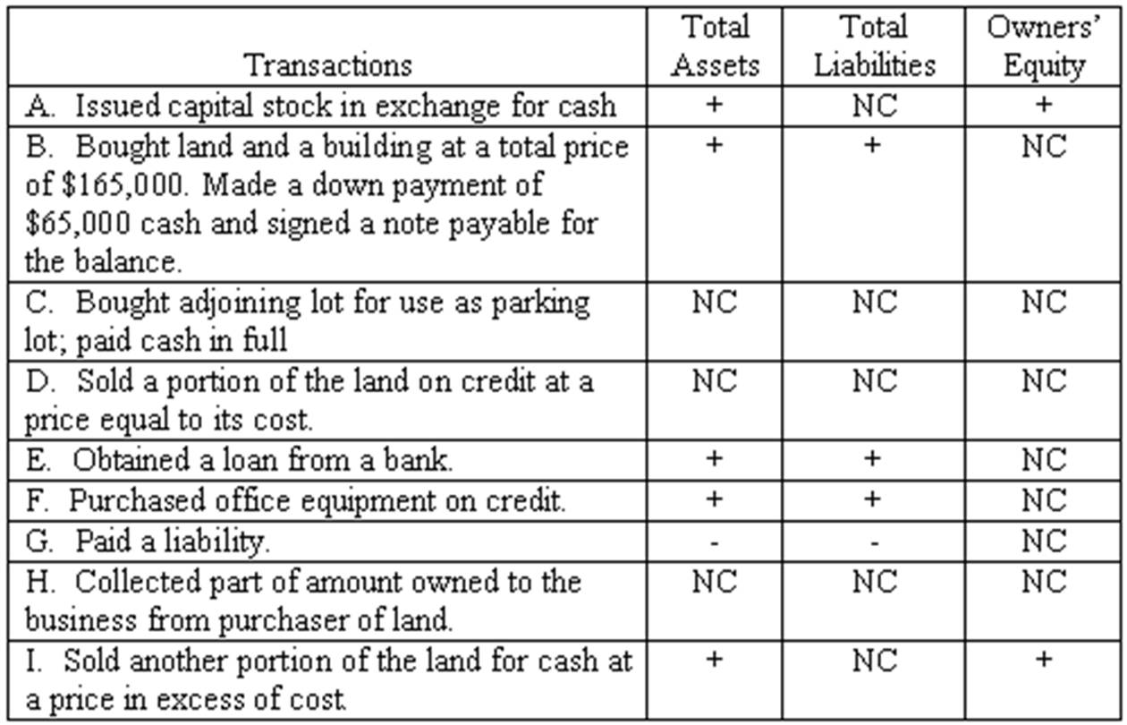

AACSB: Analytic
AICPA BB: Critical Thinking
AICPA FN: Measurement
Blooms: Understand
Difficulty: 2 Medium
Learning Objective: 02-03 Demonstrate how certain business transactions affect the elements of the accounting equation: Assets = Liabilities + Owners' Equity.
Topic: A Starting Point: Statement of Financial Position

132. | Effects of transactions on elements of the accounting equation  Some of the transactions carried out by Tsang Company during the first month of the company's operations are listed below. You are to determine the dollar effect of each transaction on the total assets, the total liabilities, and the owners' equity of Tsang Company. Use the symbols (+) for increase, (-) for decrease, and (NC) for no change. An answer is provided for the first transaction to serve as an example.  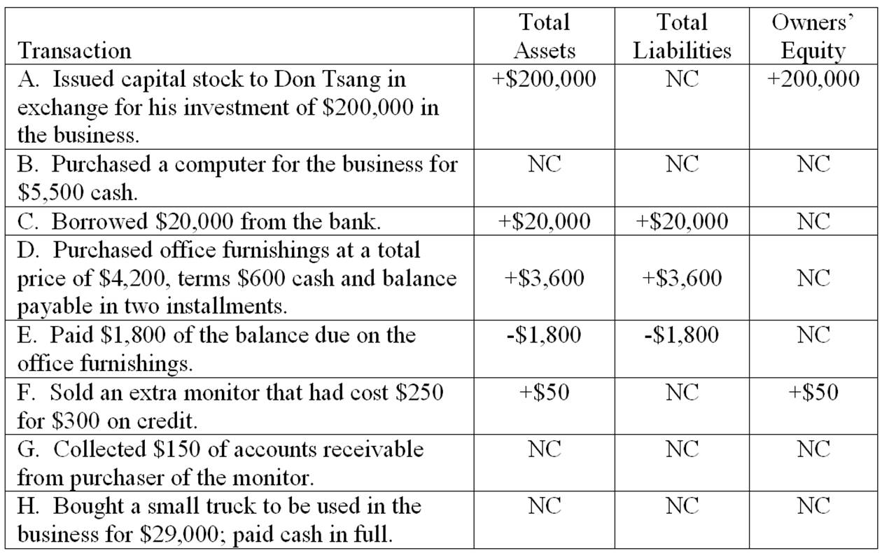

AACSB: Analytic
AICPA BB: Critical Thinking
AICPA FN: Measurement
Blooms: Understand
Difficulty: 2 Medium
Learning Objective: 02-03 Demonstrate how certain business transactions affect the elements of the accounting equation: Assets = Liabilities + Owners' Equity.
Topic: A Starting Point: Statement of Financial Position

133. | List the following accounts in the order that they would appear in a balance sheet.  Capital Stock  Equipment  Accounts Receivable  Retained Earnings  Revenue  Accounts Payable  Cash  Rent Expense  Cash, Accounts Receivable, Equipment, Accounts Payable, Capital Stock, Retained Earnings (Revenue and Rent Expense do not appear in a balance sheet).

AACSB: Analytic
AICPA BB: Critical Thinking
AICPA FN: Reporting
Blooms: Remember
Difficulty: 1 Easy
Learning Objective: 02-04 Explain how the statement of financial position; often referred to as the balance sheet; is an expansion of the basic accounting equation.
Topic: A Starting Point: Statement of Financial Position

134. | Computation of assets, liabilities, and owners' equity after a series of transactions  On April 30, 2014, the balance sheet of China Collectibles showed total assets of $700,000, total liabilities of $400,000, and owners' equity of $300,000. The following transactions occurred in May of 2014:  (1) Capital stock was issued in exchange for $165,000 cash.  (2) The business purchased equipment for $360,000, paying $160,000 cash and issuing a note payable for $200,000.  (3) The business paid $70,000 of its accounts payable.  (4) The business collected $54,000 of its accounts receivable.  Compute the following as of May 31, 2014:  (A.) Total assets $____________  (B.) Total liabilities $____________  (C.) Owners' equity $____________  (A.) Total assets = $995,000  (B.) Total liabilities = $530,000  (C.) Owners' equity = $465,000  Feedback: (A.) Total assets: $700,000 + $165,000 + $360,000 - $160,000 - $70,000 + $54,000 - $54,000 = $995,000  (B.) Total liabilities: $400,000 + $200,000 - $70,000 = $530,000  (C.) Owners' equity: $300,000 + $165,000 = $465,000 (or, $995,000 - $530,000 = $465,000)

AACSB: Analytic
AICPA BB: Critical Thinking
AICPA FN: Measurement
AICPA FN: Reporting
Blooms: Apply
Difficulty: 2 Medium
Learning Objective: 02-04 Explain how the statement of financial position; often referred to as the balance sheet; is an expansion of the basic accounting equation.
Topic: A Starting Point: Statement of Financial Position

135. | Computation of assets, liabilities, and owners' equity after a series of transactions  The December 31, 2014 balance sheet of Charles Realty reported total assets of $900,000, total liabilities of $350,000, and owners' equity of $550,000. The following transactions occurred in January of 2014:  (1) The business purchased land for $250,000, paying $100,000 cash and issuing a note payable for the balance.  (2) The business collected accounts receivable totaling $45,000.  (3) The business sold land costing $50,000 for $60,000 cash.  (4) The business paid $50,000 of the note payable.  Compute the following at January 31, 2014:  (A.) Total assets $___________  (B.) Total liabilities $___________  (C.) Owners' equity $___________  (A.) Total assets = $1,010,000  (B.) Total liabilities = $450,000  (C.) Owners' equity = $560,000  Feedback: (A.) Total assets: $900,000 + $250,000 - $100,000 + $45,000 - $45,000 - $50,000 + $60,000 - $50,000 = $1,010,000  (B.) Total liabilities: $350,000 + $150,000 - $50,000 = $450,000  (C.) Owners' equity: $550,000 + $10,000 = $560,000 (or, $1,010,000 - $450,000 = $560,000)

AACSB: Analytic
AICPA BB: Critical Thinking
AICPA FN: Measurement
AICPA FN: Reporting
Blooms: Apply
Difficulty: 2 Medium
Learning Objective: 02-04 Explain how the statement of financial position; often referred to as the balance sheet; is an expansion of the basic accounting equation.
Topic: A Starting Point: Statement of Financial Position

136. | Preparation of balance sheet  Prepare the balance sheet as of December 31, 2014, for Gamma Company, from the following list of items which are arranged in random order. You must compute the amount for accounts payable to complete the balance sheet.  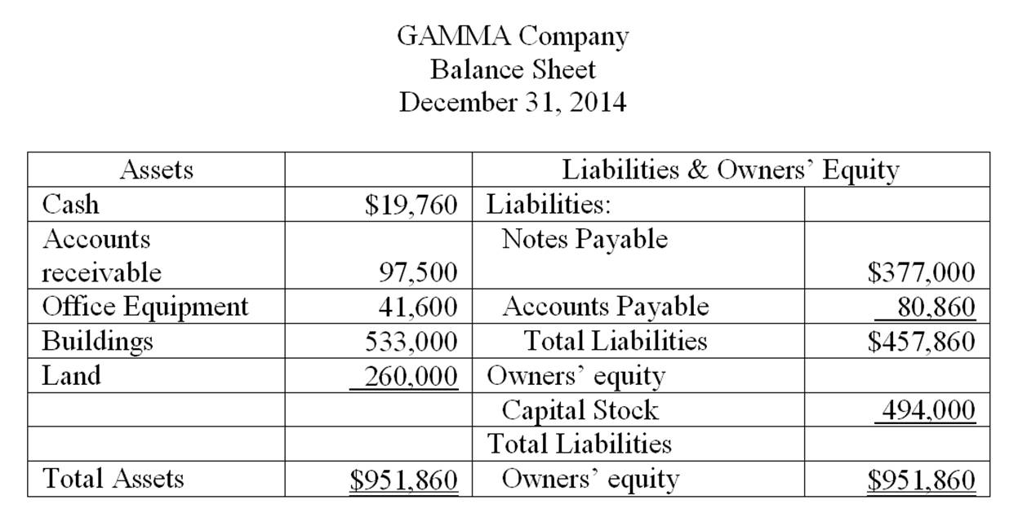

AACSB: Analytic
AICPA BB: Critical Thinking
AICPA FN: Measurement
AICPA FN: Reporting
Blooms: Apply
Difficulty: 2 Medium
Learning Objective: 02-04 Explain how the statement of financial position; often referred to as the balance sheet; is an expansion of the basic accounting equation.
Topic: A Starting Point: Statement of Financial Position

137. | Preparation of balance sheet after a series of transactions  The balance sheet was as follows for Custom Ceramics on February 1, 2014:  During the first week of February, the following transactions occurred:  * The business used cash to pay off $5,000 of its accounts payable. (No payment was made on the notes payable.)  * Additional capital stock was issued to Joan Custom for $15,000 cash.  * Equipment was purchased on credit for $1,800.  * The business collected $4,000 cash from accounts receivable.  Complete the balance sheet for Custom Ceramics as of February 8, 2014.  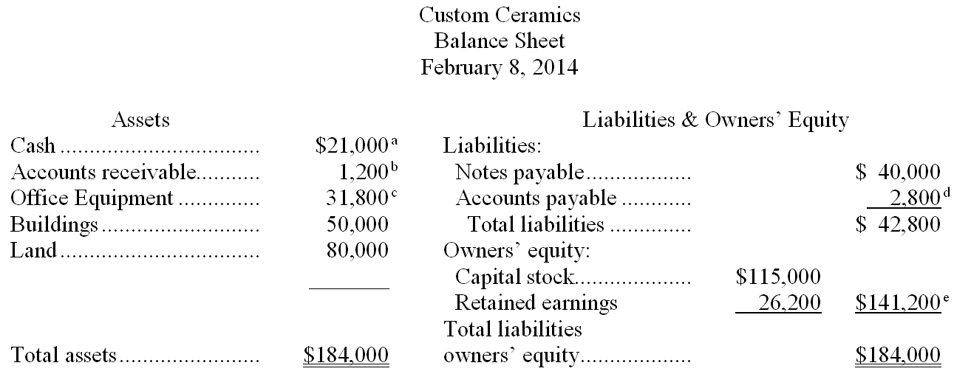  Feedback: (a.) $7,000 + $4,000 + $15,000 - $5,000 = $21,000  (b.) $5,200 - $4,000 collected = $1,200  (c.) $30,000 + $1,800 = $31,800  (d.) $6,000 + $1,800 (equipment purchase) - $5,000 paid = $2,800  (e.) $126,200 + $15,000 (additional investment) = $141,200

AACSB: Analytic
AICPA BB: Critical Thinking
AICPA FN: Measurement
AICPA FN: Reporting
Blooms: Apply
Difficulty: 2 Medium
Learning Objective: 02-04 Explain how the statement of financial position; often referred to as the balance sheet; is an expansion of the basic accounting equation.
Topic: A Starting Point: Statement of Financial Position

138. | Completion of balance sheet  Use the following information to complete the balance sheet of Adelphi Construction as of December 31, 2014.  (1) The company was organized on January 1, 2014 and has operated for the full year 2014.  (2) Earnings were $275,000 and dividends of $70,000 were paid to stockholders.  (3) Cash and accounts receivable together amount to one and one-half times as much as notes payable.  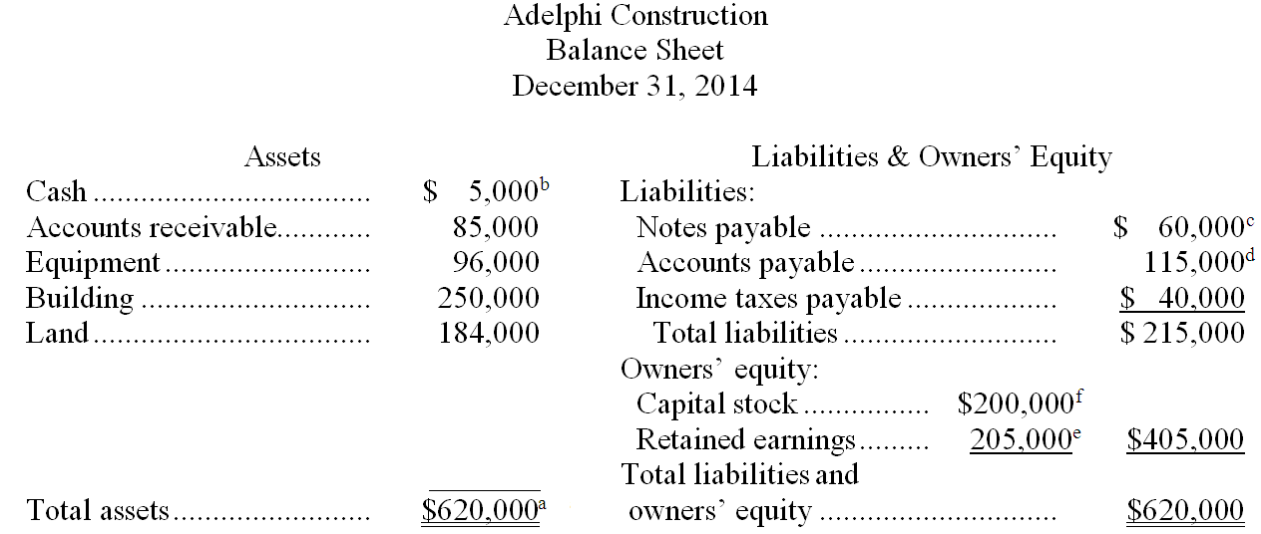  Feedback: (a.) Total assets must be $620,000 to agree with the total of liabilities plus owners' equity.  (b.) Cash must be $5,000 to achieve a total asset figure of $620,000.  (c.) Cash ($5,000) plus accounts receivable ($85,000) equals $90,000. This total is stated to be 1.5 times the amount of notes payable. Notes payable is computed as $90,000 divided by 1.5, or $60,000.  (d.) Accounts payable must be $115,000 to achieve total liabilities figure of $215,000.  (e.) Retained earnings at the end of the first accounting period must be earnings ($275,000) less dividends $(70,000), or $205,000.  (f.) Capital stock must be $200,000 to achieve total liabilities and owners' equity figure of $620,000.

AACSB: Analytic
AICPA BB: Critical Thinking
AICPA FN: Measurement
AICPA FN: Reporting
Blooms: Apply
Difficulty: 2 Medium
Learning Objective: 02-04 Explain how the statement of financial position; often referred to as the balance sheet; is an expansion of the basic accounting equation.
Topic: A Starting Point: Statement of Financial Position

139. | Completion of balance sheet  Use the following information to complete the December 31, 2014 balance sheet of Copper Supplies Company.  (1) Owners' equity as of January 1, 2014, totaled $175,000, which included capital stock of $150,000.  (2) Additional capital stock was issued during 2014 in exchange for $40,000 cash.  (3) Net income for 2014 amounted to $200,000; no dividends were paid during 2014.  (4) Cash and accounts receivable together amount to 3 times as much as accounts payable.  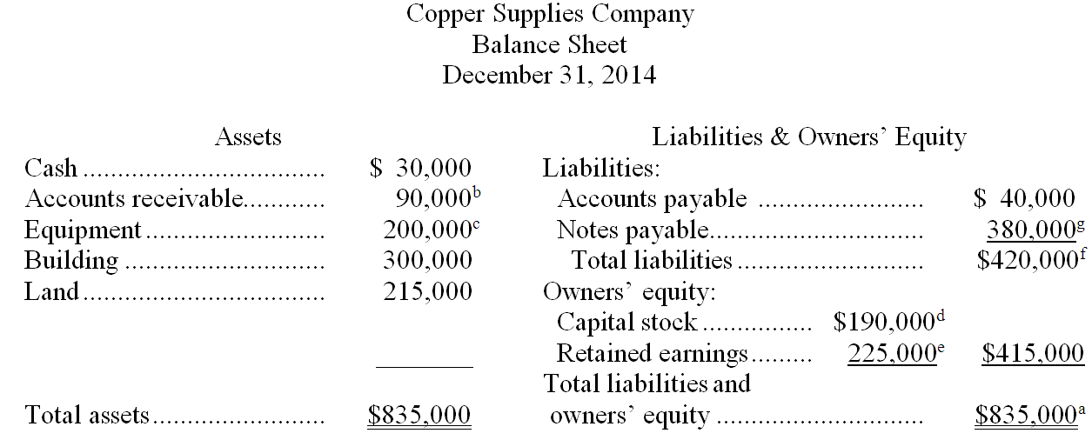  Feedback: (a.) Total of liabilities & owners' equity must be $835,000 to agree with the amount of total assets.  (b.) Cash and accounts receivable together amount to 3 times accounts payable, or $120,000. Since cash is $30,000, accounts receivable are $120,000 - $30,000, or $90,000.  (c.) Equipment must be $200,000 to achieve total assets of $835,000.  (d.) Beginning capital stock is $150,000 + stock issued of $40,000 = $190,000.  (e.) Beginning retained earnings (175,000 - 150,000) + net income of 200,000 = 225,000.  (f.) Total liabilities must be $420,000 to achieve the total of liabilities plus owners' equity of $835,000.  (g.) Since total liabilities are $420,000 and accounts payable are $40,000, notes payable must be $380,000.

AACSB: Analytic
AICPA BB: Critical Thinking
AICPA FN: Measurement
AICPA FN: Reporting
Blooms: Apply
Difficulty: 2 Medium
Learning Objective: 02-04 Explain how the statement of financial position; often referred to as the balance sheet; is an expansion of the basic accounting equation.
Topic: A Starting Point: Statement of Financial Position

140. | Effects of transactions on balance sheet items  Show the effect of each of the seven listed transactions on the balance sheet items of Distinctive Draperies. Indicate the new balances after the transaction of May 2 and each subsequent transaction. The effects of the May 1 transaction are already filled in to provide you with an example.  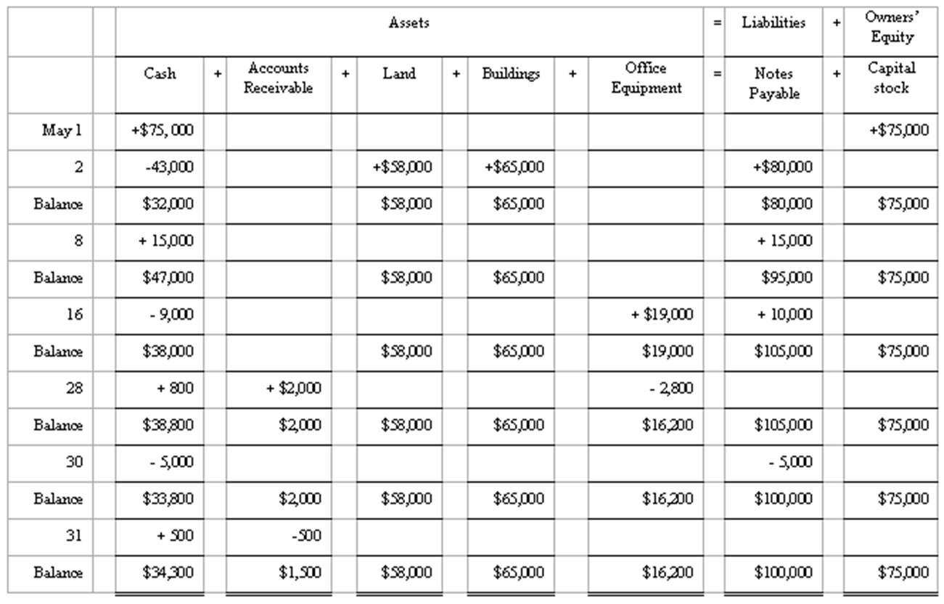

AACSB: Analytic
AICPA BB: Critical Thinking
AICPA FN: Measurement
Blooms: Apply
Difficulty: 2 Medium
Learning Objective: 02-04 Explain how the statement of financial position; often referred to as the balance sheet; is an expansion of the basic accounting equation.
Topic: A Starting Point: Statement of Financial Position

141. | Effects of transactions on balance sheet items  Show the effect of each of the six listed transactions on the balance sheet items of Renaissance Investment Services, Inc. Indicate the new balances after the transaction of November 2 and each subsequent transaction. The effects of the November 1 transaction are already filled in to provide you with an example.  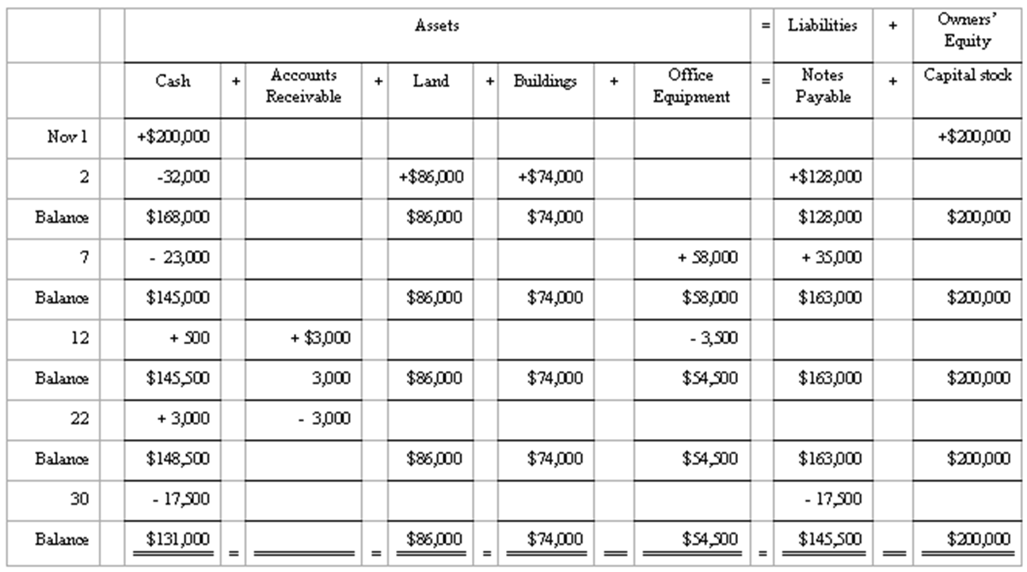

AACSB: Analytic
AICPA BB: Critical Thinking
AICPA FN: Measurement
Blooms: Apply
Difficulty: 2 Medium
Learning Objective: 02-04 Explain how the statement of financial position; often referred to as the balance sheet; is an expansion of the basic accounting equation.
Topic: A Starting Point: Statement of Financial Position

142. | An inexperienced accounting intern at Tasso Company prepared the following income statement for the month of July 2014:  Instructions: Prepare a revised income statement in accordance with generally accepted accounting principles.  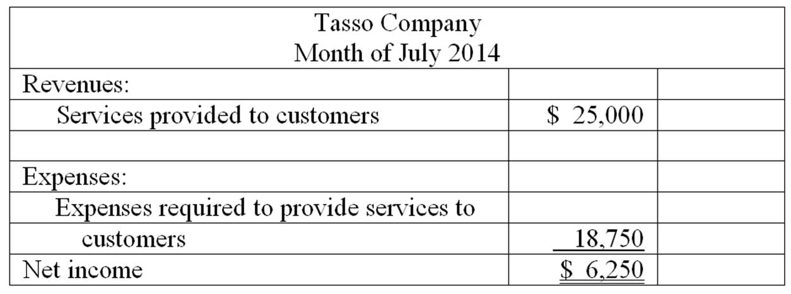

AACSB: Analytic
AICPA BB: Critical Thinking
AICPA FN: Reporting
Blooms: Apply
Difficulty: 2 Medium
Learning Objective: 02-05 Explain how the income statement reports an enterprise's financial performance for a period of time in terms of the relationship of revenues and expenses.
Topic: Income Statement

143. | From the following accounts and amounts prepare a balance sheet for the Swell Company for December 31, 2014. You must compute the amount for retained earnings to complete the balance sheet.  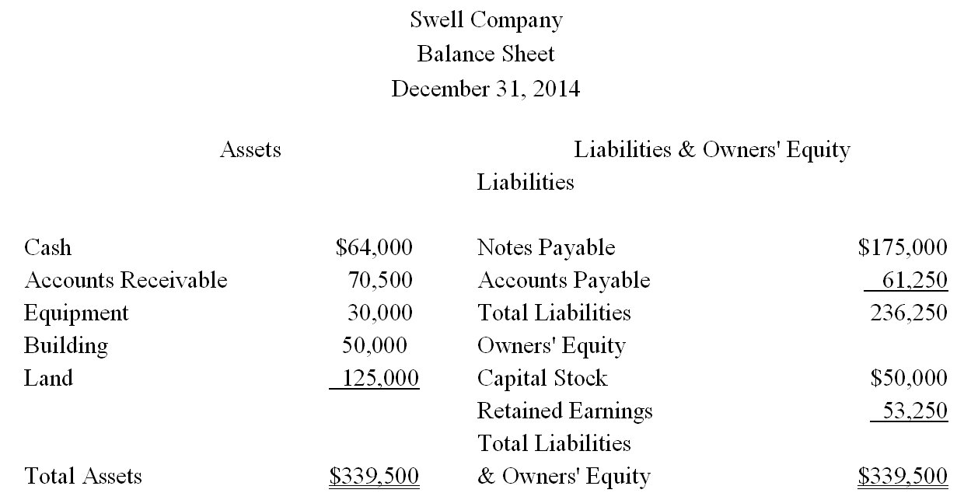

AACSB: Analytic
AICPA BB: Critical Thinking
AICPA FN: Reporting
Blooms: Apply
Difficulty: 2 Medium
Learning Objective: 02-04 Explain how the statement of financial position; often referred to as the balance sheet; is an expansion of the basic accounting equation.
Topic: A Starting Point: Statement of Financial Position

144. | Forms of Business Organization  State and describe the three most common forms of business organizations in the United States.  (1) Sole Proprietorship - One person, unlimited liability, and owner acts as manager.  (2) Partnership - Two or more persons and owners are personally responsible for debts.  (3) Corporation - Stockholders are owners, limited liability, ease of transfer of ownership, and separate entity under the law.

AACSB: Reflective Thinking
AICPA BB: Legal
AICPA FN: Reporting
Blooms: Remember
Difficulty: 1 Easy
Learning Objective: 02-08 Explain common forms of business ownership-sole proprietorship; partnership; and corporation-and demonstrate how they differ in terms of their statements of financial position.
Topic: Forms of Business Organization

