Organic Chemistry, 8e (Wade)
Chapter 2 Structure and Properties of Organic Molecules

1) An orbital can be described by its ________, which is the mathematical description of the shape of the electron wave as it oscillates.
Answer: wave function
Diff: 1
Section: 2.1

2) The electron density at any point is proportional to the ________ of the electron wave at that point.
Answer: square of the wave function
Diff: 2
Section: 2.1

3) Which atomic orbital combination would result in a molecular sigma bond?
A)
B)
C)
D)
Answer: B
Diff: 1
Section: 2.2

4) Two p orbitals can overlap to form a s molecular orbital. How many nodes are present in this s molecular orbital?
A) 0
B) 1
C) 2
D) 3
Answer: C
Diff: 1
Section: 2.2

5) Two p orbitals can overlap to form a s* molecular orbital. How many nodes are present in this s* molecular orbital?
A) 0
B) 1
C) 2
D) 3
Answer: D
Diff: 1
Section: 2.2
6) When orbitals on different atoms interact, ________ are produced.
Answer: molecular orbitals
Diff: 1
Section: 2.2

7) What kind of molecular orbital (σ, σ*, π, or π*) results when the two atomic orbitals shown below interact in the manner indicated?

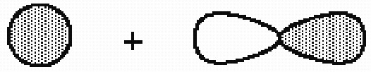
Answer: σ*
Diff: 2
Section: 2.2

8) What kind of molecular orbital (σ, σ*, π, or π*) results when the two atomic orbitals shown below interact in the manner indicated?

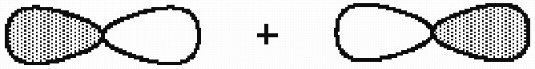
Answer: σ
Diff: 2
Section: 2.2

9) What kind of molecular orbital (σ, σ*, π, or π*) results when the two atomic orbitals shown below interact in the manner indicated?

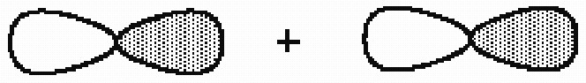
Answer: σ*
Diff: 2
Section: 2.2

10) How many carbon-carbon σ bonds are present in the molecule shown?

A) 1
B) 2
C) 3
D) 4
E) 5
Answer: E
Diff: 2
Section: 2.2
11) How many carbon-carbon s bonds are present in the molecule shown?

A) 1
B) 2
C) 3
D) 4
E) 5
Answer: D
Diff: 2
Section: 2.2

12) How many carbon-carbon s bonds are present in the molecule shown?

A) 1
B) 2
C) 3
D) 4
E) 5
Answer: C
Diff: 2
Section: 2.2

13) Consider the interaction of two hydrogen 1s atomic orbitals of the same phase. Which of the statements below is an incorrect description of this interaction?
A) A sigma bonding molecular orbital is formed.
B) The molecular orbital formed is lower in energy than a hydrogen 1s atomic orbital.
C) The molecular orbital formed has a node between the atoms.
D) The molecular orbital formed is cylindrically symmetric.
E) A maximum of two electrons may occupy the molecular orbital formed.
Answer: C
Diff: 3
Section: 2.2

14) A ________ bond results when parallel p orbitals overlap sideways.
Answer: π
Diff: 1
Section: 2.3
15) What kind on molecular orbital (σ, σ*, π, or π*) results when the two atomic orbitals shown below interact in the manner indicated?

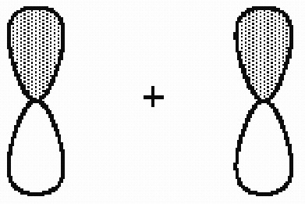
Answer: π
Diff: 2
Section: 2.3

16) What kind of molecular orbital (σ, σ*, π, or π*) results when the two atomic orbitals shown below interact in the manner indicated?

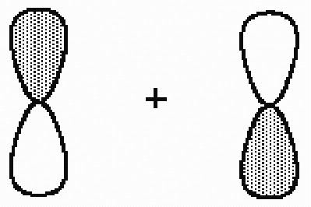
Answer: π*
Diff: 2
Section: 2.3

17) If a compound, C5H7NO, contains 1 ring, how many pi bonds are there in this compound?
A) 0
B) 1
C) 2
D) 3
Answer: C
Diff: 2
Section: 2.3
18) How many π bonds are present in the molecule shown?

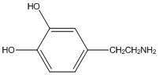

A) 0
B) 1
C) 3
D) 4
E) 6
Answer: C
Diff: 2
Section: 2.3

19) How many π bonds are present in the molecule shown?

A) 0
B) 1
C) 2
D) 4
E) 6
Answer: C
Diff: 2
Section: 2.3

20) Which of the following statements about π molecular orbitals is/are correct?
A) π molecular orbitals are cylindrically symmetric.
B) Most of the electron density in a π molecular orbital is centered above and below the internuclear axis.
C) When two atoms are connected by a double bond, both of these bonds are π bonds.
D) Both statements B and C are correct.
E) Statements A, B, and C are all correct.
Answer: B
Diff: 3
Section: 2.3
21) Vildagliptin is a recently released antidiabetic drug (J. Med. Chem. 2010, 7902). How many degrees of unsaturation are in Vildagliptin?

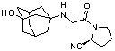

A) 3
B) 4
C) 5
D) 6
Answer: D
Diff: 3
Section: 2.3

22) What is the approximate value of any HCC bond angle in H2C=CHCCl3?
Answer: 120°
Diff: 1
Section: 2.4

23) What is the approximate value of the CCC bond angle in CH3CH2CH2OH?
Answer: 109.5°
Diff: 1
Section: 2.4

24) What is the approximate value of the CCC bond angle in CH3C≡CCH3?
Answer: 180°
Diff: 1
Section: 2.4

25) Based on the structure below, what is the value for the H-N-CH3 bond angle?

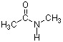

A) 60 degrees
B) 90 degrees
C) 109 degrees
D) 120 degrees
Answer: D
Diff: 2
Section: 2.4
26) In the structure below, the sigma bond of the carbonyl is formed from the overlap of a(n) ________ atomic orbital of carbon and a(n) ________ atomic orbital of oxygen.

A) sp, sp2
B) sp3, sp2
C) sp2, sp2
D) p, p
Answer: C
Diff: 2
Section: 2.4

27) Choose the term below which best describes the geometry of acetylene (HCCH).
A) trigonal bipyramidal
B) trigonal
C) tetrahedral
D) square planar
E) linear
Answer: E
Diff: 2
Section: 2.4
28) Which of the following line orbital energy diagrams describes the orbital location of valence electrons in an sp3 hybridized carbon atom (consider that SP is a generic notation that could reference either sp, sp2 or sp3 hybrid orbitals)?
A)
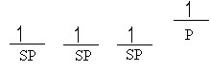
B)
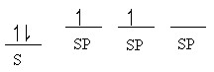
C)
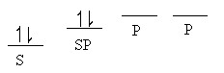
D)
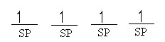
E)
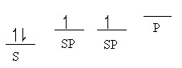
Answer: D
Diff: 2
Section: 2.4

29) Complete the structure of methyl azide by adding any necessary formal charges.

Answer:
Diff: 2
Section: 2.4

30) The CCC bond angle in allene (H2CCCH2) is ________.
Answer: 180°
Diff: 2
Section: 2.4
31) The HCH bond angle in allene (H2CCCH2) is ________.
Answer: approximately 120°
Diff: 2
Section: 2.4

32) What two hybrid atomic orbitals overlap to form the C-C s bond in acetonitrile,
CH3C≡N?
Answer: Csp3 and Csp
Diff: 2
Section: 2.4

33) What two hybrid atomic orbitals overlap to form the C-C s bond in acetaldehyde, CH3CHO?
Answer: Csp3 and Csp2
Diff: 2
Section: 2.4

34) What two hybrid atomic orbitals overlap to form the C-C s bond in allene, H2C=C=CH2?
Answer: Csp and Csp2
Diff: 2
Section: 2.4

35) Circle the coplanar atoms in 1-ethylcyclopentene shown below.

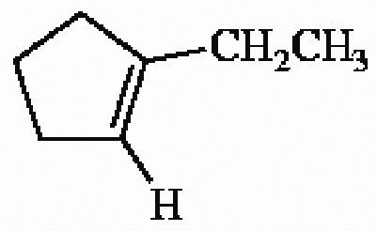
Answer:
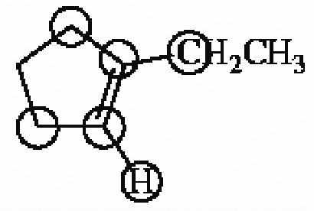
Diff: 2
Section: 2.4
36) How many sp3 hybridized carbon atoms are present in the molecule shown?

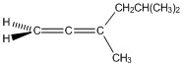
A) 1
B) 2
C) 3
D) 4
E) 5
Answer: E
Diff: 2
Section: 2.4

37) How many sp2 hybridized carbon atoms are present in the molecule shown?

A) 1
B) 2
C) 3
D) 4
E) 5
Answer: B
Diff: 2
Section: 2.4

38) How many sp hybridized carbon atoms are present in the molecule shown?

A) 0
B) 1
C) 2
D) 3
E) 5
Answer: B
Diff: 2
Section: 2.4
39) Choose the correct hybridization for the atom indicated in the molecule below.

CH3CH2CH2CH3
↑
A) sp
B) sp2
C) sp3
D) none of the above
Answer: C
Diff: 1
Section: 2.6

40) Choose the correct hybridization for the atom indicated in the molecule below.

CH3CH2CH2CH3
↑
A) sp
B) sp2
C) sp3
D) none of the above
Answer: C
Diff: 1
Section: 2.6

41) The structure of vitamin C is shown below. Which one of the following statements concerning this structure is not correct?

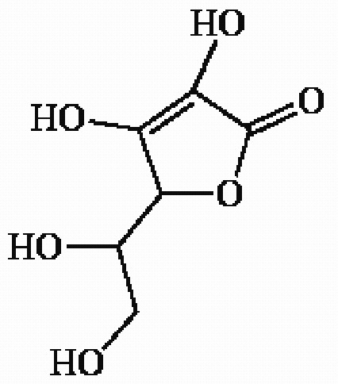
A) The molecule contains 2 pi bonds.
B) The molecule contains sp3 hybridized oxygen atoms.
C) The molecule contains 3 sp2 hybridized carbon atoms.
D) The molecule can be classified as an aldehyde.
E) The molecule contains more than one hydroxyl group.
Answer: D
Diff: 1
Section: 2.6
42) What is the hybridization of the nitrogen atom in the molecule below?

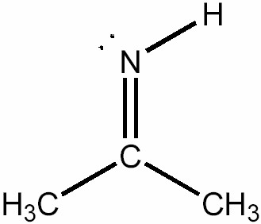
A) s
B) sp
C) sp2
D) sp3
E) none of the above
Answer: C
Diff: 1
Section: 2.6

43) What is the approximate CCC bond angle in the compound below?

A) 60°
B) 90°
C) 109.5°
D) 120°
E) 180°
Answer: D
Diff: 1
Section: 2.6

44) The HCC bond angle in allene (H2C=C=CH2) is approximately what?
Answer: 120°
Diff: 1
Section: 2.6

45) The CCC bond angle in allene (H2C=C=CH2) is approximately what?
Answer: 180°
Diff: 1
Section: 2.6
46) Triethylamine [(CH3CH2)3N] is a molecule in which the nitrogen atom is ________ hybridized and the CNC bond angle is ________.
A) sp2, >109.5°
B) sp2, <109.5°
C) sp3, >109.5°
D) sp3, <109.5°
E) sp, 109.5°
Answer: D
Diff: 2
Section: 2.6

47) Choose the correct hybridization for the atom indicated in the molecule below.

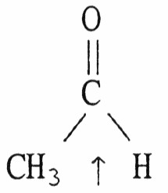
A) sp
B) sp2
C) sp3
D) none of the above
Answer: B
Diff: 2
Section: 2.6

48) Choose the correct hybridization for the atom indicated in the molecule below.

(CH3)2CHCN
↑
A) sp
B) sp2
C) sp3
D) none of the above
Answer: A
Diff: 2
Section: 2.6
49) Choose the correct hybridization for the atom indicated in the molecule below.

(CH3)2CHCN
↑
A) sp
B) sp2
C) sp3
D) none of the above
Answer: C
Diff: 2
Section: 2.6

50) Choose the correct hybridization for the atom indicated in the molecule below.

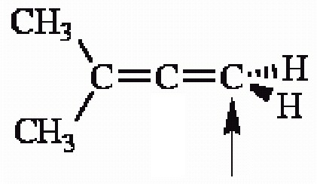
A) sp
B) sp2
C) sp3
D) none of the above
Answer: B
Diff: 2
Section: 2.6

51) How many s bonds does the compound shown contain?

A) 3
B) 5
C) 9
D) 10
E) 11
Answer: D
Diff: 2
Section: 2.6
52) Acrylonitrile (CH2=CHCN) contains ________ s bonds and ________ p bonds.
A) 4, 1
B) 6, 3
C) 4, 3
D) 6, 1
E) 2, 0
Answer: B
Diff: 2
Section: 2.6

53) The CCN bond angle in acrylonitrile (CH2=CHCN) is approximately ________.
A) 60°
B) 90°
C) 109.5°
D) 120°
E) 180°
Answer: E
Diff: 2
Section: 2.6

54) Which of the following statements concerning the cyclic molecule shown is not true?

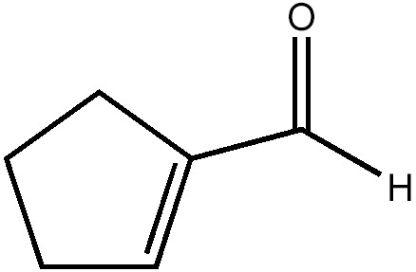
A) It contains a π molecular orbital formed by the overlap of a carbon p atomic orbital with an oxygen p atomic orbital.
B) It contains a σ molecular orbital formed by the overlap of two carbon sp2 hybrid atomic orbitals.
C) It contains a σ molecular orbital formed by the overlap of two carbon sp3 hybrid atomic orbitals.
D) It contains a π molecular orbital formed by the overlap of two carbon p atomic orbitals.
E) It contains a σ molecular orbital formed by the overlap of a carbon p atomic orbital with an oxygen sp3 atomic orbital.
Answer: E
Diff: 2
Section: 2.6
55) The HNC bond angle in the cation [CH2NH2]+ is approximately ________.
A) 60°
B) 90°
C) 109.5°
D) 120°
E) 180°
Answer: D
Diff: 2
Section: 2.6

56) Which of the labeled atoms in the following structure are sp2 hybridized?
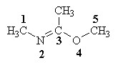
A) 1 & 4
B) 2 & 5
C) 2 & 4
D) 2 & 3
E) 2, 3, & 4
Answer: D
Diff: 2
Section: 2.6

57) The HCN bond angle in hydrogen cyanide (HCN) is ________.
Answer: 180°
Diff: 2
Section: 2.6

58) The HCH bond angle in propane (CH3CH2CH3) is ________.
Answer: approximately 109.5°
Diff: 2
Section: 2.6

59) The CCO bond angle in acetone (CH3COCH3) is ________.
Answer: approximately 120°
Diff: 2
Section: 2.6
60) The molecule shown below contains ________ pi bonds and ________ sigma bonds.

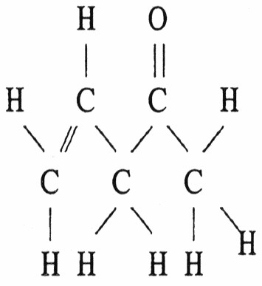
Answer: 2, 13
Diff: 2
Section: 2.6

61) The molecule shown below contains ________ sigma bonds and ________ pi bonds.

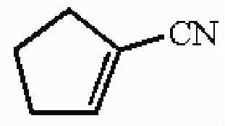
Answer: 14 sigma, 3 pi
Diff: 2
Section: 2.6

62) What hybrid atomic orbitals are overlapping to form the carbon-oxygen s bond in acetaldehyde (CH3CHO)?
Answer: carbon sp2 and oxygen sp2
Diff: 2
Section: 2.6

63) Provide the hybridization of oxygen in dimethyl ether (CH3OCH3) and estimate the COC bond angle.
Answer: The hybridization of the oxygen atom is sp3 and the COC bond angle is slightly less than 109.5°.
Diff: 2
Section: 2.6

64) Provide the hybridization of oxygen in acetaldehyde (CH3CHO) and estimate the OCH bond angle.
Answer: The hybridization of the oxygen atom is sp2 and the OCH bond angle is approximately 120°.
Diff: 2
Section: 2.6
65) Choose the correct hybridization for the atom indicated in the molecule below.

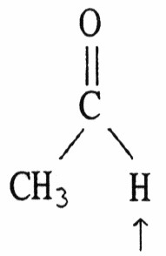
A) sp
B) sp2
C) sp3
D) none of the above
Answer: D
Diff: 3
Section: 2.6

66) Choose the correct hybridization for the atom indicated in the molecule below.

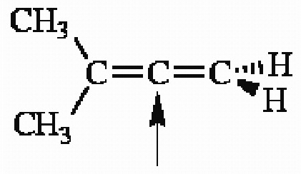
A) sp
B) sp2
C) sp3
D) none of the above
Answer: A
Diff: 3
Section: 2.6

67) Boron trifluoride (BF3) is a molecule in which the boron atom is ________ hybridized and the FBF bond angle is ________.
Answer: sp2, 120°
Diff: 3
Section: 2.6

68) The synthetic steroid RU-486 is shown below. How many pi bonds does RU-486 contain?

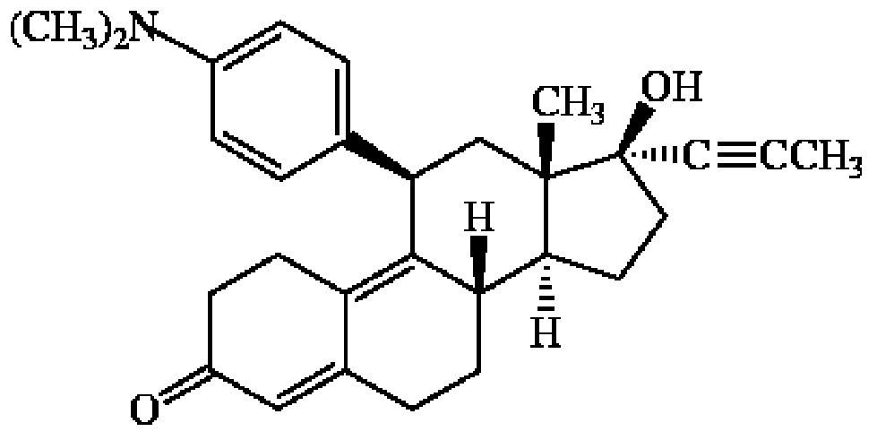
Answer: 8
Diff: 3
Section: 2.6
69) Structures which differ only in rotations about a single bond are called ________.
Answer: conformations
Diff: 2
Section: 2.7

70) From a molecular orbital perspective, why is there relatively free rotation about the carbon-carbon bond of ethane (CH3CH3)?
Answer: This carbon-carbon s bond is formed by the head-to-head overlap of two sp3 hybrid orbitals. Rotation about this bond does not disrupt the orbital overlap.
Diff: 2
Section: 2.7

71) From a molecular orbital perspective why isn't there relatively free rotation about the carbon-carbon double bond in ethene (CH2=CH2)?
Answer: Two carbon p atomic orbitals overlap side-to-side and in phase to form the p bond that is present. Rotation about the carbon-carbon bond axis requires quite a bit of energy because the p bond is broken as the overlap between the two p orbitals is disrupted.
Diff: 2
Section: 2.7

72) Explain why the free rotation about the carbon-carbon bond in CH3CH3 is not present in CH2CH2.
Answer: The single carbon-carbon sigma bond present in CH3CH3 is formed by the overlap of two C sp3 hybrid atomic orbitals. The overlap of these orbitals is not disrupted by rotation about the carbon-carbon bond axis. In the case of CH2CH2, the carbon-carbon bond is a double bond with both a sigma and pi bond present. Rotation about the carbon-carbon bond axis disrupts the overlap of the two carbon p orbitals forming the pi bond.
Diff: 2
Section: 2.7
73) Which of the following best describes the relationship between the two structures shown?

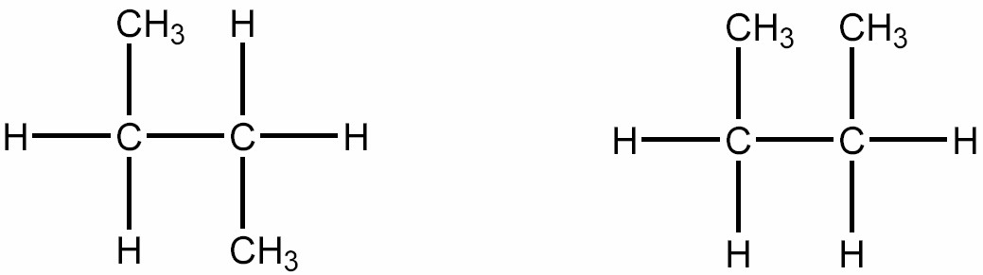
A) They represent the same compound.
B) They represent different compounds that are constitutional isomers.
C) They represent different compounds that are geometric isomers.
D) They represent different compounds that are alkenes.
E) They represent different compounds that are alkanes.
Answer: A
Diff: 1
Section: 2.8

74) Are the two compounds shown below best described as cis-trans isomers, constitutional isomers, or not isomeric?

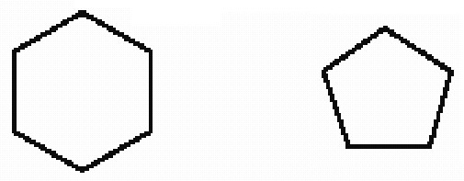
Answer: not isomeric
Diff: 1
Section: 2.8

75) Are the two compounds shown below best described as cis-trans isomers, constitutional isomers, or not isomeric?

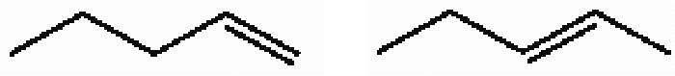
Answer: constitutional isomers
Diff: 1
Section: 2.8

76) Are the two compounds shown below best described as cis-trans isomers, constitutional isomers, or not isomeric?

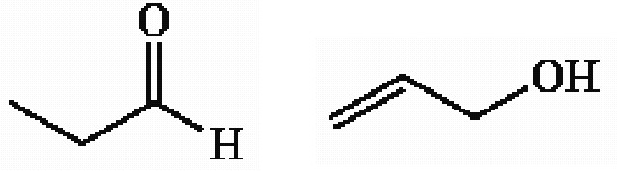
Answer: constitutional isomers
Diff: 2
Section: 2.8
77) Which of the following compounds is not a constitutional isomer of a compound with an empirical formula C3H7O and a formula mass of 118.164?
A)
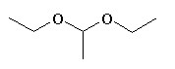
B)
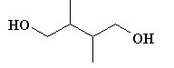
C)
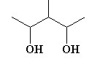
D)
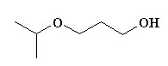
E)
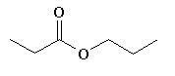
Answer: E
Diff: 2
Section: 2.8

78) Provide the skeletal structures of the five constitutional isomers with molecular formula C6H14.
Answer:
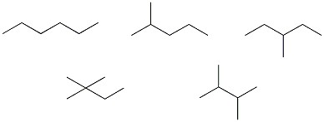
Diff: 2
Section: 2.8
79) Are the two compounds shown below best described as cis-trans isomers, constitutional isomers, or not isomeric?

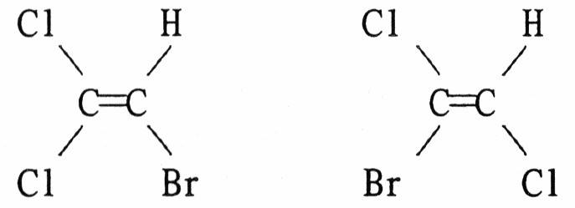
Answer: constitutional isomers
Diff: 2
Section: 2.8

80) Are the two compounds shown below best described as cis-trans isomers, constitutional isomers, or not isomeric?

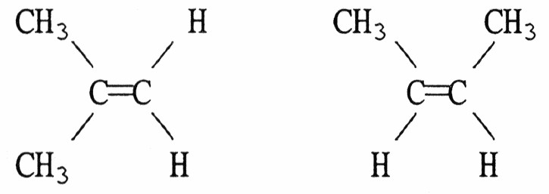
Answer: constitutional isomers
Diff: 2
Section: 2.8

81) Are the two compounds shown below best described as cis-trans isomers, constitutional isomers, or not isomeric?

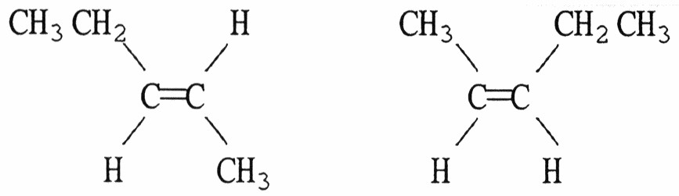
Answer: cis-trans isomers
Diff: 2
Section: 2.8

82) Are the two compounds shown below best described as cis-trans isomers, constitutional isomers, or not isomeric?

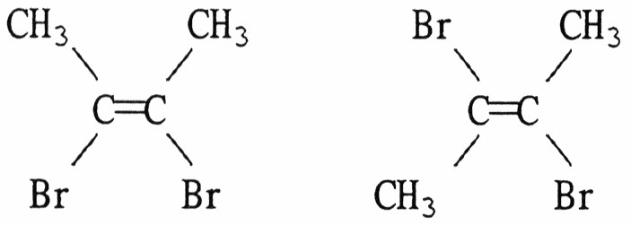
Answer: cis-trans isomers
Diff: 2
Section: 2.8
83) Are the two compounds shown below best described as cis-trans isomers, constitutional isomers, or not isomeric?

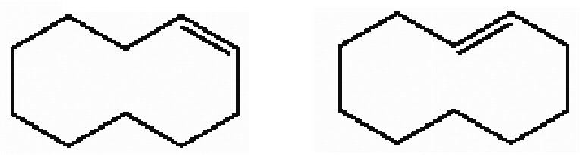
Answer: cis-trans isomers
Diff: 2
Section: 2.8

84) Provide the condensed formulas of three structural isomers with molecular formula C5H12 and arrange them in order of increasing boiling point.
Answer: C(CH3)4 < (CH3)2CHCH2CH3 < CH3(CH2)3CH3
Diff: 2
Section: 2.8

85) A molecule of acetylene (C2H2) has a ________ geometry and a molecular dipole moment that is ________.
A) tetrahedral, nonzero
B) bent, nonzero
C) bent, zero
D) linear, nonzero
E) linear, zero
Answer: E
Diff: 1
Section: 2.9

86) Which of the following statements is correct?
A) Higher molecular dipole values (μ) are associated with nonpolar molecules
B) All polar molecules are capable of hydrogen bond formation
C) The polarity of a molecule is dependent on its three-dimensional structure
D) Induced dipole interactions are usually stronger than dipole-dipole interactions
E) Polar solutes tend to be more soluble in nonpolar solvents
Answer: C
Diff: 1
Section: 2.9
87) Which one of the molecules shown below has no net molecular dipole moment?
A) CH3Cl
B) H2CCH2
C) CH2O
D) CH2Cl2
E) CH3OH
Answer: B
Diff: 2
Section: 2.9

88) Which one of the molecules shown below has a net molecular dipole moment?
A) CCl4
B) CO2
C) CH3CCl3
D) BeCl2
Answer: C
Diff: 2
Section: 2.9

89) Does 1,1-dichloroethene (Cl2CCH2) have a net molecular dipole moment? If it does, draw the molecule and indicate the direction of this molecular dipole moment.
Answer: Net molecular dipole moment present.

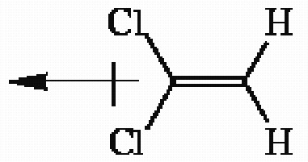
Diff: 2
Section: 2.9

90) Draw the three-dimensional structure of chloroform (CHCl3) and show the direction of the molecular dipole moment.
Answer:
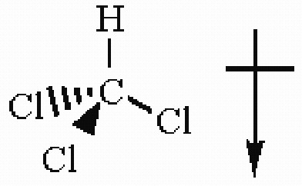
Diff: 2
Section: 2.9
91) Which sequence ranks the following isomers in order of increasing boiling points?

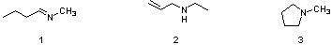

A) 2<1<3
B) 2<3<1
C) 3<1<2
D) 3<2<1
Answer: C
Diff: 2
Section: 2.9

92) Does the CO bond in methanol (CH3OH) possess an individual bond dipole moment? Briefly explain your answer.
Answer: Yes, the CO bond in methanol does have an individual bond dipole moment since the C and O atoms comprising the bond have differing electronegativities.
Diff: 3
Section: 2.9

93) Draw the structure of the isomeric form of 1,2-dichloroethene (CHClCHCl) which has no net dipole moment.
Answer:
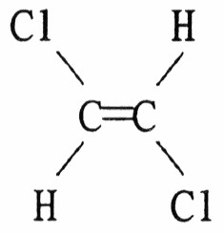
Diff: 3
Section: 2.9
94) Which of the following has the highest boiling point?
A)
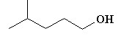
B)
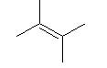
C)
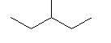
D)
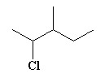
E)
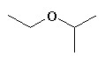
Answer: A
Diff: 1
Section: 2.10

95) What intermolecular forces are present among molecules in dimethyl ether, CH3OCH3?
A) London forces only
B) hydrogen bonding only
C) both London dispersion forces and hydrogen bonding
D) both London dispersion forces and dipole-dipole forces
Answer: D
Diff: 2
Section: 2.10
96) Which of the molecules below can hydrogen bond to another of the same compound?
A) CH3CH2OCH2CH3
B) CH3CH2COOCH3
C) (CH3CH2)2CHOH
D) CH3CH2COCH2CH3
E) all of the above
Answer: C
Diff: 2
Section: 2.10

97) What intermolecular attractions exist in a pure sample of methylthiol, CH3SH?
Answer: London dispersion forces and dipole-dipole attractions
Diff: 2
Section: 2.10

98) Which of the molecules below has the higher boiling point? Briefly explain your choice.

CH3CH2CH2OH or CH3CH2OCH3
Answer: CH3CH2CH2OH has the higher boiling point since it is capable of intermolecular hydrogen bonding.
Diff: 2
Section: 2.10

99) Which of the molecules below has the higher boiling point? Briefly explain your choice.

CH3CH2CH2CH2CH3 or (CH3)2CHCH2CH3
Answer: CH3CH2CH2CH2CH3 has the higher boiling point. As the degree of branching increases, the surface area of the molecule decreases and the potential for intermolecular attraction via London forces decreases. Greater surface area leads to a more intermolecular attraction which in results in a higher boiling point.
Diff: 2
Section: 2.10

100) Would you expect sodium chloride (NaCl) to be highly soluble in the organic solvent hexane (CH3CH2CH2CH2CH2CH3)? Briefly explain your answer.
Answer: One would not expect NaCl to be highly soluble in hexane. NaCl is an ionic solid (i.e., a very polar material) while hexane is nonpolar. Nonpolar solvent molecules do not solvate ions well. The attractions of oppositely charged ions to each other are vastly greater than the weak attractions of the ions for the solvent.
Diff: 2
Section: 2.10
101) What type of intermolecular force results from the attraction of coordinated temporary dipoles induced in adjacent molecules?
Answer: London dispersion forces
Diff: 2
Section: 2.10

102) Which of the molecules below has the higher boiling point? Briefly explain your choice.

(CH3)3N or CH3CH2CH2NH2
Answer: CH3CH2CH2NH2 has the higher boiling point since it is capable of intermolecular hydrogen bonding.
Diff: 3
Section: 2.10

103) The compounds below are base pairs used to form supramolecular polymers (Org. Lett. 2011, 240). They are held together by three intermolecular hydrogen bonds and each contains one intramolecular hydrogen bond. Which atom in structure B forms a hydrogen bond with the circled hydrogen in structure A?

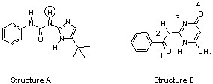

A) 1
B) 2
C) 3
D) 4
Answer: C
Diff: 3
Section: 2.10

104) Which compound is more soluble in water? Briefly explain your choice.

(CH3)2NH or CH3CH2CH3
Answer: (CH3)2NH is more soluble in water since it can hydrogen bond with water. Alkanes are not capable of hydrogen bonding with water.
Diff: 2
Section: 2.11
105) Which compound is more soluble in water? Briefly explain your choice.

CH3OCH3 or CH3CH2OH
Answer: CH3CH2OH is more soluble in water since it can donate a hydrogen bond to water and accept a hydrogen bond from water. CH3OCH3 can only accept a hydrogen bond from water; it does not have hydrogen which can hydrogen bond to water.
Diff: 3
Section: 2.11

106) Which functional groups below indicate the presence of two atoms connected by a triple bond?
A) alkyne
B) alkene
C) nitrile
D) ester
E) both A and C
Answer: E
Diff: 1
Section: 2.12

107) What name is given to a hydrocarbon that contains a carbon-carbon triple bond?
A) alkane
B) alkene
C) alkyne
D) aromatic
E) none of the above
Answer: C
Diff: 1
Section: 2.12

108) Do any of the six-membered rings present in RU-486 have the structural features which characterize an aromatic hydrocarbon?
Answer: Yes
Diff: 1
Section: 2.12

109) Draw the structure of any hydrocarbon alkane which contains 5 carbon atoms.
Answer: CH3CH2CH2CH2CH3 (CH3)2CHCH2CH3 (CH3)4C
Diff: 2
Section: 2.12
110) Draw the structure of any hydrocarbon alkene which contains 4 carbon atoms.
Answer:
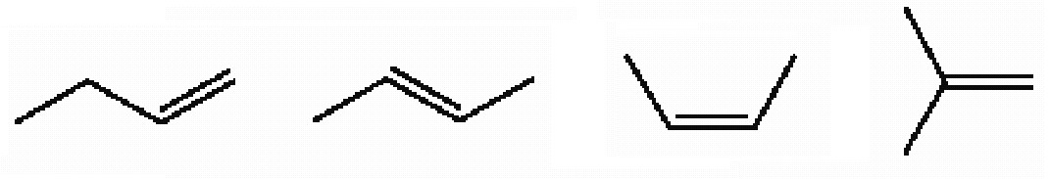
Diff: 2
Section: 2.12

111) Provide the structure of an aromatic compound with seven carbon atoms.
Answer:
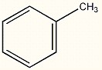
Diff: 2
Section: 2.12

112) Choose the functional group which is not represented in the structure of RU-486.
A) alkyne
B) alcohol
C) ketone
D) amine
E) ether
Answer: E
Diff: 1
Section: 2.13

113) Which of the molecules below is an ester?
A) CH3CH2CH(CH3)2
B) CH3OCH2CH2CH3
C) CH3COOH
D) CH3COOCH3
E) HC≡CCH3
Answer: D
Diff: 1
Section: 2.13
114) Which of the functional groups below contain a hydroxyl group as a part of their structure?
A) aldehyde
B) alcohol
C) carboxylic acid
D) amine
E) B and C only
Answer: E
Diff: 1
Section: 2.13

115) Which of the class of organic compound below contains a carbonyl group as a part of its structure?
A) aldehyde
B) ketone
C) carboxylic acid
D) ester
E) all of the above
Answer: E
Diff: 1
Section: 2.13

116) Which of the following does not contain a carbonyl group?
A) aldehyde
B) ketone
C) carboxylic acid
D) ester
E) ether
Answer: E
Diff: 1
Section: 2.13

117) Which of the following functional groups does not have at least one sp2 hybridized carbon atom as a constituent of the group?
A) carboxylic acid
B) alkene
C) aldehyde
D) ether
E) ester
Answer: D
Diff: 1
Section: 2.13
118) Anisole, the compound shown below, is an example of ________.

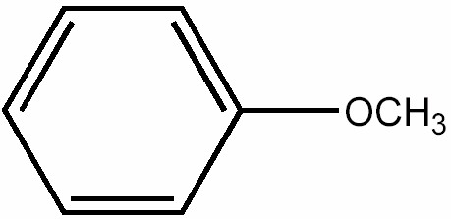
A) an ester
B) an ether
C) an alcohol
D) an aldehyde
E) a ketone
Answer: B
Diff: 1
Section: 2.13

119) Acetone is a ketone that contains three carbon atoms. Provide its structure.
Answer:
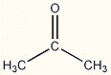
Diff: 1
Section: 2.13

120) What is the name of the characteristic functional group found in the molecule CH3CH2COOH?
Answer: This molecule is a carboxylic acid which contains the carboxyl group as its characteristic functional group.
Diff: 1
Section: 2.13
121) Dopamine is shown below. What functional group, or structural element is not present in this compound?

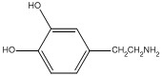

A) hydroxyl
B) amino
C) methylene
D) aromatic ring
E) carboxyl
Answer: E
Diff: 1
Section: 2.13

122) Which molecule below is an ether?
A) CH3CH2OCH2CH3
B) (CH3)2CHCH2OH
C) (CH3)2CHCH2NH2
D) (CH3)2C=CH2
E) CH3CH2CH2CO2H
Answer: A
Diff: 1
Section: 2.13
Use the following structure for the questions below.

Saquinavir Structure
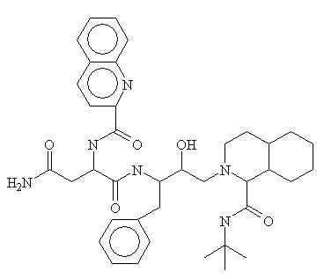

123) Which of the following functional groups is not present in the HIV protease inhibitor drug called Saquinavir?
A) alcohol
B) amide
C) aromatic
D) amine
E) ketone
Answer: E
Diff: 2
Section: 2.13

124) Which functional group occurs more than two times in the structure of the HIV protease inhibitor drug called Saquinavir?
A) ketone
B) carboxylic acid
C) amine
D) amide
E) alkene
Answer: D
Diff: 2
Section: 2.14
125) Which of the molecules below can be properly called an amine?
A) CH3CN
B) CH3COOH
C) CH3CH2CH2OH
D) CH3CH2NHCH3
E) CH3CH2CH2NO2
Answer: D
Diff: 1
Section: 2.14

126) Provide the condensed structures of two structurally isomeric amines that contain two carbons.
Answer: (CH3)2NH and CH3CH2NH2
Diff: 2
Section: 2.14

127) Vildagliptin is a recently released antidiabetic drug (J. Med. Chem. 2010, 7902).
Circle and name each functional group in vildagliptin.

Answer:

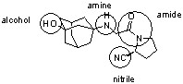

Diff: 2
Section: 2.14

128) Which molecule below is an alkene?
A) CH3CH2OCH2CH3
B) (CH3)2CHCH2OH
C) (CH3)2C=CH2
D) (CH3)2CHCH2NH2
E) CH3CH2CH2CO2H
Answer: C
Diff: 2
Section: 2.14
129) The structure of Tamiflu, an antiinfluenza drug, is shown below (Organic Lett. 2007, 259). Circle and identify each functional group in Tamiflu.

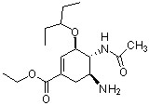

Answer:
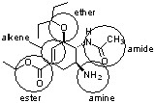

Diff: 3
Section: 2.14

