Chapter 02
Reporting Intercorporate Investments and Consolidation of Wholly Owned Subsidiaries with No Differential

Multiple Choice Questions
1. | If Push Company owned 51 percent of the outstanding common stock of Shove Company, which reporting method would be appropriate?  A. Cost method  B. Consolidation  C. Equity method  D. Merger method

2. | Usually, an investment of 20 to 50 percent in another company's voting stock is reported under the:  A. cost method  B. equity method  C. full consolidation method  D. fair value method

3. | From an investor's point of view, a liquidating dividend from an investee is:  A. a dividend declared by the investee in excess of its earnings in the current year  B. a dividend declared by the investee in excess of its earnings since acquisition by the investor  C. any dividend declared by the investee since acquisition  D. a dividend declared by the investee in excess of the investee's retained earnings

4. | Which of the following observations is NOT consistent with the cost method of accounting?  A. Investee dividends from earnings since acquisition by investor are treated as a reduction of the investment.  B. Investments are carried by the investor at historical cost.  C. No journal entry is made regarding the earnings of the investee.  D. It is consistent with the treatment normally accorded noncurrent assets.

5. | On January 1, 20X9 Athlon Company acquired 30 percent of the common stock of Opteron Corporation, at underlying book value. For the same year, Opteron reported net income of $55,000, which includes an extraordinary gain of 40,000. It did not pay any dividends during the year. By what amount would Athlon's investment in Opteron Corporation increase for the year, if Athlon used the equity method?  A. $0  B. $16,500  C. $4,500  D. $12,000

6. | On January 1, 20X8, William Company acquired 30 percent of eGate Company's common stock, at underlying book value of $100,000. eGate has 100,000 shares of $2 par value, 5 percent cumulative preferred stock outstanding. No dividends are in arrears. eGate reported net income of $150,000 for 20X8 and paid total dividends of $72,000. William uses the equity method to account for this investment.  Based on the preceding information, what amount would William Company receive as dividends from eGate for the year?  A. $62,000  B. $21,600  C. $18,600  D. $54,000

7. | On January 1, 20X8, William Company acquired 30 percent of eGate Company's common stock, at underlying book value of $100,000. eGate has 100,000 shares of $2 par value, 5 percent cumulative preferred stock outstanding. No dividends are in arrears. eGate reported net income of $150,000 for 20X8 and paid total dividends of $72,000. William uses the equity method to account for this investment.  Based on the preceding information, what amount of investment income will William Company report from its investment in eGate for the year?  A. $45,000  B. $42,000  C. $62,000  D. $35,000

8. | On January 1, 20X8, William Company acquired 30 percent of eGate Company's common stock, at underlying book value of $100,000. eGate has 100,000 shares of $2 par value, 5 percent cumulative preferred stock outstanding. No dividends are in arrears. eGate reported net income of $150,000 for 20X8 and paid total dividends of $72,000. William uses the equity method to account for this investment.  Based on the preceding information, what amount would be reported by William Company as the balance in its investment account on December 31, 20X8?  A. $100,000  B. $123,400  C. $120,400  D. $142,000

9. | On January 1, 20X7, Yang Corporation acquired 25 percent of the outstanding shares of Spiel Corporation for $100,000 cash. Spiel Company reported net income of $75,000 and paid dividends of $30,000 for both 20X7 and 20X8. The fair value of shares held by Yang was $110,000 and $105,000 on December 31, 20X7 and 20X8 respectively.  Based on the preceding information, what amount will be reported by Yang as income from its investment in Spiel for 20X8, if it used the equity method of accounting?  A. $7,500  B. $11,250  C. $18,750  D. $26,250

10. | On January 1, 20X7, Yang Corporation acquired 25 percent of the outstanding shares of Spiel Corporation for $100,000 cash. Spiel Company reported net income of $75,000 and paid dividends of $30,000 for both 20X7 and 20X8. The fair value of shares held by Yang was $110,000 and $105,000 on December 31, 20X7 and 20X8 respectively.  Based on the preceding information, what amount will be reported by Yang as balance in investment in Spiel on December 31, 20X8, if it used the equity method of accounting?  A. $108,250  B. $118,750  C. $100,000  D. $122,500

11. | On January 1, 20X7, Yang Corporation acquired 25 percent of the outstanding shares of Spiel Corporation for $100,000 cash. Spiel Company reported net income of $75,000 and paid dividends of $30,000 for both 20X7 and 20X8. The fair value of shares held by Yang was $110,000 and $105,000 on December 31, 20X7 and 20X8 respectively.  Based on the preceding information, what amount will be reported by Yang as income from its investment in Spiel for 20X7 if it used the fair value option to account for its investment in Spiel?  A. $17,500  B. $12,500  C. $11,250  D. $7,500

12. | On January 1, 20X7, Yang Corporation acquired 25 percent of the outstanding shares of Spiel Corporation for $100,000 cash. Spiel Company reported net income of $75,000 and paid dividends of $30,000 for both 20X7 and 20X8. The fair value of shares held by Yang was $110,000 and $105,000 on December 31, 20X7 and 20X8 respectively.  Based on the preceding information, what amount will be reported by Yang as income from its investment in Spiel for 20X8 if it used the fair value option to account for its investment in Spiel?  A. $11,250  B. $2,500  C. $6,250  D. $7,500

13. | On January 1, 20X7, Yang Corporation acquired 25 percent of the outstanding shares of Spiel Corporation for $100,000 cash. Spiel Company reported net income of $75,000 and paid dividends of $30,000 for both 20X7 and 20X8. The fair value of shares held by Yang was $110,000 and $105,000 on December 31, 20X7 and 20X8 respectively.  Based on the preceding information, what amount will be reported by Yang as balance in investment in Spiel on December 31, 20X8, if it used the fair value option to account for its investment in Spiel?  A. $105,000  B. $118,750  C. $100,000  D. $122,500

14. | A change from the cost method to the equity method of accounting for an investment in common stock resulting from an increase in the number of shares held by the investor requires:  A. only a footnote disclosure  B. that the cumulative amount of the change be shown as a line item on the income statement, net of tax  C. that the change be accounted for as an unrealized gain included in other comprehensive income  D. retroactive restatement as if the investor always had used the equity method

15. | Under the equity method of accounting for a stock investment, the investment initially should be recorded at:  A. cost  B. cost minus any differential  C. proportionate share of the fair value of the investee company's net assets  D. proportionate share of the book value of the investee company's net assets

16. | Which of the following observations is consistent with the equity method of accounting?  A. Dividends declared by the investee are treated as income by the investor.  B. It is used when the investor lacks the ability to exercise significant influence over the investee.  C. It may be used in place of consolidation.  D. Its primary use is in reporting nonsubsidiary investments.

17. | Note: This is a Kaplan CPA Review Question  On July 1, 20X4, Denver Corp. purchased 3,000 shares of Eagle Co.'s 10,000 outstanding shares of common stock for $20 per share. On December 15, 20X4, Eagle paid $40,000 in dividends to its common stockholders. Eagle's net income for the year ended December 31, 20X4, was $120,000, earned evenly throughout the year. In its 20X4 income statement, what amount of income from this investment should Denver report?  A. $12,000  B. $36,000  C. $18,000  D. $6,000

18. | Note: This is a Kaplan CPA Review Question  On January 2, 20X5, Well Co. purchased 10 percent of Rea, Inc.'s outstanding common shares for $400,000. Well is the largest single shareholder in Rea, and Well's officers are a majority on Rea's board of directors. As a result, Well is able to exercise significant influence over Rea. Rea reported net income of $500,000 for 20X5, and paid dividends of $150,000. In its December 31, 20X5, balance sheet, what amount should Well report as investment in Rea?  A. $385,000  B. $450,000  C. $400,000  D. $435,000

19. | Note: This is a Kaplan CPA Review Question  The Jamestown Corporation (Jamestown) reported net income for the current year of $200,000 and paid cash dividends of $30,000. The Stadium Company (Stadium) holds 22 percent of the outstanding voting stock of Jamestown. However, another corporation holds the other 78 percent ownership and does not take Stadium's wants and wishes into consideration when making financing and operating decisions for Jamestown. What investment income should Stadium recognize for the current year?  A. $6,600  B. $0  C. $44,000  D. $50,600

20. | Note: This is a Kaplan CPA Review Question  Grant, Inc. acquired 30 percent of South Co.'s voting stock for $200,000 on January 2, 20X4. Grant's 30 percent interest in South gave Grant the ability to exercise significant influence over South's operating and financial policies. During 20X4, South earned $80,000 and paid dividends of $50,000. South reported earnings of $100,000 for the six months ended June 30, 20X5, and $200,000 for the year ended December 31, 20X5. On July 1, 20X5, Grant sold half of its stock in South for $150,000 cash. South paid dividends of $60,000 on October 1, 20X5.  What amount should Grant include in its 20X4 income statement as a result of the investment?  A. $15,000  B. $24,000  C. $50,000  D. $80,000

21. | Note: This is a Kaplan CPA Review Question  Grant, Inc. acquired 30 percent of South Co.'s voting stock for $200,000 on January 2, 20X4. Grant's 30 percent interest in South gave Grant the ability to exercise significant influence over South's operating and financial policies. During 20X4, South earned $80,000 and paid dividends of $50,000. South reported earnings of $100,000 for the six months ended June 30, 20X5, and $200,000 for the year ended December 31, 20X5. On July 1, 20X5, Grant sold half of its stock in South for $150,000 cash. South paid dividends of $60,000 on October 1, 20X5.  In Grant's December 31, 20X4, balance sheet, what should be the carrying amount of this investment?  A. $224,000  B. $200,000  C. $234,000  D. $209,000

22. | Note: This is a Kaplan CPA Review Question  Grant, Inc. acquired 30 percent of South Co.'s voting stock for $200,000 on January 2, 20X4. Grant's 30 percent interest in South gave Grant the ability to exercise significant influence over South's operating and financial policies. During 20X4, South earned $80,000 and paid dividends of $50,000. South reported earnings of $100,000 for the six months ended June 30, 20X5, and $200,000 for the year ended December 31, 20X5. On July 1, 20X5, Grant sold half of its stock in South for $150,000 cash. South paid dividends of $60,000 on October 1, 20X5.  In its 20X5 income statement, what amount should Grant report as a gain from the sale of half of its investment?  A. $35,000  B. $24,500  C. $30,500  D. $45,500

23. | What portion of the subsidiary stockholders' equity account balances should be eliminated in preparing the consolidated balance sheet?  A. Common stock  B. Additional paid-in capital  C. Retained Earnings  D. All of the balances are eliminated

24. | The consolidation process consists of all the following except:  A. combining the financial statements of two or more legally separate companies  B. eliminating intercompany transactions and holdings  C. closing the individual subsidiary's revenue and expense accounts into the parent's retained earnings  D. combining the accounts of separate companies, creating a single set of financial statements

25. | Beta Company acquired 100 percent of the voting common shares of Standard Video Corporation, its bitter rival, by issuing bonds with a par value and fair value of $150,000. Immediately prior to the acquisition, Beta reported total assets of $500,000, liabilities of $280,000, and stockholders' equity of $220,000. At that date, Standard Video reported total assets of $400,000, liabilities of $250,000, and stockholders' equity of $150,000. Included in Standard's liabilities was an account payable to Beta in the amount of $20,000, which Beta included in its accounts receivable.  Based on the preceding information, what amount of total assets did Beta report in its balance sheet immediately after the acquisition?  A. $500,000  B. $650,000  C. $750,000  D. $900,000

26. | Beta Company acquired 100 percent of the voting common shares of Standard Video Corporation, its bitter rival, by issuing bonds with a par value and fair value of $150,000. Immediately prior to the acquisition, Beta reported total assets of $500,000, liabilities of $280,000, and stockholders' equity of $220,000. At that date, Standard Video reported total assets of $400,000, liabilities of $250,000, and stockholders' equity of $150,000. Included in Standard's liabilities was an account payable to Beta in the amount of $20,000, which Beta included in its accounts receivable.  Based on the preceding information, what amount of total assets was reported in the consolidated balance sheet immediately after acquisition?  A. $650,000  B. $880,000  C. $920,000  D. $750,000

27. | Beta Company acquired 100 percent of the voting common shares of Standard Video Corporation, its bitter rival, by issuing bonds with a par value and fair value of $150,000. Immediately prior to the acquisition, Beta reported total assets of $500,000, liabilities of $280,000, and stockholders' equity of $220,000. At that date, Standard Video reported total assets of $400,000, liabilities of $250,000, and stockholders' equity of $150,000. Included in Standard's liabilities was an account payable to Beta in the amount of $20,000, which Beta included in its accounts receivable.  Based on the preceding information, what amount of total liabilities was reported in the consolidated balance sheet immediately after acquisition?  A. $500,000  B. $530,000  C. $280,000  D. $660,000

28. | Beta Company acquired 100 percent of the voting common shares of Standard Video Corporation, its bitter rival, by issuing bonds with a par value and fair value of $150,000. Immediately prior to the acquisition, Beta reported total assets of $500,000, liabilities of $280,000, and stockholders' equity of $220,000. At that date, Standard Video reported total assets of $400,000, liabilities of $250,000, and stockholders' equity of $150,000. Included in Standard's liabilities was an account payable to Beta in the amount of $20,000, which Beta included in its accounts receivable.  Based on the preceding information, what amount of stockholders' equity was reported in the consolidated balance sheet immediately after acquisition?  A. $220,000  B. $150,000  C. $370,000  D. $350,000

29. | Parent Co. purchases 100 percent of Son Company on January 1, 20X1, when Parent's retained earnings balance is $520,000 and Son's is $150,000. During 20X1, Son reports $15,000 of net income and declares $6,000 of dividends. Parent reports $105,000 of separate operating earnings plus $15,000 of equity-method income from its 100 percent interest in Son; Parent declares dividends of $40,000.  Based on the preceding information, what is Parent's post-closing retained earnings balance on December 31, 20X1?  A. $485,000  B. $505,000  C. $525,000  D. $600,000

30. | Parent Co. purchases 100 percent of Son Company on January 1, 20X1, when Parent's retained earnings balance is $520,000 and Son's is $150,000. During 20X1, Son reports $15,000 of net income and declares $6,000 of dividends. Parent reports $105,000 of separate operating earnings plus $15,000 of equity-method income from its 100 percent interest in Son; Parent declares dividends of $40,000.  Based on the preceding information, what is Son's post-closing retained earnings balance on December 31, 20X1:  A. $141,000  B. $150,000  C. $159,000  D. $165,000

31. | Parent Co. purchases 100 percent of Son Company on January 1, 20X1, when Parent's retained earnings balance is $520,000 and Son's is $150,000. During 20X1, Son reports $15,000 of net income and declares $6,000 of dividends. Parent reports $105,000 of separate operating earnings plus $15,000 of equity-method income from its 100 percent interest in Son; Parent declares dividends of $40,000.  Based on the preceding information, what is the consolidated retained earnings balance on December 31, 20X1?  A. $470,000  B. $585,000  C. $600,000  D. $759,000

32. | The main guidance on equity-method reporting, found in ASC 323 and 325 requires all of the following except:  A. the investor's share of the investee's extraordinary items should be reported  B. the investor's share of the investee's prior-period adjustments should be reported  C. continued use of the equity-method even if continued losses results in a zero or negative balance in the investment account  D. preferred dividends of the investee should be deducted from net income before the investor computes its share of investee earnings

33. | On January 1, 20X4, Plimsol Company acquired 100 percent of Shipping Corporation's voting shares, at underlying book value. Plimsol uses the cost method in accounting for its investment in Shipping. Shipping's retained earnings was $75,000 on the date of acquisition. On December 31, 20X4, the trial balance data for the two companies are as follows:  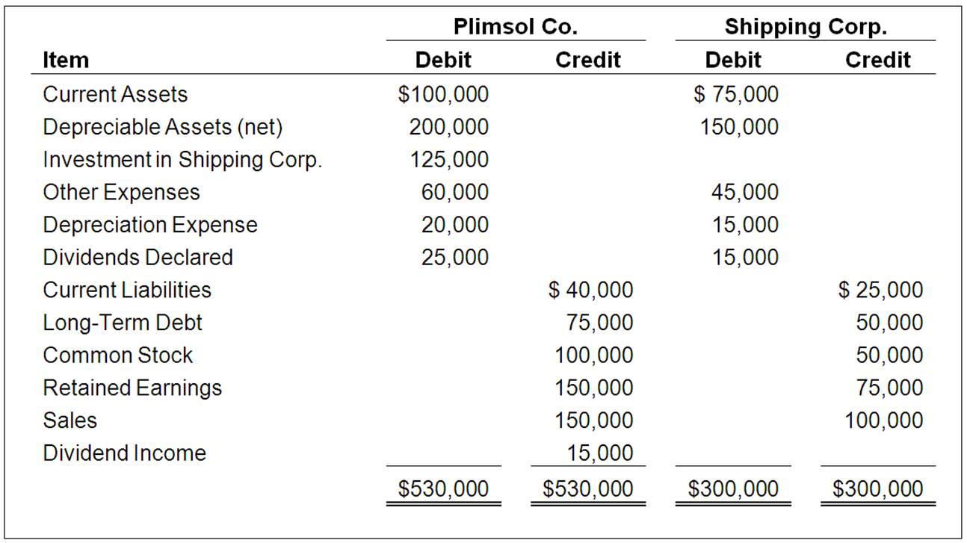  Based on the information provided, what amount of net income will be reported in the consolidated financial statements prepared on December 31, 20X4?  A. $100,000  B. $85,000  C. $110,000  D. $125,000

34. | On January 1, 20X4, Plimsol Company acquired 100 percent of Shipping Corporation's voting shares, at underlying book value. Plimsol uses the cost method in accounting for its investment in Shipping. Shipping's retained earnings was $75,000 on the date of acquisition. On December 31, 20X4, the trial balance data for the two companies are as follows:  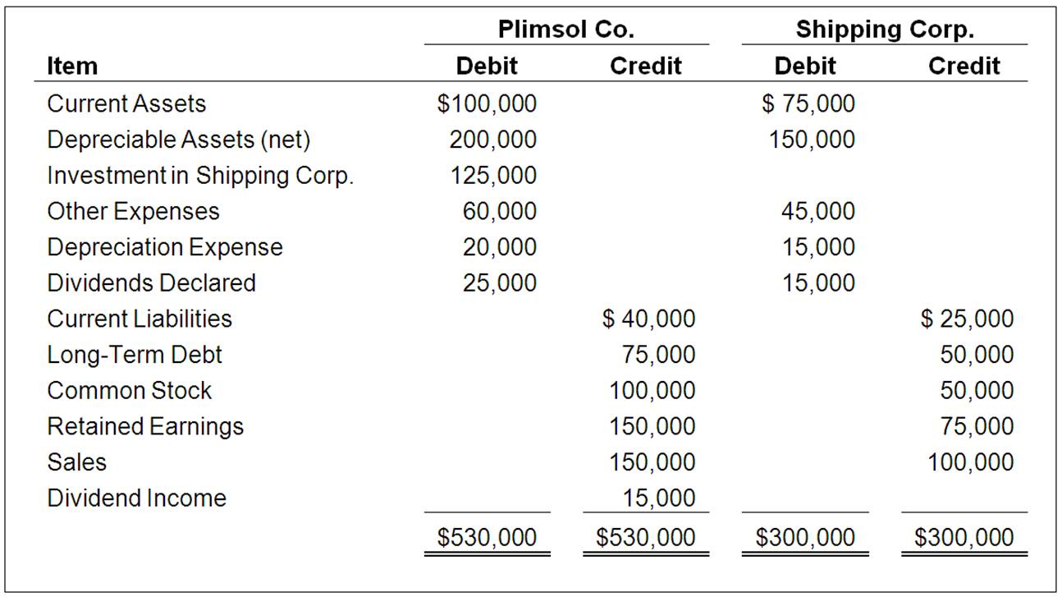  Based on the information provided, what amount of total assets will be reported in the consolidated balance sheet prepared on December 31, 20X4?  A. $425,000  B. $525,000  C. $650,000  D. $630,000

35. | On January 1, 20X4, Plimsol Company acquired 100 percent of Shipping Corporation's voting shares, at underlying book value. Plimsol uses the cost method in accounting for its investment in Shipping. Shipping's retained earnings was $75,000 on the date of acquisition. On December 31, 20X4, the trial balance data for the two companies are as follows:  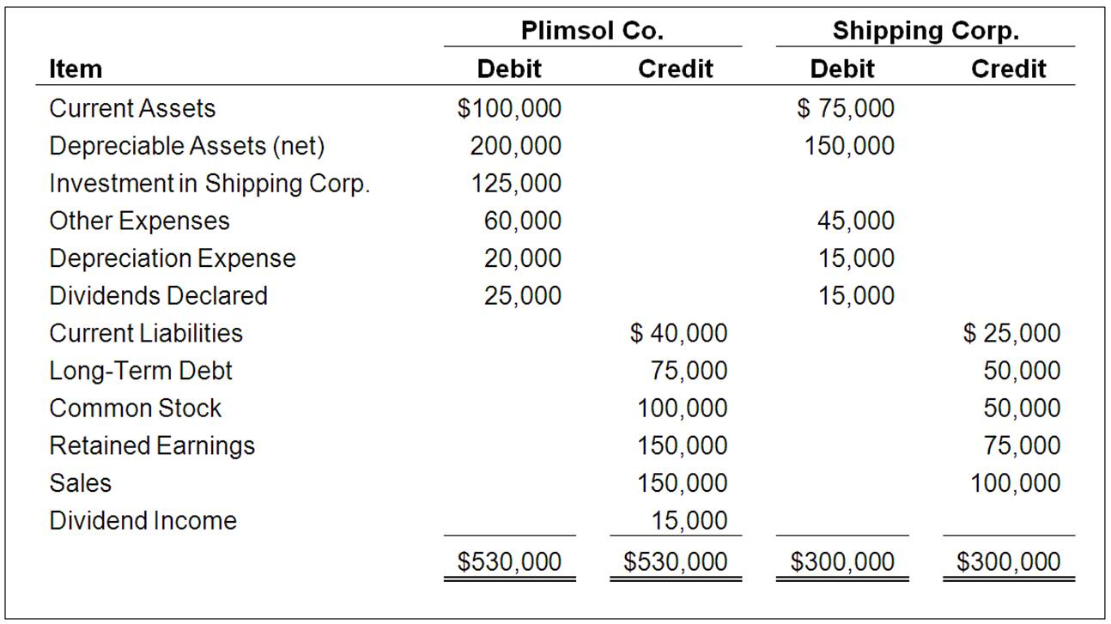  Based on the information provided, what amount of retained earnings will be reported in the consolidated balance sheet prepared on December 31, 20X4?  A. $235,000  B. $210,000  C. $310,000  D. $225,000

36. | On January 1, 20X4, Plimsol Company acquired 100 percent of Shipping Corporation's voting shares, at underlying book value. Plimsol uses the cost method in accounting for its investment in Shipping. Shipping's retained earnings was $75,000 on the date of acquisition. On December 31, 20X4, the trial balance data for the two companies are as follows:  Based on the information provided, what amount of total liabilities will be reported in the consolidated balance sheet prepared on December 31, 20X4?  A. $525,000  B. $115,000  C. $125,000  D. $190,000

37. | On January 1, 20X4, Plimsol Company acquired 100 percent of Shipping Corporation's voting shares, at underlying book value. Plimsol uses the cost method in accounting for its investment in Shipping. Shipping's retained earnings was $75,000 on the date of acquisition. On December 31, 20X4, the trial balance data for the two companies are as follows:  Based on the information provided, what amount of total stockholder's equity will be reported in the consolidated balance sheet prepared on December 31, 20X4?  A. $190,000  B. $335,000  C. $460,000  D. $310,000

38. | Parent Company purchased 100 percent of Son Inc. on January 1, 20X2 for $420,000. Son reported earnings of $82,000 and declared dividends of $4,000 during 20X2.  Based on the preceding information and assuming Parent uses the cost method to account for its investment in Son, what is the balance in Parent's Investment in Son account on December 31, 20X2, prior to consolidation?  A. $416,000  B. $420,000  C. $424,000  D. $498,000

39. | Parent Company purchased 100 percent of Son Inc. on January 1, 20X2 for $420,000. Son reported earnings of $82,000 and declared dividends of $4,000 during 20X2.  Based on the preceding information and assuming Parent uses the equity method to account for its investment in Son, what is the balance in Parent's Investment in Son account on December 31, 20X2, prior to consolidation?  A. $416,000  B. $420,000  C. $424,000  D. $498,000

Essay Questions
40. | A cash dividend returns assets to the stockholders while reducing corporate liquidity. Why are not all cash dividends considered to be "liquidating dividends"? In your response include a discussion of how an investor accounts for a liquidating dividend.

41. | Dear Corporation acquired 100 percent of the voting shares of Therry Inc. by issuing 10,000 new shares of $5 par value common stock with a $30 market value.  Required:  1. Which company is the parent and which is the subsidiary?  2. Define a subsidiary corporation.  3. Define a parent corporation.  4. Which entity prepares consolidated worksheet?  5. Why are elimination entries used?

42. | On January 1, 20X9, Zigma Company acquired 100 percent of Standard Company's common shares at underlying book value. Zigma uses the equity method in accounting for its ownership of Standard. On December 31, 20X9, the trial balances of the two companies are as follows:  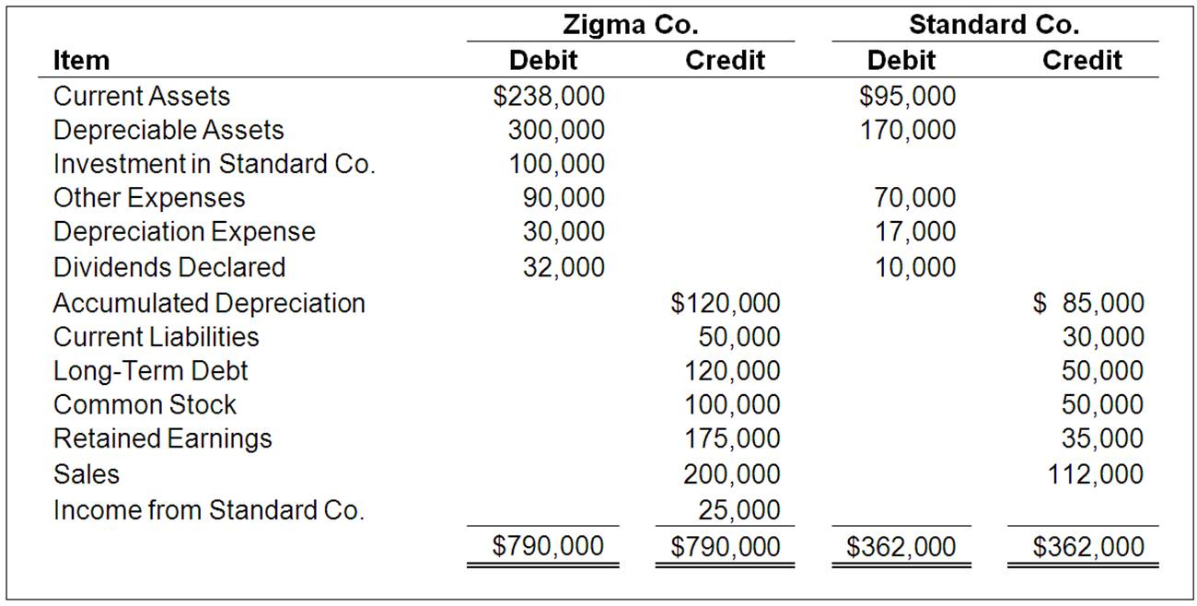  Required:  1. Prepare the eliminating entries needed as of December 31, 20X9, to complete a consolidation worksheet.  2. Prepare a three-part consolidation worksheet as of December 31, 20X9.

43. | In the absence of other evidence, common stock ownership of between 20 and 50 percent is viewed as indicating that the investor is able to exercise significant influence over the investee. What are some of the other factors that could constitute evidence of the ability to exercise significant influence?

44. | On January 1, 20X7, Plimsol Company acquired 100 percent of Shipping Corporation's voting shares, at underlying book value. Plimsol uses the cost method in accounting for its investment in Shipping. Shipping's reported retained earnings of $75,000 on the date of acquisition. The trial balances for Plimsol Company and Shipping Corporation as of December 31, 20X8, follow:  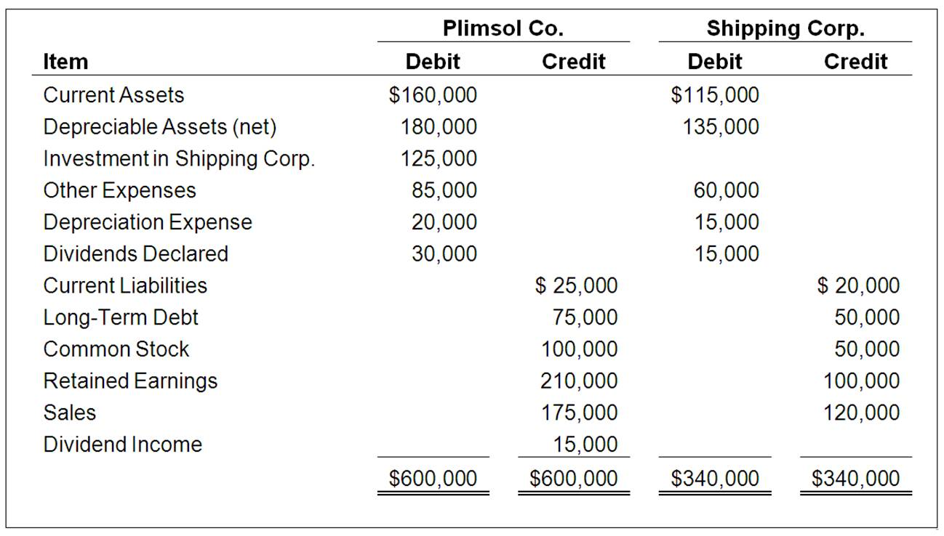  Required:  1. Provide all eliminating entries required to prepare a full set of consolidated statements for 20X8.  2. Prepare a three-part consolidation worksheet in good form as of December 31, 20X8.

Chapter 02 Reporting Intercorporate Investments and Consolidation of Wholly Owned Subsidiaries with No Differential Answer Key

Multiple Choice Questions
1. | If Push Company owned 51 percent of the outstanding common stock of Shove Company, which reporting method would be appropriate?  A. Cost method  B. Consolidation  C. Equity method  D. Merger method

AACSB: Reflective Thinking
AICPA FN: Reporting
Blooms: Remember
Difficulty: 1 Easy
Learning Objective: 02-01 Understand and explain how ownership and control can influence the accounting for investments in common stock.
Topic: Accounting for Investments in Common Stock

2. | Usually, an investment of 20 to 50 percent in another company's voting stock is reported under the:  A. cost method  B. equity method  C. full consolidation method  D. fair value method

AACSB: Reflective Thinking
AICPA FN: Reporting
Blooms: Remember
Difficulty: 1 Easy
Learning Objective: 02-01 Understand and explain how ownership and control can influence the accounting for investments in common stock.
Topic: Accounting for Investments in Common Stock

3. | From an investor's point of view, a liquidating dividend from an investee is:  A. a dividend declared by the investee in excess of its earnings in the current year  B. a dividend declared by the investee in excess of its earnings since acquisition by the investor  C. any dividend declared by the investee since acquisition  D. a dividend declared by the investee in excess of the investee's retained earnings

AACSB: Reflective Thinking
AICPA FN: Decision Making
Blooms: Remember
Difficulty: 1 Easy
Learning Objective: 02-02 Prepare journal entries using the cost method for accounting for investments.
Topic: The Cost Method

4. | Which of the following observations is NOT consistent with the cost method of accounting?  A. Investee dividends from earnings since acquisition by investor are treated as a reduction of the investment.  B. Investments are carried by the investor at historical cost.  C. No journal entry is made regarding the earnings of the investee.  D. It is consistent with the treatment normally accorded noncurrent assets.

AACSB: Reflective Thinking
AICPA FN: Decision Making
Blooms: Remember
Difficulty: 1 Easy
Learning Objective: 02-02 Prepare journal entries using the cost method for accounting for investments.
Topic: The Cost Method

5. | On January 1, 20X9 Athlon Company acquired 30 percent of the common stock of Opteron Corporation, at underlying book value. For the same year, Opteron reported net income of $55,000, which includes an extraordinary gain of 40,000. It did not pay any dividends during the year. By what amount would Athlon's investment in Opteron Corporation increase for the year, if Athlon used the equity method?  A. $0  B. $16,500  C. $4,500  D. $12,000

AACSB: Analytic
AICPA FN: Measurement
Blooms: Understand
Difficulty: 2 Medium
Learning Objective: 02-03 Prepare journal entries using the equity method for accounting for investments.
Section: Appendix 2A
Topic: Investor's Share of other Comprehensive Income
Topic: The Equity Method

6. | On January 1, 20X8, William Company acquired 30 percent of eGate Company's common stock, at underlying book value of $100,000. eGate has 100,000 shares of $2 par value, 5 percent cumulative preferred stock outstanding. No dividends are in arrears. eGate reported net income of $150,000 for 20X8 and paid total dividends of $72,000. William uses the equity method to account for this investment.  Based on the preceding information, what amount would William Company receive as dividends from eGate for the year?  A. $62,000  B. $21,600  C. $18,600  D. $54,000

AACSB: Analytic
AICPA FN: Measurement
Blooms: Apply
Difficulty: 3 Hard
Learning Objective: 02-03 Prepare journal entries using the equity method for accounting for investments.
Section: Appendix 2A
Topic: Additional Requirements of ASC 323-10
Topic: The Equity Method

7. | On January 1, 20X8, William Company acquired 30 percent of eGate Company's common stock, at underlying book value of $100,000. eGate has 100,000 shares of $2 par value, 5 percent cumulative preferred stock outstanding. No dividends are in arrears. eGate reported net income of $150,000 for 20X8 and paid total dividends of $72,000. William uses the equity method to account for this investment.  Based on the preceding information, what amount of investment income will William Company report from its investment in eGate for the year?  A. $45,000  B. $42,000  C. $62,000  D. $35,000

AACSB: Analytic
AICPA FN: Measurement
Blooms: Apply
Difficulty: 3 Hard
Learning Objective: 02-03 Prepare journal entries using the equity method for accounting for investments.
Section: Appendix 2A
Topic: Additional Requirements of ASC 323-10
Topic: The Equity Method

8. | On January 1, 20X8, William Company acquired 30 percent of eGate Company's common stock, at underlying book value of $100,000. eGate has 100,000 shares of $2 par value, 5 percent cumulative preferred stock outstanding. No dividends are in arrears. eGate reported net income of $150,000 for 20X8 and paid total dividends of $72,000. William uses the equity method to account for this investment.  Based on the preceding information, what amount would be reported by William Company as the balance in its investment account on December 31, 20X8?  A. $100,000  B. $123,400  C. $120,400  D. $142,000

AACSB: Analytic
AICPA FN: Measurement
Blooms: Apply
Difficulty: 3 Hard
Learning Objective: 02-03 Prepare journal entries using the equity method for accounting for investments.
Section: Appendix 2A
Topic: Additional Requirements of ASC 323-10
Topic: The Equity Method

9. | On January 1, 20X7, Yang Corporation acquired 25 percent of the outstanding shares of Spiel Corporation for $100,000 cash. Spiel Company reported net income of $75,000 and paid dividends of $30,000 for both 20X7 and 20X8. The fair value of shares held by Yang was $110,000 and $105,000 on December 31, 20X7 and 20X8 respectively.  Based on the preceding information, what amount will be reported by Yang as income from its investment in Spiel for 20X8, if it used the equity method of accounting?  A. $7,500  B. $11,250  C. $18,750  D. $26,250

AACSB: Analytic
AICPA FN: Measurement
Blooms: Apply
Difficulty: 2 Medium
Learning Objective: 02-03 Prepare journal entries using the equity method for accounting for investments.
Topic: The Equity Method

10. | On January 1, 20X7, Yang Corporation acquired 25 percent of the outstanding shares of Spiel Corporation for $100,000 cash. Spiel Company reported net income of $75,000 and paid dividends of $30,000 for both 20X7 and 20X8. The fair value of shares held by Yang was $110,000 and $105,000 on December 31, 20X7 and 20X8 respectively.  Based on the preceding information, what amount will be reported by Yang as balance in investment in Spiel on December 31, 20X8, if it used the equity method of accounting?  A. $108,250  B. $118,750  C. $100,000  D. $122,500

AACSB: Analytic
AICPA FN: Measurement
Blooms: Apply
Difficulty: 2 Medium
Learning Objective: 02-03 Prepare journal entries using the equity method for accounting for investments.
Topic: The Equity Method

11. | On January 1, 20X7, Yang Corporation acquired 25 percent of the outstanding shares of Spiel Corporation for $100,000 cash. Spiel Company reported net income of $75,000 and paid dividends of $30,000 for both 20X7 and 20X8. The fair value of shares held by Yang was $110,000 and $105,000 on December 31, 20X7 and 20X8 respectively.  Based on the preceding information, what amount will be reported by Yang as income from its investment in Spiel for 20X7 if it used the fair value option to account for its investment in Spiel?  A. $17,500  B. $12,500  C. $11,250  D. $7,500

AACSB: Analytic
AICPA FN: Measurement
Blooms: Apply
Difficulty: 3 Hard
Learning Objective: 02-05 Prepare journal entries using the fair value option.
Topic: The Fair Value Option

12. | On January 1, 20X7, Yang Corporation acquired 25 percent of the outstanding shares of Spiel Corporation for $100,000 cash. Spiel Company reported net income of $75,000 and paid dividends of $30,000 for both 20X7 and 20X8. The fair value of shares held by Yang was $110,000 and $105,000 on December 31, 20X7 and 20X8 respectively.  Based on the preceding information, what amount will be reported by Yang as income from its investment in Spiel for 20X8 if it used the fair value option to account for its investment in Spiel?  A. $11,250  B. $2,500  C. $6,250  D. $7,500

AACSB: Analytic
AICPA FN: Measurement
Blooms: Apply
Difficulty: 3 Hard
Learning Objective: 02-05 Prepare journal entries using the fair value option.
Topic: The Fair Value Option

13. | On January 1, 20X7, Yang Corporation acquired 25 percent of the outstanding shares of Spiel Corporation for $100,000 cash. Spiel Company reported net income of $75,000 and paid dividends of $30,000 for both 20X7 and 20X8. The fair value of shares held by Yang was $110,000 and $105,000 on December 31, 20X7 and 20X8 respectively.  Based on the preceding information, what amount will be reported by Yang as balance in investment in Spiel on December 31, 20X8, if it used the fair value option to account for its investment in Spiel?  A. $105,000  B. $118,750  C. $100,000  D. $122,500

AACSB: Analytic
AICPA FN: Measurement
Blooms: Apply
Difficulty: 2 Medium
Learning Objective: 02-05 Prepare journal entries using the fair value option.
Topic: The Fair Value Option

14. | A change from the cost method to the equity method of accounting for an investment in common stock resulting from an increase in the number of shares held by the investor requires:  A. only a footnote disclosure  B. that the cumulative amount of the change be shown as a line item on the income statement, net of tax  C. that the change be accounted for as an unrealized gain included in other comprehensive income  D. retroactive restatement as if the investor always had used the equity method

AACSB: Reflective Thinking
AICPA FN: Reporting
Blooms: Remember
Difficulty: 1 Easy
Learning Objective: 02-03 Prepare journal entries using the equity method for accounting for investments.
Topic: Changes in the Number of Shares Held

15. | Under the equity method of accounting for a stock investment, the investment initially should be recorded at:  A. cost  B. cost minus any differential  C. proportionate share of the fair value of the investee company's net assets  D. proportionate share of the book value of the investee company's net assets

AACSB: Reflective Thinking
AICPA FN: Decision Making
Blooms: Remember
Difficulty: 1 Easy
Learning Objective: 02-03 Prepare journal entries using the equity method for accounting for investments.
Topic: The Equity Method

16. | Which of the following observations is consistent with the equity method of accounting?  A. Dividends declared by the investee are treated as income by the investor.  B. It is used when the investor lacks the ability to exercise significant influence over the investee.  C. It may be used in place of consolidation.  D. Its primary use is in reporting nonsubsidiary investments.

AACSB: Reflective Thinking
AICPA FN: Decision Making
Blooms: Remember
Difficulty: 1 Easy
Learning Objective: 02-03 Prepare journal entries using the equity method for accounting for investments.
Topic: The Equity Method

17. | Note: This is a Kaplan CPA Review Question  On July 1, 20X4, Denver Corp. purchased 3,000 shares of Eagle Co.'s 10,000 outstanding shares of common stock for $20 per share. On December 15, 20X4, Eagle paid $40,000 in dividends to its common stockholders. Eagle's net income for the year ended December 31, 20X4, was $120,000, earned evenly throughout the year. In its 20X4 income statement, what amount of income from this investment should Denver report?  A. $12,000  B. $36,000  C. $18,000  D. $6,000

AACSB: Analytic
AICPA FN: Measurement
Blooms: Apply
Difficulty: 3 Hard
Learning Objective: 02-03 Prepare journal entries using the equity method for accounting for investments.
Topic: The Equity Method

18. | Note: This is a Kaplan CPA Review Question  On January 2, 20X5, Well Co. purchased 10 percent of Rea, Inc.'s outstanding common shares for $400,000. Well is the largest single shareholder in Rea, and Well's officers are a majority on Rea's board of directors. As a result, Well is able to exercise significant influence over Rea. Rea reported net income of $500,000 for 20X5, and paid dividends of $150,000. In its December 31, 20X5, balance sheet, what amount should Well report as investment in Rea?  A. $385,000  B. $450,000  C. $400,000  D. $435,000

AACSB: Analytic
AICPA FN: Measurement
Blooms: Apply
Difficulty: 2 Medium
Learning Objective: 02-03 Prepare journal entries using the equity method for accounting for investments.
Topic: The Equity Method

19. | Note: This is a Kaplan CPA Review Question  The Jamestown Corporation (Jamestown) reported net income for the current year of $200,000 and paid cash dividends of $30,000. The Stadium Company (Stadium) holds 22 percent of the outstanding voting stock of Jamestown. However, another corporation holds the other 78 percent ownership and does not take Stadium's wants and wishes into consideration when making financing and operating decisions for Jamestown. What investment income should Stadium recognize for the current year?  A. $6,600  B. $0  C. $44,000  D. $50,600

AACSB: Analytic
AICPA FN: Measurement
Blooms: Apply
Difficulty: 3 Hard
Learning Objective: 02-03 Prepare journal entries using the equity method for accounting for investments.
Topic: The Equity Method

20. | Note: This is a Kaplan CPA Review Question  Grant, Inc. acquired 30 percent of South Co.'s voting stock for $200,000 on January 2, 20X4. Grant's 30 percent interest in South gave Grant the ability to exercise significant influence over South's operating and financial policies. During 20X4, South earned $80,000 and paid dividends of $50,000. South reported earnings of $100,000 for the six months ended June 30, 20X5, and $200,000 for the year ended December 31, 20X5. On July 1, 20X5, Grant sold half of its stock in South for $150,000 cash. South paid dividends of $60,000 on October 1, 20X5.  What amount should Grant include in its 20X4 income statement as a result of the investment?  A. $15,000  B. $24,000  C. $50,000  D. $80,000

AACSB: Analytic
AICPA FN: Measurement
Blooms: Apply
Difficulty: 2 Medium
Learning Objective: 02-03 Prepare journal entries using the equity method for accounting for investments.
Topic: The Equity Method

21. | Note: This is a Kaplan CPA Review Question  Grant, Inc. acquired 30 percent of South Co.'s voting stock for $200,000 on January 2, 20X4. Grant's 30 percent interest in South gave Grant the ability to exercise significant influence over South's operating and financial policies. During 20X4, South earned $80,000 and paid dividends of $50,000. South reported earnings of $100,000 for the six months ended June 30, 20X5, and $200,000 for the year ended December 31, 20X5. On July 1, 20X5, Grant sold half of its stock in South for $150,000 cash. South paid dividends of $60,000 on October 1, 20X5.  In Grant's December 31, 20X4, balance sheet, what should be the carrying amount of this investment?  A. $224,000  B. $200,000  C. $234,000  D. $209,000

AACSB: Analytic
AICPA FN: Measurement
Blooms: Apply
Difficulty: 2 Medium
Learning Objective: 02-03 Prepare journal entries using the equity method for accounting for investments.
Topic: The Equity Method

22. | Note: This is a Kaplan CPA Review Question  Grant, Inc. acquired 30 percent of South Co.'s voting stock for $200,000 on January 2, 20X4. Grant's 30 percent interest in South gave Grant the ability to exercise significant influence over South's operating and financial policies. During 20X4, South earned $80,000 and paid dividends of $50,000. South reported earnings of $100,000 for the six months ended June 30, 20X5, and $200,000 for the year ended December 31, 20X5. On July 1, 20X5, Grant sold half of its stock in South for $150,000 cash. South paid dividends of $60,000 on October 1, 20X5.  In its 20X5 income statement, what amount should Grant report as a gain from the sale of half of its investment?  A. $35,000  B. $24,500  C. $30,500  D. $45,500

AACSB: Analytic
AICPA FN: Measurement
Blooms: Apply
Difficulty: 3 Hard
Learning Objective: 02-03 Prepare journal entries using the equity method for accounting for investments.
Topic: Changes in the Number of Shares Held
Topic: The Equity Method

23. | What portion of the subsidiary stockholders' equity account balances should be eliminated in preparing the consolidated balance sheet?  A. Common stock  B. Additional paid-in capital  C. Retained Earnings  D. All of the balances are eliminated

AACSB: Reflective Thinking
AICPA FN: Decision Making
Blooms: Remember
Difficulty: 1 Easy
Learning Objective: 02-06 Make calculations and prepare basic elimination entries for a simple consolidation.
Topic: Overview of the Consolidation Process

24. | The consolidation process consists of all the following except:  A. combining the financial statements of two or more legally separate companies  B. eliminating intercompany transactions and holdings  C. closing the individual subsidiary's revenue and expense accounts into the parent's retained earnings  D. combining the accounts of separate companies, creating a single set of financial statements

AACSB: Reflective Thinking
AICPA FN: Decision Making
Blooms: Remember
Difficulty: 1 Easy
Learning Objective: 02-06 Make calculations and prepare basic elimination entries for a simple consolidation.
Topic: Overview of the Consolidation Process

25. | Beta Company acquired 100 percent of the voting common shares of Standard Video Corporation, its bitter rival, by issuing bonds with a par value and fair value of $150,000. Immediately prior to the acquisition, Beta reported total assets of $500,000, liabilities of $280,000, and stockholders' equity of $220,000. At that date, Standard Video reported total assets of $400,000, liabilities of $250,000, and stockholders' equity of $150,000. Included in Standard's liabilities was an account payable to Beta in the amount of $20,000, which Beta included in its accounts receivable.  Based on the preceding information, what amount of total assets did Beta report in its balance sheet immediately after the acquisition?  A. $500,000  B. $650,000  C. $750,000  D. $900,000

AACSB: Analytic
AICPA FN: Measurement
Blooms: Apply
Difficulty: 2 Medium
Learning Objective: 02-07 Prepare a consolidation worksheet.
Topic: Consolidation Worksheets

26. | Beta Company acquired 100 percent of the voting common shares of Standard Video Corporation, its bitter rival, by issuing bonds with a par value and fair value of $150,000. Immediately prior to the acquisition, Beta reported total assets of $500,000, liabilities of $280,000, and stockholders' equity of $220,000. At that date, Standard Video reported total assets of $400,000, liabilities of $250,000, and stockholders' equity of $150,000. Included in Standard's liabilities was an account payable to Beta in the amount of $20,000, which Beta included in its accounts receivable.  Based on the preceding information, what amount of total assets was reported in the consolidated balance sheet immediately after acquisition?  A. $650,000  B. $880,000  C. $920,000  D. $750,000

AACSB: Analytic
AICPA FN: Measurement
Blooms: Apply
Difficulty: 3 Hard
Learning Objective: 02-07 Prepare a consolidation worksheet.
Topic: Consolidation Worksheets

27. | Beta Company acquired 100 percent of the voting common shares of Standard Video Corporation, its bitter rival, by issuing bonds with a par value and fair value of $150,000. Immediately prior to the acquisition, Beta reported total assets of $500,000, liabilities of $280,000, and stockholders' equity of $220,000. At that date, Standard Video reported total assets of $400,000, liabilities of $250,000, and stockholders' equity of $150,000. Included in Standard's liabilities was an account payable to Beta in the amount of $20,000, which Beta included in its accounts receivable.  Based on the preceding information, what amount of total liabilities was reported in the consolidated balance sheet immediately after acquisition?  A. $500,000  B. $530,000  C. $280,000  D. $660,000

AACSB: Analytic
AICPA FN: Measurement
Blooms: Apply
Difficulty: 3 Hard
Learning Objective: 02-07 Prepare a consolidation worksheet.
Topic: Consolidation Worksheets

28. | Beta Company acquired 100 percent of the voting common shares of Standard Video Corporation, its bitter rival, by issuing bonds with a par value and fair value of $150,000. Immediately prior to the acquisition, Beta reported total assets of $500,000, liabilities of $280,000, and stockholders' equity of $220,000. At that date, Standard Video reported total assets of $400,000, liabilities of $250,000, and stockholders' equity of $150,000. Included in Standard's liabilities was an account payable to Beta in the amount of $20,000, which Beta included in its accounts receivable.  Based on the preceding information, what amount of stockholders' equity was reported in the consolidated balance sheet immediately after acquisition?  A. $220,000  B. $150,000  C. $370,000  D. $350,000

AACSB: Analytic
AICPA FN: Measurement
Blooms: Apply
Difficulty: 3 Hard
Learning Objective: 02-07 Prepare a consolidation worksheet.
Topic: Consolidation Worksheets

29. | Parent Co. purchases 100 percent of Son Company on January 1, 20X1, when Parent's retained earnings balance is $520,000 and Son's is $150,000. During 20X1, Son reports $15,000 of net income and declares $6,000 of dividends. Parent reports $105,000 of separate operating earnings plus $15,000 of equity-method income from its 100 percent interest in Son; Parent declares dividends of $40,000.  Based on the preceding information, what is Parent's post-closing retained earnings balance on December 31, 20X1?  A. $485,000  B. $505,000  C. $525,000  D. $600,000

AACSB: Analytic
AICPA FN: Measurement
Blooms: Understand
Difficulty: 2 Medium
Learning Objective: 02-07 Prepare a consolidation worksheet.
Topic: Consolidation Subsequent to Acquisition

30. | Parent Co. purchases 100 percent of Son Company on January 1, 20X1, when Parent's retained earnings balance is $520,000 and Son's is $150,000. During 20X1, Son reports $15,000 of net income and declares $6,000 of dividends. Parent reports $105,000 of separate operating earnings plus $15,000 of equity-method income from its 100 percent interest in Son; Parent declares dividends of $40,000.  Based on the preceding information, what is Son's post-closing retained earnings balance on December 31, 20X1:  A. $141,000  B. $150,000  C. $159,000  D. $165,000

AACSB: Analytic
AICPA FN: Measurement
Blooms: Understand
Difficulty: 1 Easy
Learning Objective: 02-07 Prepare a consolidation worksheet.
Topic: Consolidation Subsequent to Acquisition

31. | Parent Co. purchases 100 percent of Son Company on January 1, 20X1, when Parent's retained earnings balance is $520,000 and Son's is $150,000. During 20X1, Son reports $15,000 of net income and declares $6,000 of dividends. Parent reports $105,000 of separate operating earnings plus $15,000 of equity-method income from its 100 percent interest in Son; Parent declares dividends of $40,000.  Based on the preceding information, what is the consolidated retained earnings balance on December 31, 20X1?  A. $470,000  B. $585,000  C. $600,000  D. $759,000

AACSB: Analytic
AICPA FN: Measurement
Blooms: Understand
Difficulty: 2 Medium
Learning Objective: 02-07 Prepare a consolidation worksheet.
Topic: Consolidation Subsequent to Acquisition

32. | The main guidance on equity-method reporting, found in ASC 323 and 325 requires all of the following except:  A. the investor's share of the investee's extraordinary items should be reported  B. the investor's share of the investee's prior-period adjustments should be reported  C. continued use of the equity-method even if continued losses results in a zero or negative balance in the investment account  D. preferred dividends of the investee should be deducted from net income before the investor computes its share of investee earnings

AACSB: Reflective Thinking
AICPA FN: Reporting
Blooms: Remember
Difficulty: 1 Easy
Section: Appendix 2A
Topic: Additional Requirements of ASC 323-10

33. | On January 1, 20X4, Plimsol Company acquired 100 percent of Shipping Corporation's voting shares, at underlying book value. Plimsol uses the cost method in accounting for its investment in Shipping. Shipping's retained earnings was $75,000 on the date of acquisition. On December 31, 20X4, the trial balance data for the two companies are as follows:  Based on the information provided, what amount of net income will be reported in the consolidated financial statements prepared on December 31, 20X4?  A. $100,000  B. $85,000  C. $110,000  D. $125,000

AACSB: Analytic
AICPA FN: Measurement
Blooms: Understand
Difficulty: 2 Medium
Section: Appendix 2B
Topic: Consolidation and the Cost Method

34. | On January 1, 20X4, Plimsol Company acquired 100 percent of Shipping Corporation's voting shares, at underlying book value. Plimsol uses the cost method in accounting for its investment in Shipping. Shipping's retained earnings was $75,000 on the date of acquisition. On December 31, 20X4, the trial balance data for the two companies are as follows:  Based on the information provided, what amount of total assets will be reported in the consolidated balance sheet prepared on December 31, 20X4?  A. $425,000  B. $525,000  C. $650,000  D. $630,000

AACSB: Analytic
AICPA FN: Measurement
Blooms: Understand
Difficulty: 2 Medium
Section: Appendix 2B
Topic: Consolidation and the Cost Method

35. | On January 1, 20X4, Plimsol Company acquired 100 percent of Shipping Corporation's voting shares, at underlying book value. Plimsol uses the cost method in accounting for its investment in Shipping. Shipping's retained earnings was $75,000 on the date of acquisition. On December 31, 20X4, the trial balance data for the two companies are as follows:  Based on the information provided, what amount of retained earnings will be reported in the consolidated balance sheet prepared on December 31, 20X4?  A. $235,000  B. $210,000  C. $310,000  D. $225,000

AACSB: Analytic
AICPA FN: Measurement
Blooms: Apply
Difficulty: 3 Hard
Section: Appendix 2B
Topic: Consolidation and the Cost Method

36. | On January 1, 20X4, Plimsol Company acquired 100 percent of Shipping Corporation's voting shares, at underlying book value. Plimsol uses the cost method in accounting for its investment in Shipping. Shipping's retained earnings was $75,000 on the date of acquisition. On December 31, 20X4, the trial balance data for the two companies are as follows:  Based on the information provided, what amount of total liabilities will be reported in the consolidated balance sheet prepared on December 31, 20X4?  A. $525,000  B. $115,000  C. $125,000  D. $190,000

AACSB: Analytic
AICPA FN: Measurement
Blooms: Understand
Difficulty: 2 Medium
Section: Appendix 2B
Topic: Consolidation and the Cost Method

37. | On January 1, 20X4, Plimsol Company acquired 100 percent of Shipping Corporation's voting shares, at underlying book value. Plimsol uses the cost method in accounting for its investment in Shipping. Shipping's retained earnings was $75,000 on the date of acquisition. On December 31, 20X4, the trial balance data for the two companies are as follows:  Based on the information provided, what amount of total stockholder's equity will be reported in the consolidated balance sheet prepared on December 31, 20X4?  A. $190,000  B. $335,000  C. $460,000  D. $310,000

AACSB: Analytic
AICPA FN: Measurement
Blooms: Apply
Difficulty: 3 Hard
Section: Appendix 2B
Topic: Consolidation and the Cost Method

38. | Parent Company purchased 100 percent of Son Inc. on January 1, 20X2 for $420,000. Son reported earnings of $82,000 and declared dividends of $4,000 during 20X2.  Based on the preceding information and assuming Parent uses the cost method to account for its investment in Son, what is the balance in Parent's Investment in Son account on December 31, 20X2, prior to consolidation?  A. $416,000  B. $420,000  C. $424,000  D. $498,000

AACSB: Analytic
AICPA FN: Measurement
Blooms: Understand
Difficulty: 2 Medium
Section: Appendix 2B
Topic: Consolidation and the Cost Method

39. | Parent Company purchased 100 percent of Son Inc. on January 1, 20X2 for $420,000. Son reported earnings of $82,000 and declared dividends of $4,000 during 20X2.  Based on the preceding information and assuming Parent uses the equity method to account for its investment in Son, what is the balance in Parent's Investment in Son account on December 31, 20X2, prior to consolidation?  A. $416,000  B. $420,000  C. $424,000  D. $498,000

AACSB: Analytic
AICPA FN: Measurement
Blooms: Understand
Difficulty: 2 Medium
Section: Appendix 2B
Topic: Consolidation and the Cost Method

Essay Questions
40. | A cash dividend returns assets to the stockholders while reducing corporate liquidity. Why are not all cash dividends considered to be "liquidating dividends"? In your response include a discussion of how an investor accounts for a liquidating dividend.  A dividend represents earnings of a company being returned to its shareholders. A liquidating dividend occurs when an investee declares dividends in excess of the earnings from the purchase date of the investment. An individual investor must treat a liquidating dividend associated with its investment as a return of capital and reduce the investment account accordingly. It is possible for blocks of stock acquired at different times to have different amounts associated with a potential liquidating dividend.

AACSB: Communication
AICPA FN: Decision Making
Blooms: Understand
Difficulty: 2 Medium
Learning Objective: 02-02 Prepare journal entries using the cost method for accounting for investments.
Topic: The Cost Method

41. | Dear Corporation acquired 100 percent of the voting shares of Therry Inc. by issuing 10,000 new shares of $5 par value common stock with a $30 market value.  Required:  1. Which company is the parent and which is the subsidiary?  2. Define a subsidiary corporation.  3. Define a parent corporation.  4. Which entity prepares consolidated worksheet?  5. Why are elimination entries used?  1. Dear is the parent and Therry is the subsidiary.  2. A subsidiary is an entity in which another entity, the parent company, holds a controlling financial interest.  3. A parent company holds a controlling financial interest in another company.  4. The parent, Dear, prepares the consolidated worksheet.  5. Elimination entries are used to adjust the amounts reported by the parent and all of the subsidiaries to reflect the amounts that would be reported if the separate legal entities were a single company.

AACSB: Reflective Thinking
AICPA FN: Decision Making
Blooms: Understand
Difficulty: 1 Easy
Learning Objective: 02-06 Make calculations and prepare basic elimination entries for a simple consolidation.
Topic: Overview of the Consolidation Process

42. | On January 1, 20X9, Zigma Company acquired 100 percent of Standard Company's common shares at underlying book value. Zigma uses the equity method in accounting for its ownership of Standard. On December 31, 20X9, the trial balances of the two companies are as follows:  Required:  1. Prepare the eliminating entries needed as of December 31, 20X9, to complete a consolidation worksheet.  2. Prepare a three-part consolidation worksheet as of December 31, 20X9.  1.  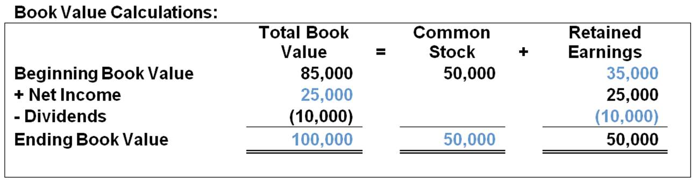  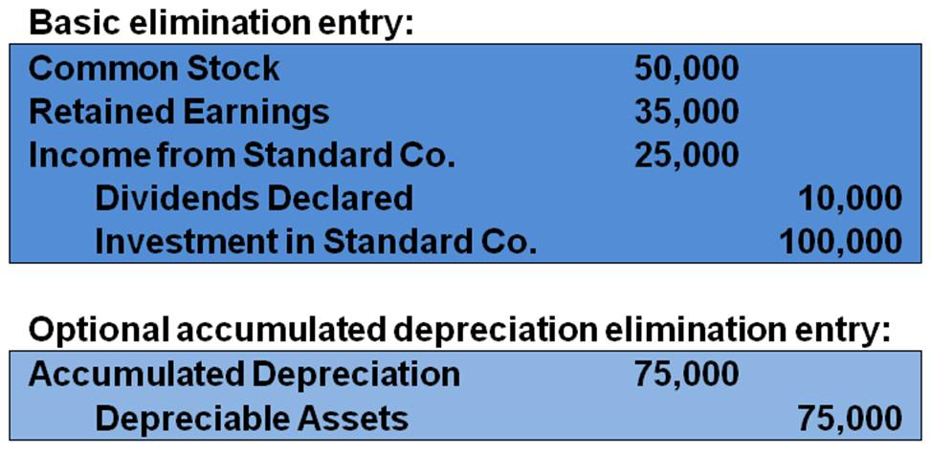  (T-Accounts not required)  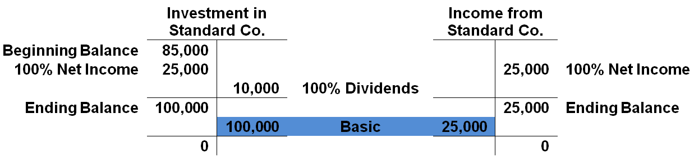  2.  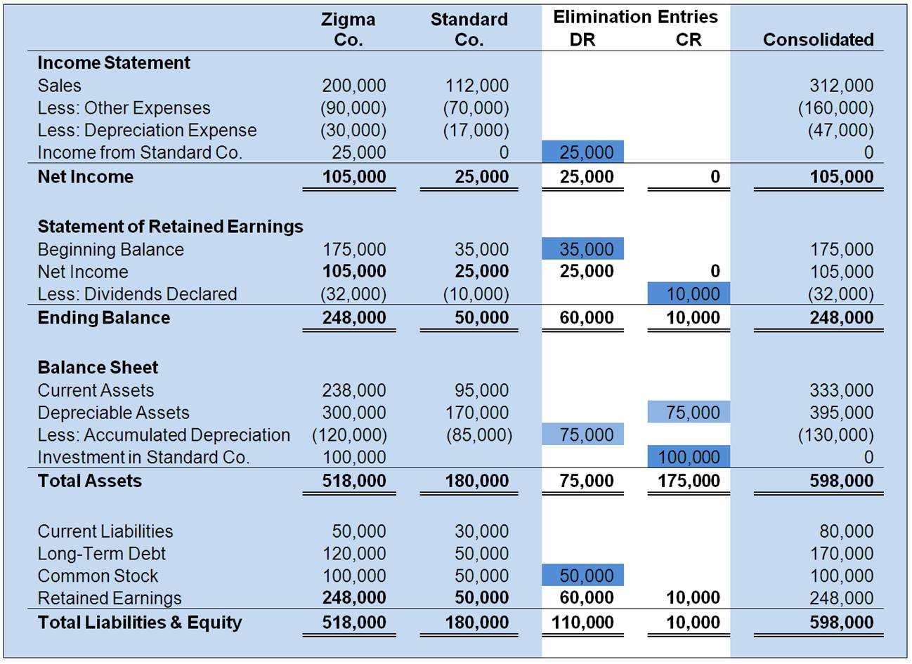

AACSB: Analytic
AICPA FN: Measurement
Blooms: Apply
Difficulty: 3 Hard
Learning Objective: 02-07 Prepare a consolidation worksheet.
Topic: Consolidation Worksheets

43. | In the absence of other evidence, common stock ownership of between 20 and 50 percent is viewed as indicating that the investor is able to exercise significant influence over the investee. What are some of the other factors that could constitute evidence of the ability to exercise significant influence?  APB stated that these include:  1. Representation on board of directors  2. Participation in policy making  3. Material intercompany transactions  4. Interchange of managerial personnel  5. Technological dependency  6. Size of investment in relation to concentration of other shareholdings

AACSB: Communication
AICPA FN: Decision Making
Blooms: Remember
Difficulty: 1 Easy
Section: Appendix 2A
Topic: Determination of Significant Influence

44. | On January 1, 20X7, Plimsol Company acquired 100 percent of Shipping Corporation's voting shares, at underlying book value. Plimsol uses the cost method in accounting for its investment in Shipping. Shipping's reported retained earnings of $75,000 on the date of acquisition. The trial balances for Plimsol Company and Shipping Corporation as of December 31, 20X8, follow:  Required:  1. Provide all eliminating entries required to prepare a full set of consolidated statements for 20X8.  2. Prepare a three-part consolidation worksheet in good form as of December 31, 20X8.  1.  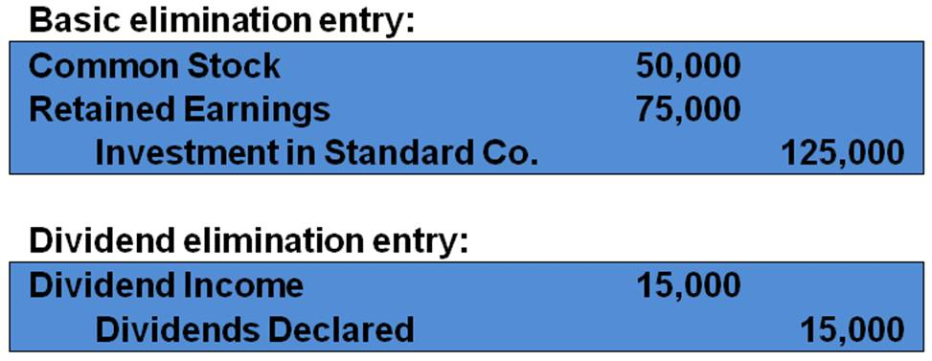  2.  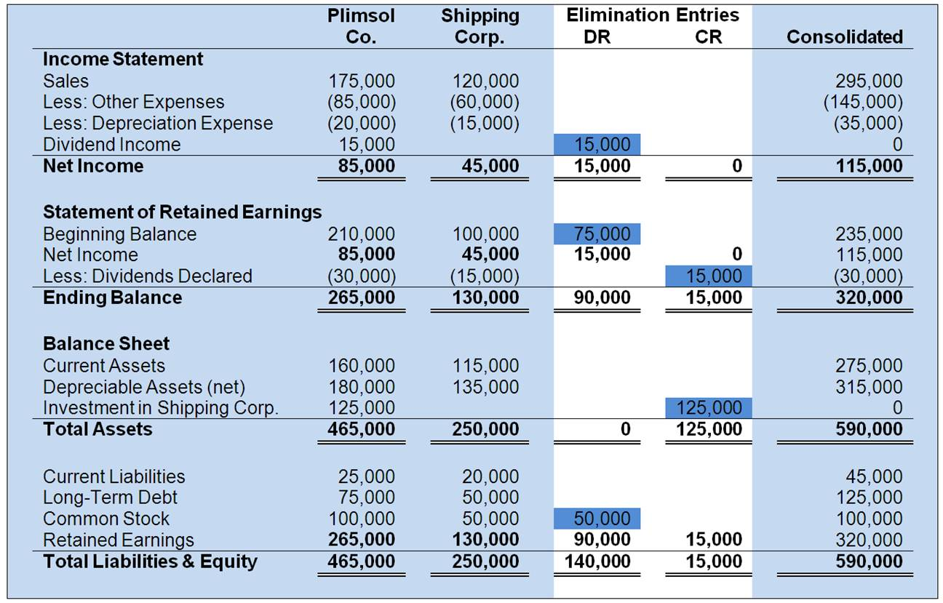

AACSB: Analytic
AICPA FN: Measurement
Blooms: Apply
Difficulty: 3 Hard
Section: Appendix 2B
Topic: Consolidation and the Cost Method

