Student name:__________

1. Minerals are organic elements extracted from the soil by plants.

* true
* false

1. Molecules composed of two or more atoms are called compounds.

* true
* false

1. Hydrogen, deuterium, and tritium are three isotopes of hydrogen.

* true
* false

1. Potassium, sodium, and chlorine are trace elements.

* true
* false

1. Ionic bonds break apart in water more easily than covalent bonds do.

* true
* false

1. A solution is a mixture of two or more substances that are physically blended but *not* chemically combined.

* true
* false

1. The pH of blood plasma is approximately 7.4, which is slightly acidic.

* true
* false

1. The high heat capacity of water makes it a very ineffective coolant.

* true
* false

1. In an exchange reaction, covalent bonds are broken and new covalent bonds are formed.

* true
* false

1. Chemical reactions in which larger molecules are broken down into smaller ones are called catabolic reactions.

* true
* false

1. The opposite of a dehydration synthesis reaction is a hydrolysis reaction.

* true
* false

1. Unsaturated fatty acids have as much hydrogen as they can carry.

* true
* false

1. A dipeptide is a molecule with two peptide bonds.

* true
* false

1. All amino acids have both a carboxyl group and an amino group attached to a central carbon.

* true
* false

1. ATP is the body's most important form of long-term energy storage.

* true
* false

1. The most abundant element in the human body, by weight, is_________.

nitrogen

hydrogen

carbon

oxygen

calcium

1. Sodium has an atomic number of 11 and an atomic mass of 23. Sodium has_________.

12 neutrons and 11 protons

12 protons and 11 neutrons

12 electrons and 11 neutrons

12 protons and 11 electrons

12 electrons and 11 protons

1. The chemical properties of an atom are determined by its_________.

protons

electrons

neutrons

protons and neutrons

particles

1. Na (atomic no. 11) reacts with Cl (atomic no. 17) to become stable. In the reaction, Na will_________, while Cl will_________.

accept one electron; give up one electron

give up one proton; accept one proton

share one electron with chlorine; share one electron with sodium

become an anion; become a cation

give up one electron; accept one electron

1. Oxygen has an atomic number of 8 and an atomic mass of 16. How many valence electrons does it have?

2

4

6

8

16

1. Oxygen has an atomic number of eight. When two oxygen atoms come together, they form a(n)_________ bond.

hydrogen

nonpolar covalent

polar covalent

ionic

Van der Waals

1. When table salt, sodium chloride (NaCl), is placed in water_________.

1formula1.mmland1formula2.mmlform ionic bonds with each other

1formula1.mmland1formula2.mmlform polar covalent bonds with each other

1formula1.mmland1formula2.mmlform hydrogen bonds with water

ionic bonds between1formula1.mmland1formula2.mmlare broken

1formula1.mmland1formula2.mmlbecome separated by their Van der Waals forces

1. The bonding properties of an atom are determined by its_________.

electrons

protons

positrons

neutrons

photons

1. What type of bond attracts one water molecule to another?

An ionic bond

A peptide bond

A hydrogen bond

A covalent bond

A hydrolytic bond

1. Which of these is a cation?

1formula3.mml

K+

Na+

1formula4.mml

1formula5.mml

1. _________ account for 98.5% of the body's weight.

Carbon, oxygen, hydrogen, sodium, potassium, and chlorine

Carbon, oxygen, iron, sodium, potassium, and chlorine

Carbon, nitrogen, hydrogen, sodium, potassium, and chlorine

Carbon, oxygen, hydrogen, nitrogen, sodium, and potassium

Carbon, oxygen, hydrogen, nitrogen, calcium, and phosphorus

1. _________ differ from one another in their number of neutrons and atomic mass.

Cations

Anions

Isotopes

Electrolytes

Free radicals

1. When jumping into water you notice resistance. This resistance is caused by water's_________.

adhesiveness

cohesiveness

hydrophobic tension

hydrophilic tension

osmotic equilibrium

1. Which of these is hydrophobic?

Glucose

1formula6.mml

1formula7.mml

Water

Fat

1. Blood contains NaCl, protein, and cells. The NaCl is in a(n)_________, the protein is in a(n)_________, and the cells are in a_________.

emulsion; solution; suspension

solvent; emulsion; colloid

colloid; suspension; solution

suspension; colloid; solution

solution; colloid; suspension

1. Which of these is the most appropriate to express the number of molecules per volume?

Molarity

Volume

Percentage

Weight per volume

Milliequivalents per liter

1. A solution with pH 4 has_________ the1formula8.mmlconcentration of a solution with pH 8.

½

2 times

4 times

10,000 times

1/10,000

1. Which of these has the highest2formula8.mmlconcentration?

Lemon juice, pH = 2.3

Red wine, pH = 3.2

Tomato juice, pH = 4.7

Saliva, pH = 6.6

Household ammonia, pH = 10.8

1. In a workout your muscle cells produce lactate, yet you maintain a constant blood pH because_________.

metabolic acids are neutralized in muscle cells before released into the blood

metabolic bases are produced at the same rate by muscle cells to neutralize the acids

the respiratory system removes excess3formula8.mmlfrom the blood before the pH is lowered

the body contains chemicals called buffers that resist changes in pH

endothelial cells secrete excess3formula8.mmlto prevent a decrease in pH

1. A solution that resists a change in pH when an acid or base is added to it is a(n)_________.

buffer

catalyst

reducing agent

oxidizing agent

colloid

1. A chemical reaction that removes electrons from an atom is called a(n)_________ reaction.

reduction

condensation

hydrolysis

anabolic

oxidation

1. The breakdown of glycogen (an energy-storage compound) is an example of a(n)_________ reaction.

exergonic

endergonic

exchange

synthesis

equilibrium

1. The most relevant free energy in human physiology is the energy stored in_________.

electrolytes ionized in water

free radicals with an odd number of electrons

radioisotopes

the chemical bonds of organic molecules

Van der Waals forces

1. Potential energy stored in bonds is released as_________ energy.

electromagnetic

electrical

chemical

heat

kinetic

1. The breakdown of glucose to yield carbon dioxide, oxygen, and ATP can be described as_________.

anabolic and endergonic

catabolic and exergonic

anabolic and exergonic

catabolic and endergonic

anabolic and exothermic

1. Which one of the following would *not* increase the rate of a reaction?

An increase in reactant concentrations

A rise in temperature

The presence of a catalyst

The presence of an enzyme

A decrease in reactant concentrations

1. Which of the following terms encompasses all of the other ones?

Catabolism

Anabolism

Metabolism

Oxidation reactions

Reduction reactions

1. The breakdown of starch by digestive enzymes into glucose molecules is a(n)_________ reaction.

synthesis

decomposition

exchange

anabolic

reduction

1. Which of the following equations depicts an exchange reaction?

AB → A + B

A + B → AB

AB + CD → AC + BD

AB → A- + B+

A + B → AB → C + D

1. Which of these functional groups contains nitrogen?

Carboxyl group

Methyl group

Hydroxyl group

Amino group

Phosphate group

1. Which of the following is *not* an organic compound?

1formula9.mml

1formula10.mml

1formula11.mml

1formula12.mml

1. A_________ reaction breaks a_________ down into its monomers.

hydrolysis; polymer

dehydration synthesis; molecule

dehydration synthesis; polymer

polymer; molecule

condensation; reactant

1. The formula of an amino group is_________; the formula of a carboxyl group is_________.

-COOH; -OH

1formula13.mml

-OH; -SH

1formula14.mml

1formula15.mml

1. Table sugar is a disaccharide called_________ and is made up of the monomer(s)_________.

maltose; glucose and sucrose

sucrose; glucose and fructose

lactose; glucose and galactose

glycogen; glucose and fructose

glucose; galactose and fructose

1. Which of the following is a disaccharide?

Galactose

Lactose

Glucose

Fructose

Amylose

1. _________ is a monosaccharide, whereas_________ is a polysaccharide.

Fructose; sucrose

Galactose; maltose

Lactose; glycogen

Glucose; starch

Cellulose; glucose

1. In general,_________ have a 2:1 ratio of hydrogen to oxygen.

enzymes

proteins

lipids

carbohydrates

nucleic acids

1. Proteoglycans are composed of_________.

carbohydrates and fats

nucleic acids and fats

carbohydrates and proteins

proteins and fats

nucleic acids and proteins

1. Triglycerides consist of a 3-carbon compound called_________ bound to three_________.

pyruvate; fatty acids

lactate; glycerols

eicosanoid; steroids

glycerol; fatty acids

sterol; fatty acids

1. _________ are major components of cell membranes, and are said to be_________.

Triglycerides; hydrophobic

Steroids; hydrophilic

Bile acids; fat-soluble

Eicosanoids; water-soluble

Phospholipids; amphiphilic

1. Which of these molecules is hydrophobic?

Glucose

Cholesterol

Amino acid

Protein

Disaccharide

1. Proteins perform all of the following functions *except _________.*

catalyze metabolic reactions

give structural strength to cells and tissues

produce muscular and other forms of movement

regulate transport of solutes into and out of cells

store hereditary information

1. A drastic conformational change in a protein in response to extreme heat or pH is called_________.

contamination

denaturation

saturation

sedimentation

deconformation

1. Proteins are _________ built from _________ different amino acids. 01_20_2015_CS-3282

monomers; 10

molecules; 10

polymers; 20

macromolecules; 40

peptides; 25

1. The folding and coiling of a protein into a globular shape is the_________ structure of the protein.

primary

secondary

tertiary

quaternary

denatured

1. An enzyme is substrate-specific because of the shape of its_________.

active site

receptor

secondary structure

terminal amino acid

alpha chain

1. Lactose is the substrate of which enzyme?

Lactase

Amylase

Galactase

Protease

Sucrase

1. All enzymes are_________.

cofactors

proteins

lipids

carbohydrates

nucleic acids

1. Nucleic acids are_________ of_________.

monomers; monosaccharides

monomers; ATP

polymers; nucleotides

polymers; cAMP

polymers; DNA

1. ATP_________ endergonic and exergonic reactions.

opposes

decomposes

reduces

links

dehydrates

1. An atom with 12 electrons, 13 neutrons, and 11 protons is a(n) _________.

anion

cation

free radical

both an anion and a free radical

both a cation and a free radical

1. The concentration of a solution may be expressed by all of the following *except*_________.

weight per volume

percentage

molarity

pH

1. The vibration of an ear drum is an example of_________ energy.

kinetic

potential

elastic

radiant

1. In the following reaction, what is(are) the product(s)?1formula16.mml

1formula17.mml

1formula18.mmland1formula19.mml

1formula18.mmland1formula17.mml

1formula19.mmland1formula17.mml

1. Which of the following will increase the rate of a chemical reaction?

An increase in reactant concentration

An increase in product concentration

A decreased temperature

Enzyme inhibition

1. Carbon is very versatile in forming bonds with other atoms because it has_________ valence electrons.

four

two

eight

six

1. Amylase is a digestive enzyme that breaks starches down into sugars through_________ reactions.

hydrolysis

dehydration synthesis

anabolic

endergonic

1. Which of the following is ***not*** a nucleotide?

RNA

GTP

ATP

cAMP

1. Metabolism is the sum of_________ and_________.

inhalation; exhalation

growth; differentiation

anabolism; catabolism

positive; negative feedback

responsiveness; movement

1. A molecule that is oxidized gains electrons and energy.

* true
* false

1. Minerals are organic molecules that must be obtained through food.

* true
* false

1. Minerals do which of the following?

Contribute to the structure of bones and teeth

Act as fully functional enzymes

Store energy within the body

Act as the monomers of nucleic acids

Form the nuclei of atoms

1. 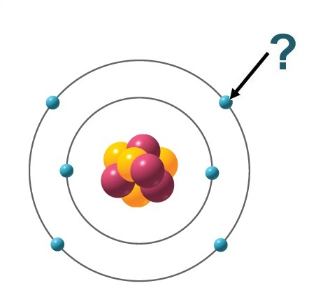  
     
   Copyright © McGraw Hill LLC. Permission required for reproduction or display.  
     
   What is indicated by the arrow?

Electron

Proton

Neutron

Anion

Prion

1. 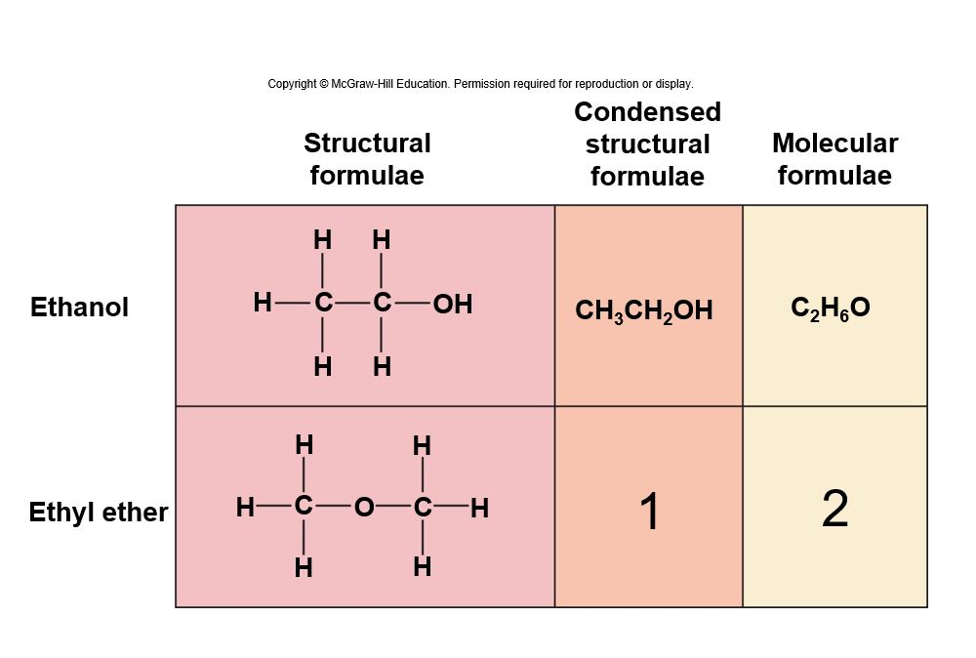  
     
   What is the correct condensed structural formula for ethyl ether? (What goes in the box labeled 1?)

1formula20.mml

1formula21.mml

1formula22.mml

1formula23.mml

1formula24.mml

1.   
     
   What is the correct molecular formula for ethyl ether? (What goes in the box labeled 2?)

1formula25.mml

1formula26.mml

1formula27.mml

1formula28.mml

1formula29.mml

1. 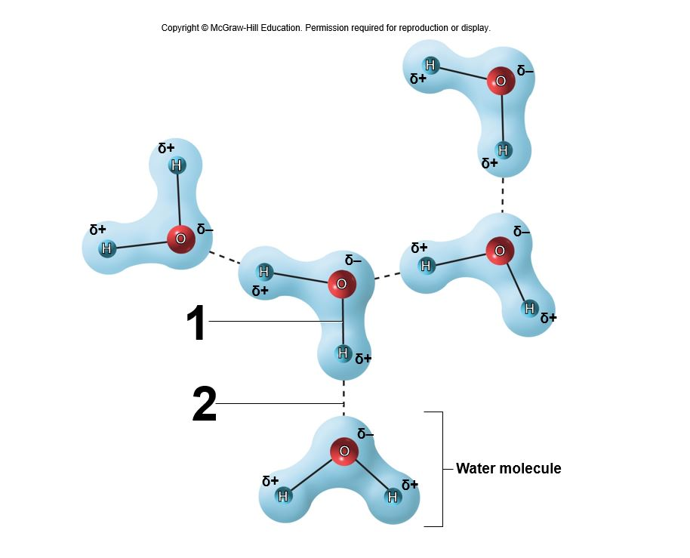  
   What type of bond is labeled 1?

Covalent

Hydrogen

Ionic

Disulfide

Van der Waals

1.   
   What type of bond is labeled 1?

Single polar covalent bond

Double polar covalent bond

Single nonpolar covalent bond

Double nonpolar covalent bond

Triple covalent bond

1.   
   What type of bond is labeled 2?

Hydrogen

Polar covalent

Nonpolar covalent bond

Ionic

Disulfide

1. 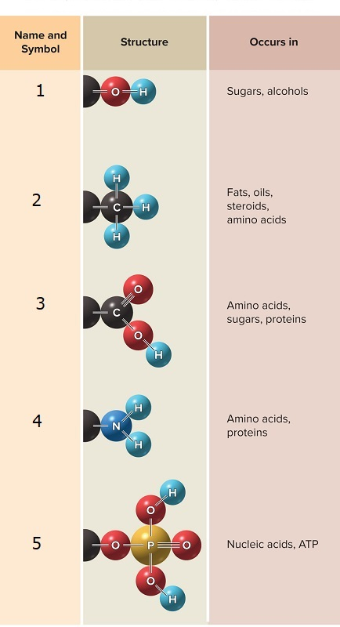  
     
   Copyright © McGraw Hill LLC. Permission required for reproduction or display.

* + 1. Which functional group is labeled 1?

Hydroxyl

Methyl

Carboxyl

Amino

Phosphate

* + 1. Which functional group is labeled 2?

Hydroxyl

Methyl

Carboxyl

Amino

Phosphate

* + 1. Which functional group is labeled 3?

Hydroxyl

Methyl

Carboxyl

Amino

Phosphate

* + 1. Which functional group is labeled 4?

Hydroxyl

Methyl

Carboxyl

Amino

Phosphate

* + 1. Which functional group is labeled 5?

Hydroxyl

Methyl

Carboxyl

Amino

Phosphate

1. 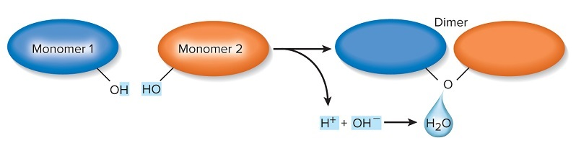  
     
   Copyright © McGraw Hill LLC. Permission required for reproduction or display.  
     
   What type of reaction is shown here?

Dehydration synthesis reaction

Hydrolysis reaction

Exergonic reaction

Catabolic reaction

Oxidation reaction

1. 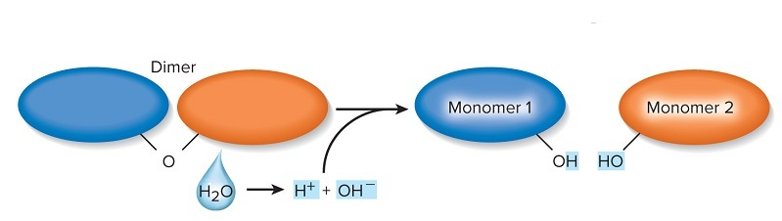  
     
   Copyright © McGraw Hill LLC. Permission required for reproduction or display.  
     
   What type of reaction is shown here?

Hydrolysis reaction

Dehydration synthesis reaction

Endergonic reaction

Anabolic reaction

Reduction reaction

1. 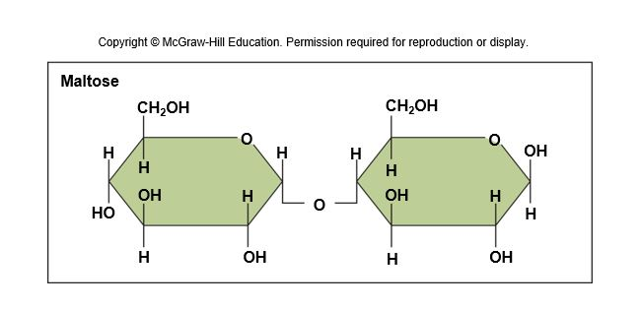  
   What type of molecule is maltose?

Disaccharide

Monosaccharide

Polysaccharide

Polypeptide

Oligopeptide

Triglyceride

1. 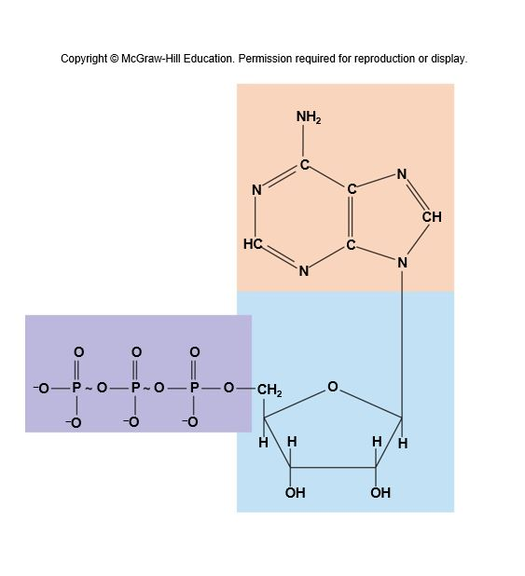  
     
   What molecule is shown here?

ATP

cAMP

Lecithin

Glucose

Cholesterol

1. 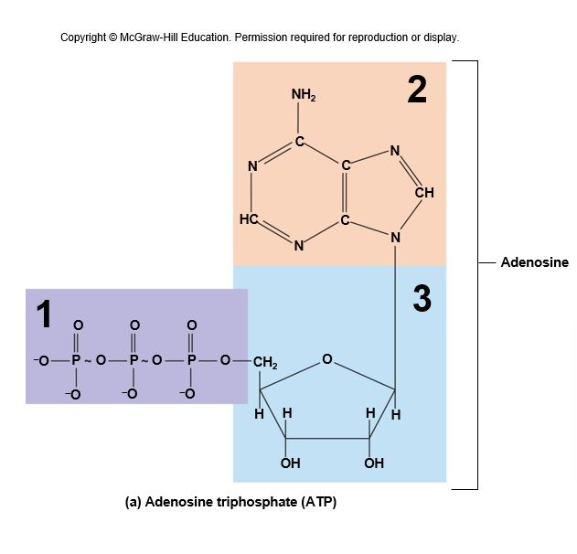

* + 1. Identify the structural component of ATP labeled 1.

Triphosphate

Adenine

Ribose

Adenosine

cAMP

* + 1. Identify the structural component of ATP labeled 2.

Triphosphate

Adenine

Ribose

Adenosine

cAMP

* + 1. Identify the structural component of ATP labeled 3.

Triphosphate

Adenine

Ribose

Adenosine

cAMP

**Answer Key**Test name: CH-02: Test Bank

FALSE

FALSE

TRUE

FALSE

TRUE

TRUE

FALSE

FALSE

TRUE

TRUE

TRUE

FALSE

FALSE

TRUE

FALSE

D

A

B

E

C

B

D

A

C

[B, C, D]

E

C

B

E

E

A

D

A

D

A

E

A

D

C

B

E

C

B

C

D

B

A

D

B

B

D

D

C

D

E

B

E

B

C

C

A

A

B

C

D

A

D

A

A

A

A

A

A

C

FALSE

FALSE

A

A

A

A

A

A

A

Section Break

A

B

C

D

E

A

A

A

A

Section Break

A

B

C